Section 1: Basic Information

Name of Partner: SUPER BUDDIES CLUB
Project Name (or number, where applicable): PSEA PROJECT
Project Country: | ESWATINI
Project Area (if applicable): | LUBOMBO | NKILONGO INKHUNDLA
Reporting Period: | December
Project Start Date: | September -December 2022

Introduction
Nkilongo Constituency has a number of communities under it. Three of the communities; Mahlabaneni, Mangwaneni and Mndobandoba implemented the PSEA project and reached in and out of school adolescents, young people, parents/caregivers and community leaders. The project was implemented over a period of 4 months and the main objective was to increase awareness on PSEA for increased reporting of SEA violations. Awareness sessions on PSEA among adolescents and young people was done in 4 schools and were facilitated by trained peer educators. IEC materials were also developed and distributed among the participants for future reference on the topics covered. The sessions were attended by both girls and boys in ages between 10-24.
Parents/caregivers and general community members that include males and females were reached with information on PSEA through community dialogues that were done in the 3 communities. The dialogues also reached out of schools adolescents and young people with information on PSEA.
In order to measure knowledge levels among the targeted groups, focus groups were conducted in the 3 communities and targeted young people in ages 10-24 years. Focus group discussions were facilitated by a consultant who was engaged to document and analyse the discussions.

Geographic Location of Nkilongo Inkhundla
Nkilongo Constituency is located in the Lubombo Region of Eswatini. The constituency is dominated by a commercial sugar-based economy established by the Ubombo Sugar company. It is characterized by significant internal and cross border migration largely of laborers in the sugar industry. It is also dominated by poor households and these dynamics expose the adolescents and young people (10-24 years), especially girls in the area to risky sexual behaviors that includes intergenerational sex, transactional sex and sexual violence, sexual exploitation and abuse. These behaviours expose many adolescents to unwanted teenage pregnancies, HIV/ AIDS and STIs.

Project Site
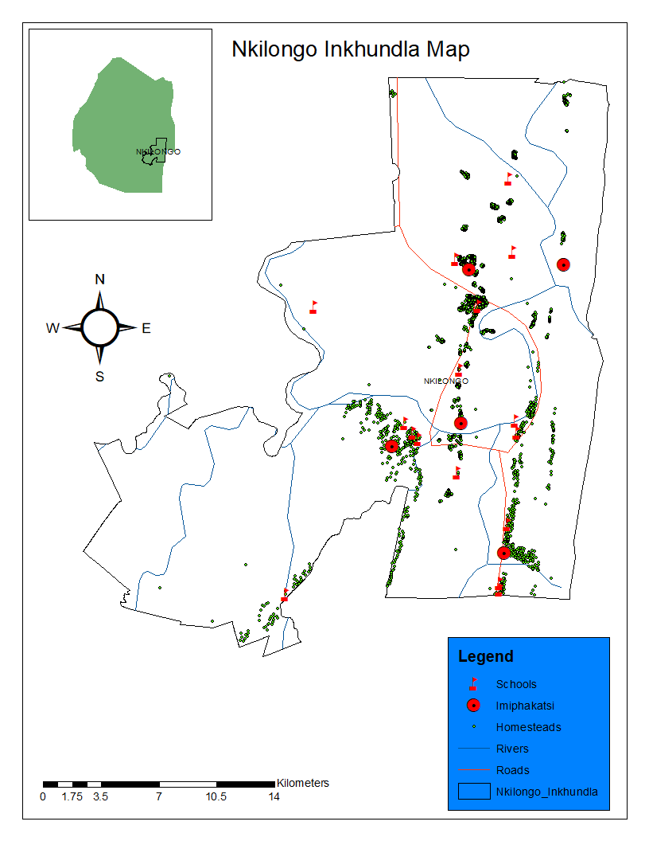
Source: Inkilongo Inkhundla Map

Focus Group Participants enrolment

Table 1: Cumulative Number of young people who particpated in the focus group discussion by their age and gender.
People Reached on Dialogues
Age Group | Males | Females | Total
10-14 years | 41 | 73 | 114
15-24 years | 25 | 84 | 109
Total | 66 | 157 | 223

Focus group participants were drown from the beneficiaries who were reached with information on PSEA through in school sessions and community dialogues. Out of the 223 young people who participated in the FGS, a total of 114 were in ages10-14 years n=41 were males and n=73 were females. Young people in ages 15-24 years were 109 in total. Out of the 109 people, n=25 were males and n=84 were females.

Findings
To assess the knowledge levels of participants on PSEA, questionnaires were developed as used during the FGDs. The questions were guided by the topics below;

Knowledge About Sexual Exploitation and Abuse
The participants were asked how much knowledge they have gained on Sexual exploitation and Abuse during the peer education sessions. The majority of them responded that they gained a lot of information on PSEA and they even gave relevant examples. They said they were not aware that people who demand sex in exchange for services or employment were violating their rights. They said the information they have received through the sessions have enlightened them and they will now be able to identify violations when they happen in their communities or schools. Through the IEC material they received, they also now know where to report.

Reporting Sexual Exploitation and Abuse
Participants were asked whether they know the services provided to report issues of sexual exploitation and abuse. Findings indicate that participants have knowledge of where they can report SEA violations. However, many of them said the police have a department that is dealing with domestic and sexual violations but members of the public are not aware of it. Many participants are also not happy with the police service provision, and said they are laughed at when they report violations. The participants said they are also expected to bribe some of the officers from the Department of Social Welfare in order to access services.

Knowledge on policies and Laws
Participants from all the communities have shallow information on a national policies or an Act that deals with cases of Sexual Exploitation and Abuse in place in Eswatini. Hence there is a need to partner with the Ministry responsible to educate community members on policies in place. The participants appreciated information on the Sexual Exploitation and Domestic Violence Act 2018 that was provided by Super Buddies club during the sessions.

Reasons why people do not report when they have experienced SEA?
- Reasons women do not report – The main reasons women highlighted include; desperation for food parcels and money from the perpetrators; fear of being stigmatized by community members if they come out and report; threats form the perpetrators and fear of losing a job if the sexual exploitation is at a workplace.
- Reasons men do not report – men perceive it as a shame to report any form of abuse, and they are not taken seriously when reporting abuse issues to the police.

- Reasons children do not report –some children do not have proper families structures or parents to report to; parents do not the capacity to communicate SRHR issues that include PSEA with their children.

- Reasons people with disabilities do not report is because they do not have access to information that can empower them to report SEA violations.

Key findings
- Young people are aware of SEA, however they do not know that it is human rights violation. They do not know that anyone who violate their rights should be reported for justice to prevail.
- Participants have a challenge with reporting SEA violations, especially to the police and the Social Welfare Department. Participants complain that cases reported to the police and the social welfare department are not followed up through the legal system.
- Participants are not aware of the policies and laws in place that are meant to protect them from SEA. Although these polices and laws are in place, they do not benefit the beneficiaries because they are not aware of their existence.
- Men do not report violations because they face stigma and discrimination from the police and also fear being stigmatized by community members
- Parents do not have the capacity to support or communicate with their children on issues that include SEA violations. Other children do not have parents or caregivers to report to in the event they are violated.
- People living with disabilities have limited access to information on SEA because many programs do not include them.

Recommendations
- There is need to scale up awareness on PSEA and reach more communities and to link information with policies and the Sexual Offences and Domestic Violence Act so that communities will be aware that this is a violation.
- There is need to advocate for partners to provide effective services and to create awareness on the services they are providing
- There is a need to create partnerships with relevant stakeholders for community awareness on the policies and Sexual Offices and Domestic Violence Act 2018 in communities to increase the reporting of SEA cases.
- Poverty is the main contributory factor to SEA violations. Many are victims because they lack employment and other economic empowerment opportunities. They do not report the violations because of fear of losing their employment benefits. There is need to incorporate economic empowerment programs, especially those that will target women and girls in order to reduce their vulnerability to SEA.
- Community members do not report SEA violations in fear of being stigmatized by other community members or peers. There is need to strengthen community structures that will also accommodate the needs of males. The structures can then refer the cases to the police and the social welfare department for follow-up.
- The capacity of parents/caregivers need to be strengthened for them to effectively communicate with their children SRHR issues that include SEA violations
- There is need to strengthen the collaboration with partners working with people living with disabilities and to also assist them with the development of PSEA policies and reporting and referral guidelines so that they can provide information and services to this target group

Conclusion
SEA is a challenge in many communities and lack of awareness on the subject prevent many victims from reporting. Weak reporting structures also prevent or discourage victims from reporting. While it is important to increase awareness, it is equally important to strengthen the capacity of partners, both at community and national level so that victims/survivors can have access to health, legal and psychosocial services.
There also a need to incorporate economic empowerment to programs to address poverty which expose women and girls to sexual exploitation and abuse.
Many people living with disabilities are also left out in community development programs because of limited capacity of partners to respond to their needs. Partnerships and collaborations with entities working with this group is key to ensure they are also protected from SEA and access the necessary services.

APPENDIX I: GUIDELINES FOR DIALOGUES

Sexual Exploitation (Kuhlukubeteka ngetelicansi ngekutsi kukhona lokuzuzako)
How knowledgeable are you about sexual exploitation? (Wati kangakanani ngalendlela lena yekuhlukubeteka ngetelicansi ngekutsi kukhona lokuzuzako nangekutsi lomuntfu unemanndla kunawe?)

- Kungaba kusemusebentini
- Etikolweni
- Etindzaweni tekujabula

Reporting Sexual exploitation
If you or a friend experience sexual exploitation, where can you get help? (Nangabe wena noma umngani wakho uyahlukubeteka ngetelicansi ngalokutsi kukhona inzuzo lekhona, ungalutfolaphi lusito?

What kind of information services (eg. Telephone, police etc) are set up in Eswatini to provide advice to victims of sexual exploitation. Do they honor confidentiality and anonymity? (Ngutiphi tinsita letikhona Eswatini letinikwa labo labahlukumeteke ngetelicansi ngalokutsi kunenzuzo. Lakutfolakala khona letinsita, tiyagcinwa yini letindzaba kutsi tingaphumeli esiveni futsi nemuntfu lobikile angavetwa?

National Policy or Act (Umtsetfo longamela kuhlukubeteka ngekwelicansi)
Does Eswatini have a comprehensive national policy or an Act on Sexual Exploitation? (Ngabe live laseSwatini linaye yini umtsetfo lobuke tekuhlukumeteka ngetelicansi ngekutsi kunenzuzo?)

Reasons why people do not report when they have experienced SEA?
Reasons women do not report (Ngutiphi tizatfu letenta bantfu besifazane bangabiki bucala bekuhlukumeteka?)

Reasons men do not report (Ngutiphi tizatfu letenta bantfu besilisa bangabiki bucala bekuhlukumeteka?)

Reasons children do not report (Ngutiphi tizatfu letenta bantfu bantfwana bangabiki bucala bekuhlukumeteka?)

Reasons people with disabilities do not report (Ngutiphi tizatfu letenta bantfu bantfwana labakhubatekile bangabiki bucala bekuhlukumeteka?)

Reasons the elderly do not report (Ngutiphi tizatfu letenta bantfu lasebakhulile bangabiki bucala bekuhlukumeteka?)

