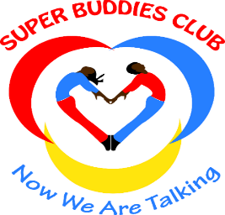

Impact Assessment on Prevention
of Sexual Exploitation and Abuse

Concept Note prepared by:
Super Buddies Club

Introduction
Super Buddies Club, a non-profit organization based in Eswatini Nkilongo Constituency has a number of communities under it. Three of the communities; Mahlabaneni, Mangwaneni and Mndobandoba will implement the Prevention of Sexual Exploitation and Abuse (PSEA) project and reach in and out-of-school adolescents, young people, parents/caregivers and community leaders. IEC materials will developed and distributed among the participants for future reference on the topics covered. The sessions will be attended by both girls and boys in ages 10-24 years including those living with disabilities. Visual material will be developed and shared via WhatsApp to reach adolescents and young people who will not be reached through the sessions, including those living with disabilities. Parents/caregivers and general community members that include males and females will be reached with information on PSEA through community dialogues that will be conducted in the 3 communities. The dialogues will also be used to reach out-of-school adolescents and young people.
The project will increase awareness on the Prevention of Sexual Exploitation and Abuse in Nkilongo Constituency in the Lubombo Region of Eswatini. The project will be implemented over a period of 4 months and the main objective is to increase awareness on PSEA for increased reporting of violations. Awareness sessions on PSEA among adolescents and young people will be done in 4 schools and will be facilitated by trained peer educators.
The project will: increase awareness on SEA among young people, particularly AGYW and those living with disabilities as this impedes their autonomy in making decisions and taking actions pertaining to their bodies and their lives; increase reporting and referral of SEA incidences reported by young people; increase awareness among community members in order for them to identify, prevent and refer incidences of SEA to legal and health service providers.

A reporting and referral protocol will be developed and used as a guide to address SEA violations within the organisation and externally.

2. Rationale of the impact assessment

The overall goal of the impact assessment is to evaluate the impact of the peer education sessions in improving knowledge and reporting outcomes for SEA among adolescents and young people from 3 communities under Nkilongo Constituency in the Lubombo Region of Eswatini
- Assessment Questions:
- How knowledgeable are you about sexual exploitation?
- If you or a friend experience sexual exploitation, where can you get help?
- What kind of information services (eg. Telephone, police etc.) are set up in Eswatini to provide advice to victims of sexual exploitation. Do they honor confidentiality and anonymity?
- Does Eswatini have a comprehensive national policy or an Act on Sexual Exploitation?
- Reasons women do not report ?
- Reasons men do not report?
- Reasons children do not report?
- Reasons people with disabilities do not report?
b. Methodology
This assessment will use Focus Group Discussion (FGDs) to engage young people who have received information on PSEA through peer education sessions and also through community dialogues to measure the impact.
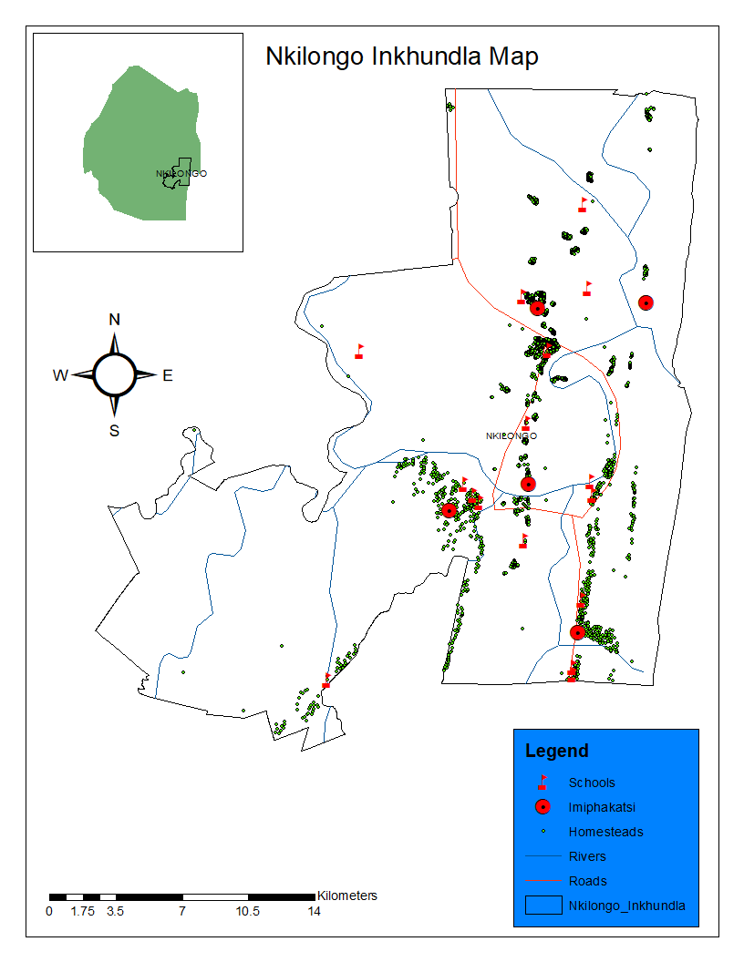
Source: Inkilongo Inkhundla Map
- Assessment Population
Table 1: Cumulative Number of young people who will participate in the focus group discussion by their age and gender. The sample size will be apportioned according to the number of adolescent and young people targeted for the project.
The table below illustrates that spectrum.
Community | Males  10-14 years | Females  10-14 years | Males  15-29 years | Female  15-29 years | TOTAL
Mangwaneni | 20 | 20 | 20 | 20 | 80
Mndobandoba | 20 | 20 | 20 | 20 | 80
Mahlabaneni | 20 | 20 | 20 | 20 | 80
TOTAL | 60 | 60 | 60 | 60 | 240

Focus group participants will be drown from the 600 beneficiaries that will be reached with information on PSEA through in school sessions and community dialogues. Out of 240 young people who will participate in the FGS, 120 will be adolescents in 10-14 years n=60 males and n=60 females. A total of 120 young people will range from the ages15-24 years will be n=60 males and n=60 females.
d. Data Collection Tools
Focus Group Discussion (FGD) guide – this is a way of bringing respondents together in discussion groups that focus on a particular topic. Under this impact assessment, a total of 16 FGDs (4 in each community in ages 10 to 14 years and 15-24 years), one for females and one form males) will be conducted after the conclusion of the peer education sessions and dialogues. A questionnaire will be developed and used as a guide for the discussions. The discussions will involve about 20 participants per group each and will take on average of one hour.
e.Data Management and Analysis
Qualitative data will be analyzed using content. Quantitative analysis will be done using basic descriptive statistics. Analysis results will be presented in tables and general observations and recommendations.

6. Publication and Dissemination
On completion of the assessment, the findings will be presented first to key stakeholders that include the young people, community members and partners.

APPENDIX I: GUIDELINES FOR DIALOGUES

Sexual Exploitation (Kuhlukubeteka ngetelicansi ngekutsi kukhona lokuzuzako)
How knowledgeable are you about sexual exploitation? (Wati kangakanani ngalendlela lena yekuhlukubeteka ngetelicansi ngekutsi kukhona lokuzuzako nangekutsi lomuntfu unemanndla kunawe?)
- Kungaba kusemusebentini
- Etikolweni
- Etindzaweni tekujabula

Reporting Sexual exploitation
If you or a friend experience sexual exploitation, where can you get help? (Nangabe wena noma umngani wakho uyahlukubeteka ngetelicansi ngalokutsi kukhona inzuzo lekhona, ungalutfolaphi lusito?

What kind of information services (eg. Telephone, police etc) are set up in Eswatini to provide advice to victims of sexual exploitation. Do they honor confidentiality and anonymity? (Ngutiphi tinsita letikhona Eswatini letinikwa labo labahlukumeteke ngetelicansi ngalokutsi kunenzuzo. Lakutfolakala khona letinsita, tiyagcinwa yini letindzaba kutsi tingaphumeli esiveni futsi nemuntfu lobikile angavetwa?

National Policy or Act (Umtsetfo longamela kuhlukubeteka ngekwelicansi)
Does Eswatini have a comprehensive national policy or an Act on Sexual Exploitation? (Ngabe live laseSwatini linaye yini umtsetfo lobuke tekuhlukumeteka ngetelicansi ngekutsi kunenzuzo?)

Reasons why people do not report when they have experienced SEA?
Reasons women do not report (Ngutiphi tizatfu letenta bantfu besifazane bangabiki bucala bekuhlukumeteka?)
Reasons men do not report (Ngutiphi tizatfu letenta bantfu besilisa bangabiki bucala bekuhlukumeteka?)
Reasons children do not report (Ngutiphi tizatfu letenta bantfu bantfwana bangabiki bucala bekuhlukumeteka?)
Reasons people with disabilities do not report (Ngutiphi tizatfu letenta bantfu bantfwana labakhubatekile bangabiki bucala bekuhlukumeteka?)
Reasons the elderly do not report (Ngutiphi tizatfu letenta bantfu sebakhulile bangabiki bucala bekuhlukumeteka?)

