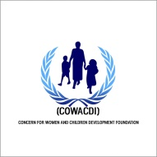
Concern for Women and Children Development Foundation
Supported by Interagency Community Outreach and Communications Fund.
Focus Group Discussion (FGD) Report on Protection from Sexual Exploitation and Abuse (PSEA)

Focus Group Discussion (FGD) Report
Purpose of Activity
The aim of the activity was to have robust engagement sessions with affected population, to strengthen communication with communities as well as build their capacity and resilience on Prevention of Sexual Exploitation and Abuse (PSEA).
Description of Activity
A community based approach was adopted in carrying out the activity to meet the needs identified during baseline assessment while also contributing to improving PSEA reporting mechanisms. FGD sessions were carried out in identified private locations (in English, Hausa and Kanuri) within the communities; the materials and approaches developed created an enabling environment for communication with women, men, girls, and boys of diverse backgrounds, through means that are most appropriate and accessible to all groups in the communities including the use of interpreters (community volunteers) where necessary. Warm up activities were also carried to encourage active participation.
19 FGD group sessions was held for 20 participants each group (6 sessions in Bolori and Modusulumri Communities respectively and 7 sessions in Gwange community). The FGD sessions were conducted once in each of the locations every week with each group of 20 participants of male, female, children throughout the project cycle with the total target of 1200 participants reached comprising:
Adult =Male:96 Female:125
PLWD=Male:28 Female:20
Youth= Male:177 Female:534
Children=Boys:140 Girls:80
The project targeted men, women, boys, girls and persons with disabilities. Both genders benefitted in a comparable way. This includes making sure that the needs of women, men, children and persons with disabilities are equally addressed. After implementation 75-80% of the direct beneficiaries now have knowledge on SEA, which includes equal number of women and men.
Outcome of the Activity
- Affected population had little or no knowledge of SEA and how to report it due to cultural and religious norms (discrimination, stigmatization etc) and the how it is been handle via the community channel of reporting SEA through the Community leaders, demonstrates increase in knowledge on PSEA as a result of the focused group discussion sessions they participated in.
- Participants now have improved knowledge on SEA and safe, accessible, child sensitive mechanisms for reporting of SEA in the communities
- Participants reached said they now know their rights and are now aware of their right when violated by aid worker through SEA and they can report it without any fear or doubt.
- Affected women, girls, boys and men have access to a safe, gender and child-sensitive pathways to report SEA through community-based complaints mechanisms (i.e. the email address, hotline).
Challenges
- Beneficiaries always expect livelihood
- PSEA related issues and sensitive issues to deal with due to some societal and religious norms and values.
- Discrimination, stigmatisation and judgement is hindering survivors to report SEA

Lessons Learnt:
- Recognizing that individual and socio-cultural differences of people in the community can lead to diverse effect and interpretations of key PSEA-related concepts. To address such potentially opposing views, positive behaviour, cultural norms and communication skills were encouraged.

- The PSEA team found the need for a safe and inclusive space for open discussions, considering the sensitive nature of the topics around PSEA.

- Other lessons learned include collaboration with local partners/organizations for referrals for SEA and gender based violence concerns and issues which are been reported during PSEA activities (awareness raising sessions).This is effective in helping survivors of GBV to received support that needed.

- Including specific safeguarding activities in all program activities. This include distribution of IEC materials to different programs in COWACDI (MCN, Nutrition, Education) etc. This is done so as to integrate PSEA and protection into all COWACDI activities.

- The need to balance between focusing on SEA for both genders.

- Involving faith based/religious leaders as safeguarding champions to build awareness among communities and reduce taboos and misconceptions about PSEA.

PICTURES:
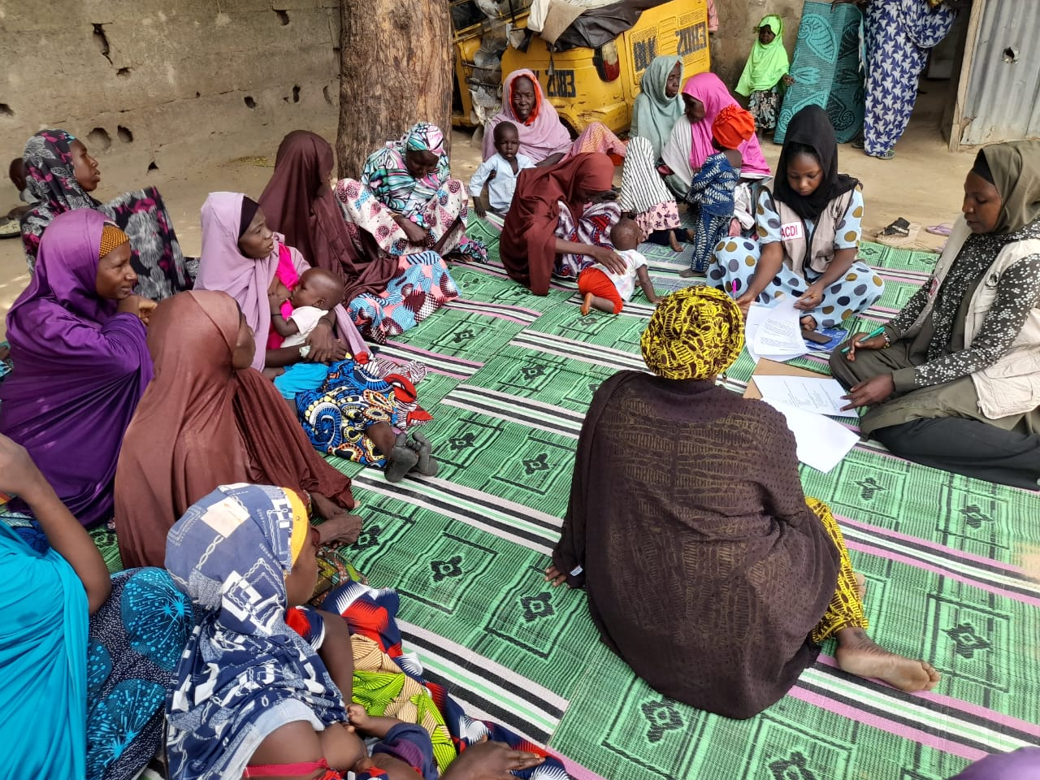 Female group FGD Session
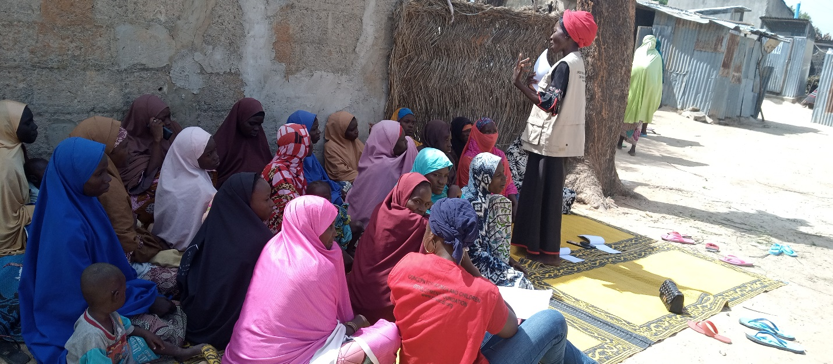
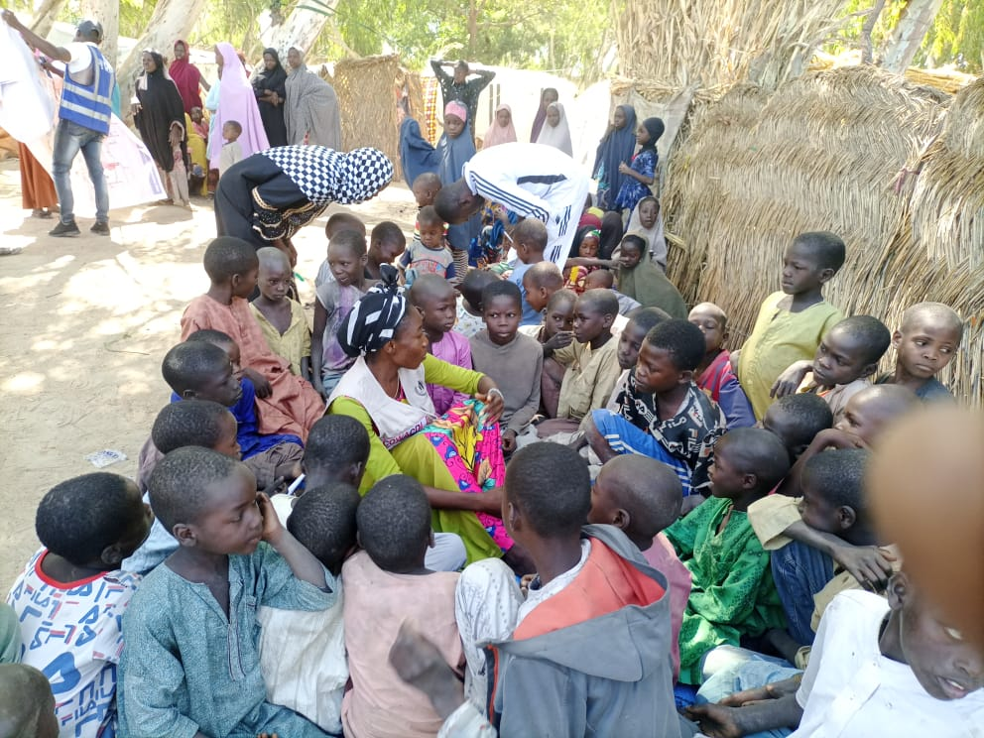 Children group FGD session
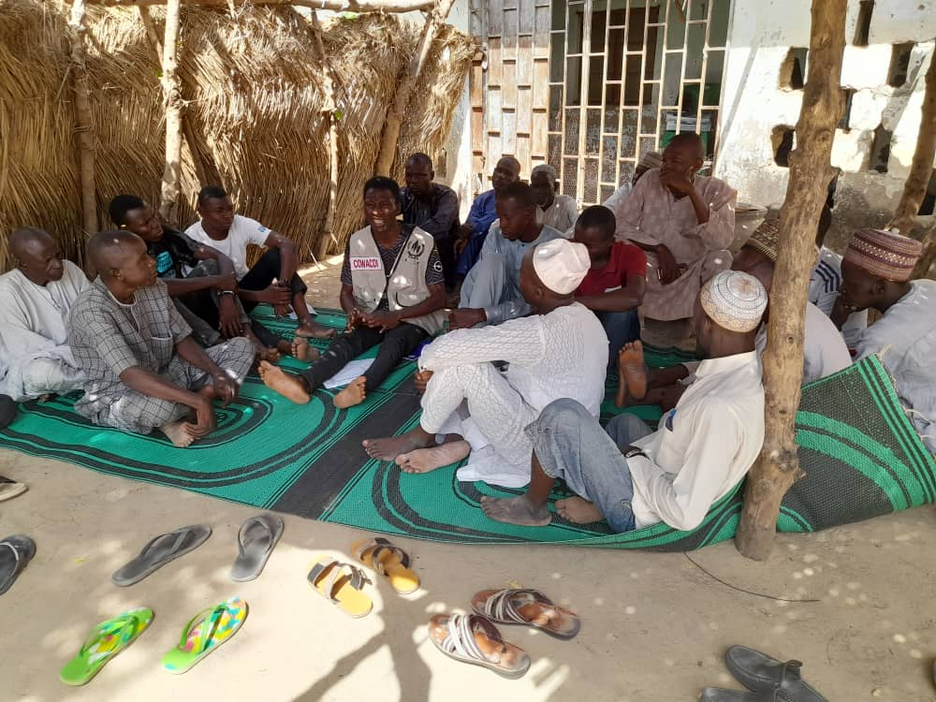
Male group FGD session
