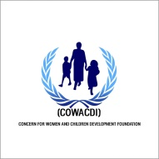
Concern for Women and Children Development Foundation
with supported by Interagency Community Outreach and Communications Fund.
Focus group Discussion (FGD) agenda on Protection from Sexual Exploitation and Abuse (PSEA) Project
AGENDA
 | ACTIVITY: Focus Group Discussion on SEA | PERSON RESPONSIBLE | Time
1. | Introduction and consent | COWACDI PSEA Team | 10:30am -10:45am
2. | Administration of FGD questionnaire | COWACDI PSEA Team | 10:45am -11:15am
3. | Emphasis on the importance of reporting SEA | COWACDI PSEA Team | 11:15am -11:30am
4. | Where to report SEA/ice breaker | COWACDI PSEA Team | 11:30am -12:00pm
5. | Questions and answers | COWACDI PSEA Team | 112:00pm -12:15pm
6. | Issues for immediate follow up | COWACDI PSEA Team | 12:15pm -12:30pm
7. | Signing of attendance and refreshment | COWACDI PSEA Team | 12:30pm -1:00pm
8. | Departure | COWACDI PSEA Team | 1:15pm

