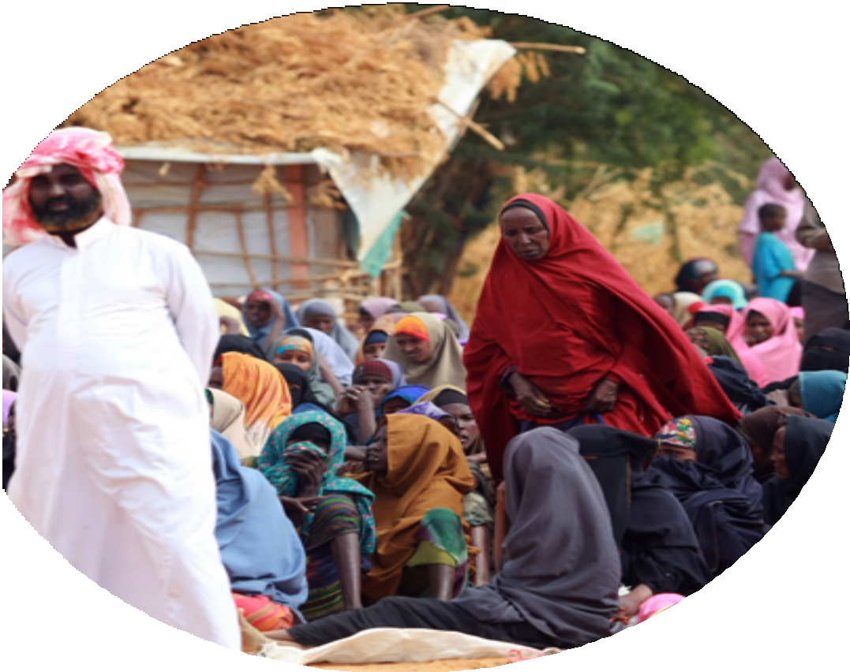
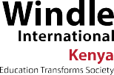

Community Dialogue Guide on Protection from Sexual Exploitation and Abuse
Prevent & Protect

Coordinated by: Agnes Mwangi, HR Child Protection and Safeguarding Coordinator – Windle International Kenya

Supported by: Phyllis Mureu, Executive Director, Windle International Kenya

Funded by: International Council of Voluntary Agencies (ICVA)
Inter-Agency Standing Committee (IASC) The UN Refugee Agency (UNHCR)

Copyright©2021

Contents
Acknowledgement 5
Executive Summary 6
PSEA Community Dialogue Guide 7
Introduction and scope 8
Introduction to SEA community awareness session 9
Module 1 - Understanding SEA 9
Session 1.1: Ask the participants what they think SEA means 9
Session 1.2: Ask the participants what they think causes SEA 10
Session 1.3: Ask the participants what they think are the risks/effects/ consequences of SEA to: a) children b) youth c) people living with disability d)the old men and women e) perpetrator
f ) Organization & their staff 11
Session 1.4: Ask the participants to brainstorm on the rights of the community 12
Module 2 - Prevention of Sexual Exploitation and Abuse (SEA) 13
Session 2.1: Ask the participants why people don’t report cases
of SEA to the relevant authority. 13
Session 2.2: Ask the participants to give reasons why they think
reporting cases of SEA is a good thing (advantages). 15
Session 2.3 IASC Core Principles/Code of conduct for Aid workers in
SEA prevention 16
Session 2.4 The role of the community in preventing SEA 18
Module 3 - Response to SEA concerns & incidents 19
Session 3.1: Reporting/Referral pathway 19
Session 3.2 Hagadera Referral Pathway 20
Session 3.3 Dagahaley Referral Pathway 21
Session 3.4 Ifo Referral Pathway 22
Annex 1 - Protection From Sexual Exploitation And Abuse-Message
To The Community 23

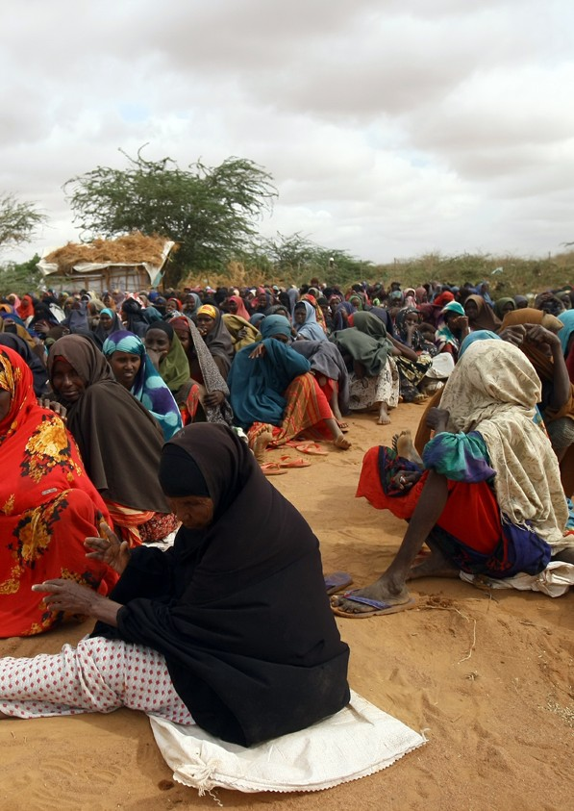
4 COMMUNITY DIALOGUE GUIDE ON PROTECTION FROM SEA

Acknowledgement
Our appreciation to Interagency Community and Communications fund on Protection from Sexual Exploitation and Abuse from International Council of Voluntary Agencies (ICVA),Inter- Agency Standing Committee (IASC) & The UN Refugee Agency (UNHCR) that made production of this community dialogue training guide possible. Special thanks to UNHCR Dadaab-Kenya for their valuable support and feedback during the development of this guide.

We acknowledge the support from Dadaab Child Protection (CP), Sexual Gender Based Violence (SGBV) and Protection from Sexual Exploitation and Abuse (PSEA) Working groups. We appreciate the Dadaab community for their immense cooperation and the commitment to keep the refugee camps in Dadaab safe for our children. We also acknowledge the valuable time and resources provided by Windle International Kenya Dadaab team in the development of the guide and facilitation of community dialogues in IFO, Dagahaley and Hagadera.

Executive Summary
According to the U.N. Secretary-General’s Bulletin on Protection from Sexual Exploitation and Abuse, sexual exploitation refers to “any actual or attempted abuse of a position of vulnerability, differential power, or trust, for sexual purposes, including, but not limited to, profiting monetarily, socially or politically from the sexual exploitation of another. Sexual Exploitation and Abuse (SEA) occurs when people in power exploit or abuse vulnerable populations for sexual purposes. The purpose of Interagency community outreach and communications fund on Protection from Sexual Exploitation and Abuse (PSEA) therefore contributes greatly in enhancing community empowerment required for them to protect themselves from the vice.

Windle International Kenya is not only committed to creating community awareness on risks, prevention and safe reporting of SEA but has also adopted a zero-tolerance approach to any form of abuse against the refugees and vulnerable communities. This community dialogue guide will be used by our direct beneficiaries who comprise of young people, vulnerable persons, community and religious leaders not only for their own learning but to also teach others in the wider community.

Phyllis Mureu Executive Director

PSEA Community Dialogue Guide
This community dialogue guide was developed with support from International Council of Voluntary Agencies (ICVA), Inter-Agency Standing Committee (IASC) and The UN Refugee Agency (UNHCR) and coordinated by Windle International Kenya with Inter- agency working groups (service providers) playing a key role. Their aim was to fulfill commitments, obligations and requirements to protect the community from Sexual Exploitation and Abuse, ensure community empowerment to enable them prevent and report safely concerns and incidents of Sexual Exploitation and Abuse (SEA).

The participating service providers have put in place an elaborate reporting mechanism and strategies to ensure appropriate actions are taken against perpetrators and the community remains safe.

Introduction and scope
Purpose: This guide is designed to engage participants through dialogue, exercises or focus group discussions to understand what constitutes Sexual Exploitation and Abuse (SEA), risks involved, how to prevent and respond to incidents and concerns of SEA within the community. It can be used to dialogue with various segments of people in the community-children, youth, security officers, people living with disability and the aged men and women. The facilitator should guide the discussions towards achieving each group’s needs. The guide should be translated into local languages.

Timing: Depending on the category of participants, this discussion may take 60-90 minutes. However, the facilitator should allocate time to each session depending on the needs of the participants.

Materials: The IASC Six core principles/Code of conduct relating to SEA should be translated into the relevant local languages and shared. If this is not possible, it will be important to have the facilitator or a co-facilitator provide oral translations during the session.

Introduction to SEA community awareness session
The facilitator welcomes the participants and introduces other facilitators. He or she explains that the purpose of the meeting is to discuss issues related to Protection from Sexual Exploitation and Abuse (PSEA), explore ways in which SEA can be prevented and share how incidents or concerns of SEA can be reported safely.

Module 1 - Understanding SEA

Session 1.1: Ask the participants what they think SEA means.
Make sure you create a comfortable setting where they feel “safe” to talk about this sensitive issue. Do not be judgmental. It is culturally appropriate to talk about SEA (Note all the answers given). Remember this is supposed to be a dialogue so probe, ask questions and allow them to also ask questions, make suggestions and share their experiences.

After the discussion, if the meaning did not come out, explain that:
- Sexual Abuse means the actual or threatened physical intrusion of a sexual nature, whether by force or under unequal or coercive conditions.

- Sexual Exploitation is actual or attempted abuse of someone’s position of vulnerability, differential power, or trust, for sexual purposes including but not limited to profiting monetarily, socially or politically from the sexual exploitation of another including trafficking and prostitution.

- Sexual Exploitation and Abuse (SEA) constitutes an abuse of power by aid workers against the affected population. It is based on gender inequality, power imbalance and disrespect of human rights. Anyone can commit SEA but those with more power are more likely to perpetrate while those with less power are vulnerable to becoming victims. Aid workers always have more power over those they serve.

We therefore understand Sexual Exploitation and Abuse as acts committed by aid workers or people associated with aid organizations against the people they are supposed to protect or provide aid to. SEA undermines the credibility and integrity of humanitarian aid workers and inflicts harm on those they are obliged to protect.

Session 1.2 : Ask the participants what they think causes SEA.
(Note all their responses)
Facilitate the discussion in line with the category of people you are working with for instance what points do you expect from the children, the youth, security personnel, people living with disability, the aged in the community.

Raise the following points if they have not been mentioned.
- Community lack knowledge on whether SEA is a crime or not as some see it as a survival strategy. Give examples such as an aid worker approaches a refugee girl for friendship. She agrees and the aid worker provides her with money and other basic needs in exchange for sex.

- Every agency has a code of conduct which every staff signs prohibiting sexual relationships with the refugees and the vulnerable communities they work with. Yet they take their advantage by engaging in sexual relationships knowing it’s a crime.

- Some refugees and vulnerable communities see aid workers as people with solutions to their problems e.g. resettlement, good life and therefore became easy prey. Give examples- An aid worker lie to a refugee woman promising to help them get resettlement in exchange for sexual relationship.

- Some cultural norms and expectations about sexual behavior regarding minors, gender, sexual orientation,power e.tc contribute heavily to SEA. Give examples-Some cultures value virginity. A girl who suffers sexual abuse will prefer silence than speaking out.

- Abuse of power by aid workers

- Lack of respect for human rights by aid workers

- Gender inequity- A man has more power, capacity and access to resources than a woman

Session 1.3: Ask the participants what they think are the risks/effects/ consequences of SEA to: a) children b) youth c) people living with disability d) the old men and women e) perpetrator f) Organization & their staff
(Note all their responses)
Facilitate the discussion focusing on effects of each group then the perpetrator and the organization. For instance, an aid worker who abuses a child. How does this act affect the child, the perpetrator and the organization that has employed the perpetrator?

Raise the following points if they have not been mentioned.

  - Children survivors-develop mistrust of the adults, withdraws and exhibit fear, has sleep-wake disorder, feeding and eating disorder, feels guilty and cries in silence.

  - Youth survivor- Suffer mental disorders such as anxiety disorder, substance related and addictive disorder, feel helpless guilt and anger, exhibit fear of infection unwanted pregnancy and sometimes withdraws. If they are students some loose interest in school, they are stigmatized and lose their reputation and peers withdraw leaving them lonely and isolated.

  - People living with disability- They feel helpless, guilt and anger. Suffer mental disorders like trauma, anxiety and fear of sexually transmitted infections and unwanted pregnancy. Many victims report flashbacks of the sexual abuse and experience feelings of isolation, shock and confusion. The whole person is psychologically and physically affected.

  - Perpetrator- Lose job, suffer rejection from both the community and other aid workers, suffer physically and psychologically, likely to get jailed.

  - The community- Lose trust in Aid workers, the relationship between agencies and the community is compromised. The community might retaliate, suffer apathy.

  - Organization- lose funding, they lose staff, the organization’s image is tainted, it becomes a security risk, community lose trust

  - Other staff in the organization- suffer compassion burnout, loss of team spirit, might retaliate, low job performance, social interaction with the community is affected.

Session 1.4: Ask the participants to brainstorm on the rights of the community
(Note their points)

Raise the following points if they have not been mentioned.

- The community has a right to be protected from any form of sexual exploitation and abuse for free.

- An individual who reports a case of SEA has a right to be protected from any form of retaliation for free

- A victim/survivor has a right to get assistance for free. He or she has a right to feel safe.

- The community has a right to report any suspicion, concern or incident of SEA without fear

- The community has a right to protect other community members from SEA without fear

- The community has a right to champion these rights in the community.

Module 2 -Prevention of Sexual Exploitation and Abuse (SEA)

Session 2.1: Ask the participants why people don’t report cases of SEA to the relevant authority.
Facilitate the discussion in relation to the group participating-children/ youth/ people living with disability/ security personnel/the aged in the community. (Note all their responses)

Raise the following points if they have not been mentioned.

  - Fear of not being believed

  - Fear of being asked for bribery especially in police stations for the perpetrator to be arrested.

  - Sometimes when perpetrators are arrested, they bribe the police and they are released.

  - Lack of resources to obtain help e.g. transport.

  - Shame, guilt and embarrassment

  - Fear whether confidentiality will be maintained

  - Fear of retaliation by perpetrator

  - Financial dependence and other support from the perpetrator

  - Perpetrator threatening the victim/survivor in-case they report

  - Not wanting the perpetrator to lose job or be prosecuted.

  - When SEA cases are reported nothing is done.

  - Reporting or talking about sexual issues in public is culturally prohibited.

  - The community is likely to blame you as the cause of the incident (community backlash)

  - Fear reporting may force agencies to withdraw their support to the community

  - Not knowing how or where to complain or report

Explain that children too do not report incidents of SEA for the following reasons:
- They will not be believed because they have no tangible evidence
- They will be killed or hurt if they tell
- They will be taken away from their families
- They will not be able to explain/articulate what happened
- Their families will be hurt or will hurt them
- The notion that abuse is normal and it happens to everyone
- The abuser will be sent to prison, lose job, or get killed
- They are bad and it is their fault that it happened
- Will not receive presents, money, food any more

Session 2.2: Ask the participants to give reasons why they think reporting cases of SEA is a good thing (advantages).
Balance the discussion to elicit points from those saying it’s a good thing( advantages) and those saying it’s not a good thing( disadvantages). (Note all their responses)
Conclude by explaining that reporting cases of abuse may have benefits to those who have experienced the abuse as well as preventing future abuse from happening. Some advantages are:

- Healing- some survivors have confessed that after reporting and telling it out to their family and friends has made them heal faster. However, not everybody will heal by telling it out to the public only those who are ready to.

- Access to support- Once someone reports sexual abuse, they may be referred to support and counselling that they may not have known before. Seeking effective treatment can help reduce consequences of abuse such as unwanted pregnancy, sexually transmitted infections such as HIV.

- Increased reporting by others- Hearing one story may encourage others to come forward and share their stories too and the case against the perpetrator become much stronger.

- Reduced reoffending- Identifying the perpetrator may make it less likely that they will offend again.
Inform the participants that the survivors must make the best decisions for themselves. Reporting sexual abuse is a personal decision. However, there may be some personal benefits to reporting as well as the possibility of decreasing future abuse.

Session 2.3 IASC Core Principles/Code of conduct for Aid workers in SEA prevention
Explain that the IASC ( Inter Agency Standing Committee on PSEA) has provided a code of conduct forall aidworkerswhichtheymustabideby. Beforesigningemploymentcontract, theyhavetosign the agency code of conduct which includes the following: Take them through one by one.

- Sexual exploitation and abuse by humanitarian workers constitute acts of gross misconduct and are therefore grounds for termination of employment.

- Sexual activity with children (persons under the age of 18) is prohibited regardless of the age of majority or age of consent locally. Mistaken belief regarding the age of a child is not a defense.

- Exchange of money, employment, goods, or services for sex, including sexual favors or other forms of humiliating, degrading or exploitative behavior is prohibited. This includes exchange of assistance that is due to beneficiaries.

- Any sexual relationship between those providing humanitarian assistance and protection and a person benefitting from such humanitarian assistance and protection that involves improper use of rank or position is prohibited. Such relationships undermine the credibility and integrity of humanitarian aid work.

- Where a humanitarian worker develops concerns or suspicions regarding sexual abuse or exploitation by a fellow worker, whether in the same agency or not, he or she must report such concerns via established agency reporting mechanisms.

- Humanitarian workers are obliged to create and maintain an environment which prevents sexual exploitation and abuse and promotes the implementation of their code of conduct. Managers at all levels have particular responsibilities to support and develop systems which maintain this environment.

Divide the participants into groups and give each a case scenario. Let them discuss and answer these 3 questions. Or read the scenarios to them and let them brainstorm and respond to the three questions.

- Has the code of conduct been breached?
- If so which rule has been broken?
- What would you do next?

Case scenario

  - Peter is a 20 year old driver employed in one of the agencies. He transports relief items from the warehouse to the refugee camp where the items are distributed. On one of his trips he recognized a 16-year-old refugee girl walking on the side of the road and gave her a ride back to the camp. Since then, to impress her, he frequently offers to drive her wherever she is going and sometimes gives her small items from the relief packages in his truck, which he thinks she and her family could use. The last time he drove her home she asked him to come inside her home to meet her family. The family was pleased that she had made friends with a NGO worker. Peter really likes the girl; he wants to start a romantic relationship with her and to ask her parent’s permission to marry her. He knows her family will approve.

  - Zainab is a refugee in one of the camps. Abdi is a staff recruited from the host community to distribute food in the camp. He has offered to give Zainab a little extra during the distribution if she will be his ‘special friend’. She agrees willingly. Both of them agree that they should start a sexual relationship and neither of them thinks that anything is wrong. Zainab hopes that the relationship might be a passport to getting local citizenship or at least an opportunity to supplement her rations. Abdi does nothing to discourage these hopes.

  - Omar is a business man in one of the camp. He wakes up very early to buy glossaries in the market for his shop. On several occasions, he has seen John –a national staff with one of the agencies coming from his neighbor-Asha’s house very early in the morning. He suspects John has a relationship with her.

Session 2.4 The role of the community in preventing SEA

Ask the participants to brainstorm on what their role is in preventing incidents of SEA.

Explain the following points if they were not raised in the discussion.
- The community has to report cases of SEA! Humanitarian organizations and their staff work under the principles of humanity, impartiality, dignity for all and respect. The community must therefore report if they are harmed, discriminated against or asked by a staff working for a humanitarian organization to do something that is inappropriate in return for services. All complaints are kept confidential and no harm will come to you for reporting the issue.

- If you are worried about the wellbeing or safety of a child, a person living with disability, the old persons in the community or have seen, heard or suspects an aid worker acting improperly, you must report this. You may be the only person with this information, and the only one who can help keep the affected people safe.

- Religion (Islamic, Christian, Hindu etc.) does not condone sexual exploitation and abuse. Speak out as a community and declare in one voice: “We will not tolerate anyone committing or condoning sexual exploitation and abuse. We will not let anyone cover up these crimes. Let us make Zero tolerance a reality”. So talk!

- The community and religious leaders do not support traditional secret courts set up in the community to determine cases of sexual exploitation and abuse such as child marriage, forced marriage or female genital mutilation. When you see, hear or suspect such meetings are going on-Report.

Module 3 - Response to SEA concerns & incidents

Session 3.1: Reporting/Referral pathway
Explain to the participants that for this war to be won, they must be ready to report what they see, hear or suspect to relevant reporting points without fear. They should not first investigate or find out if what they suspect is true. That will be done by the relevant agencies where the issue is reported.

Ask the participants to mention where they think they should report concerns or incidents of SEA in:

  - Hagadera
  - Dagahaley
  - Ifo

Share the following information with the participants and remind them that this referral includes reporting by children, youth, People living with disability, adults including the aged men and women in the community:

Hagadera Referral Pathway

Children/ children
with disability
Youth/Youth with disability
Adults/adults with disability/ Aged men and women
TDH
IRC
IRC Main Hospital

Explain that children below 18 years can report to TDH, Youth and adults above 18 years can report to IRC. If the case requires hospital first then both children and adults should report to IRC Main hospital. Reporting can be done by self, family member, friends or community members.

Dagahaley Referral Pathway
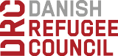
Children/ children
with disability
Youth/Youth with disability
Adults/adults with disability/ Aged men and women
Save The Children
DRC
MSF
Medical

Explain that children below 18 years can report to Save the Children, Youth and adults above 18 years can report to DRC. If the case requires medical attention first, then both children and adults should report to MSF. Reporting can be done by self, family members, friends or community members

Ifo Referral Pathway
Children/ children
with disability
Youth/Youth with disability
Adults/adults with disability/ Aged men and women
Save The Children
DRC
KRCS -
Medical

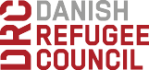

Explain that children below 18 years can report to Save the Children, Youth and adults above 18 years can report to DRC. If the case requires medical attention first, then both children and adults should report to KRCS. Reporting can be done by self, family member, friends or community members.

Annex 1

Protection From Sexual Exploitation And Abuse-Message To The Community

IASC Rules on sexual conduct for humanitarian workers

Humanitarian workers can be disciplined – even fired – for unacceptable behaviour in relation to sex. These are the rules they must comply with:

    - Humanitarian workers are not allowed to have sexual relationships with anyone under the age of 18, even if it is legal in their country. Saying they did not know the person’s true age is not a valid excuse.

    - Humanitarian workers are not allowed to pay for sex with money, employment, goods or services – including goods and services intended as aid to people in need. They must not use promises of these things to make other people accept any kind of behaviour that humiliates or exploits them. This includes paying or offering money for sex with a prostitute.

    - Humanitarian workers have influence over who receives goods and services. This places them in a position of power in relation to people who need assistance. For that reason, humanitarian organizations strongly encourage staff not to have sexual relationships with anyone affected by a humanitarian emergency. Such relationships make humanitarian action seem less honest and credible.

    - If a humanitarian worker is worried or suspects that anyone in their organization or another aid organization may be breaking humanitarian rules on sexual conduct, they must report it, following procedures set up by their agency.

    - Humanitarian workers must create and maintain a work environment which prevents unacceptable sexual behaviour and encourages staff to behave as set out in their codes of conduct. All managers are responsible for supporting and developing systems which maintain this environment.

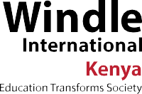
24 COMMUNITY DIALOGUE GUIDE ON PROTECTION FROM SEA
By
No.10 Amboseli Road,
Ou Gitanga Road, Lavington
P.O. Box 40521-00100 Nairobi Mobile +254 721 551 451 Email: info@windle.org Website: www.windle.org

