Volunteer’s Training Report – redacted by ICVA
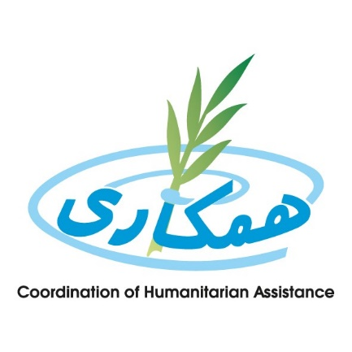

Project Title: PSEA Outreach Project
Type of training: Capacity building of student of PSEA volunteers in regards to PSEA and Covid-19
Organized by: CHA, Faryab
Reporting date: October 20, 2020

Section B:

- Rational and Background

Faryab is one of the thirty-four provinces of Afghanistan, which is located in the north of the country bordering neighboring Turkmenistan. It has a population of about 309422 which is multi-ethnic. The capital of Faryab province is Maimana. It also borders Jowzjan Province, Sar-e Pol Province, Ghor Province and Badghis Province.

- Training objectives
The training was conducted to build the capacity of PSEA volunteers in order to enable them to capacitate and provide awareness sessions for female and child headed households. At the end of the training the participants will be able to:
- General information about Covid-19 virus
- PSEA

- Overall process of Training
Before training get started the below steps are taken as preparation:
- Coordination with PPHD and DOWA
- Coordination with volunteers
- Reserve the venue
- Print out the documents including attendance sheet
- Preparing participants package.

Target groups and selection criteria

PSEA volunteers are considered as target group of the training.

Duration and timeline

The training was conducted for two days

Teaching methodology

Trainer used both visual and practical methodology. The trainer presented the lessons in PowerPoint presentation. During the presentation, the audiences were asked questions for brain storming.

Training facilitation

Handouts and training materials was shared with participants.

Section C:

Result and Conclusion

Overall, 20 Volunteers received the training for 2 days. They all were from different Villages of Faryab province.

Annex 2: Training agenda

Program Description | Presenter/Facilitator
Participants Registration | All
Welcoming and opening Remarks | Representative of DoWA
Participants Self-Introduction and workshop Introduction | All Participants
Information on ( P.S.E.A –COVID -19) | Focal Point(PSEA)

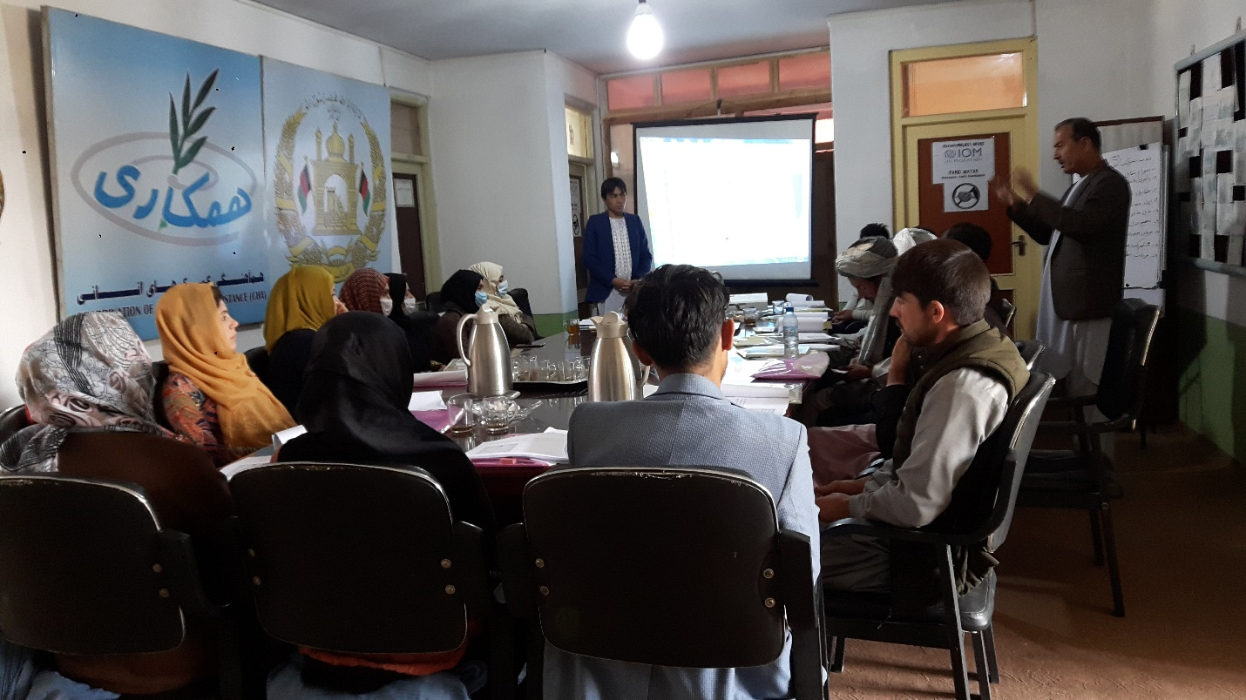

During training of PSEA volunteers

