toferf.rSwf;Mrf:Ogif sv; vgif;teftrfxkuf,tmyf;vgif;uK,r eef.yAefOif?
yAefyldifwgef;wK,sp.uif;zl;pAwf:umefqGh;xSrfwlif,olif:ulef:sv;tefuAof,cgif;qgrf:qldof:eef.eif,pkdofawtrf,vh;xkuf,cmrf,wAuf:wAifvgif;erf.rSwf;Mrf:Ogif(sex)sv;vgif;teftrf,xkuf,tmyfvgif;uK,reef.bof./
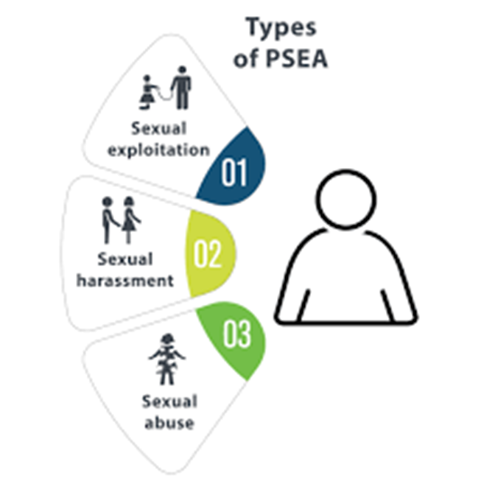
- Vguf,p[;pAwf:vgif;uK,r(trf,eef)xdkifeldof.xdkifwloffpAwf:zdwf:
ydlifvgif; (sex) yAefvgif;trfxkuf,rSef;/
- blMrf;qgrf:(Sex)zl;teftK,bl.rD:wGf;(18)eef.yAefvgif; trf,xkuf, rSef;/
- uAof,vlnf;vgif;(Sex)sv;pAwf:Omif;vgif;trf,vDxdkifeldof.xkdifwlofyAefvgif;trf,xkuf,rSef;/
- wgef;wK,vgif;Mrf:Ogif(Sex)uK,raOsv;tofulef:uK.chmulef:/
- wAuf:wAifvgif;uK,rpgrf;Ogif/
- yefvgif;Okuf.bkif;uK,raeaO sv; vguf,ildwf;vgif;uK,r/

wgef;wK,sp.uif;wAuff:wAifvgifuK,r sv; yefvgif;Okuf.bkif; uK,r aeeef.yAefOif
- wSyf:wwf:yuf:yldifoh. vgif;( Sex)aOqgrf:yuf:yldif/
- wSwf:wwf:oh.ykef;zgef:ul;zGfref:aOpAwf:zSefumef၊
- omif:zSefumefwgef;wK,ygif,cmof,aOwmif,vmwf;?
- wrf:omif:oh.acK;ref;yuf:yldif/

vgif;sp.uif;vlif;eK;
- ymifzkduf;zgef.yefyhm:pl.
- qSuf,ohydofyefwmif;pl.၊
- xhm,qldif:VideoaOyefwmif:pl.
- wdwf:Vinyl sv; pmif;(Poster)ydkefcmof,
- pAwf:ymifygh:yefyhm:pl. (Campaign)
vgif;urf.xSrfsv;vgifpAwf:Omif;vlif;vif
- vgif;pAwf:Omif;yefyhm:pl.rguf,umofwmifvmwf;ae
- vlofvh;pAwf:Omif;yefeK;umeftefvrf,vgif;
- vgif;qgh;xSrf zhm,eK;
- yefwmif:ch;q[

vgif;Olif,cmof,wmif,umefimef:
- urf.xSrfyefulef:vh;cmrf,wmif:yldef;sy.udefwAuf:wAif
- Okdyf,ydkefs'ymifZkduf:Zgef.yefyhm:pl.
- umefimef:vlifeK;

awpAwf:pkdofwmif,seyefpK
- wmrfwlofwmifvmwf;
- tD:ar:(Email)
- Olif,rK:yefwD;vkrf:plif:vduf;
- Olif,yefwif:wlduf;vduf;ch;q[
- uyf:Okdyf,wif:'lif:(trf,eef)Olif,vduf;ygwf: Massage yef
- Viber,Signal,Skype,Messenger
- uyf:Okdyf,rK:wif: Community feedback mechanism aOOkdyf,wmif,serK:vh;bl,

vgif;wmif,vmwf;xkuf,vDrD:Oif

- vlofyK:qkdof;?wD;bl,?ulef:cmrf,wAuf:wAif (trfeef) auK.tefxmif,oK;xkuf, wAuf:wAifeef.
- vlofyK:qkdof;? cmof:bmrf:?wD;bl,?oef:xd?sv; wD;bl,?ykef;zgef:?plif:umef?tgif;wD;? zl;zdwf:yuf:yldiftrf,eefzl;xkuf,umofpj/
- wmif:pefxkdifauK.teffOlifygif,acK;rkef:(awtrf,vh;yAefacK;xmif,xldrf)
- vlof,yK:vhm:rkdof: zl;ygif,cmofsv;oef:xd
- OifuAof,vlnf;vkuf,tgef,rK;eh.awvh;Okdyf,wmif,yefqgrf:yuf;yldifvgif;sp.uif;vkuf;tgef,

vgif;Oldif,Odrf:
- qgyf,cmofxmrfwlnf:vgif;qldof:yAefrK:
- zl;auK.wmif,ae
- zl;auK.tefxkuf,ydlef;tofwmif:zdwf:
- zl;tefuAof,cgif;qgrf:
- awtrfP;cmofygif,xdkifqldof:teftrfuAofcgif;qgrf:
vgif;eh.

wAuf:wAifvgif;uK,r (SE)
- yefikdef:crf:?yefcgif,zmuf,?yefeK;umefaOsv; vSuf;tofvgif;Mrf:Ogif (uK,r)
- qefcmof:bmrf:wgef;wK,Olef,vh;Olef,yAefulef:omef;aO (trf,eef) vguf,ildwf;aO vSuf;vgif;uK,r Mrf:Ogif/
- cmwf;emif:sr;rguf,bK;aObl,Mrf:qgrf:/
- vguf,ildwf;wgef;wK,wAuf:wAifvgif;uK,r/
ဒေါ် နှင်းသဇင်အောင်
၀၉၄၅၈၀၃၀၈၈၇
mawkkon16@gmail.com
olef.vgif;pAwf:wmif:trf,xkuf,rSef;vgif;uK,r (SA)
- wAuf:wAifaOelrf?Mrf?xdkifeldof. xkdifwlof wmof:bdyf: wDtef trf,xkuf,rSef; vgif;uK,r/
- pAwf:Omif;wAuf:wAifvgif;uK,raOpAwf:vgif;wmif:teftrfxkuf,rSef; /
- wAuf:uef.tofvgif;Mrf:Ogif (trf,eef) olef.cwf:qGfwgef;wK, uef.tofvgif; Mrf:OgifuK,r/
- pAwf:vgif;trf,xkuf,rSef;bl,Mrf:Ogifqgrf:vkuf;tgef,(vgif;Mrf:OgifuK,rrAof:vGftrf,oK;)/

olef.vguf,uof:vAef;vgif;uK,r (SH)
- vmwf;uGmrf: vgif;uK,r wkrf.wldof.ulef:wDeGf:Mgif;umef eif,uef (trf,eef) wldof.eldof.?wldof.wlof? qkyf,elrf/
- cwf:qGfolef.vgif; Mrf:Ogif (trf,eef) olef.cwf:qGf tmif;pAwf: vgif; wAuf:wAif uK,r/
- wAuf:uef.bl,Mrf:Ogif (trf,eef) olef.cwf:qGftmif;uef.Mrf:Ogif

Qkrf:rguf,ugefyhm:pkef;rkef:ckdef;bGf,rGf,Okif
OAef;wmif:cwf.wK,?cAwf,(3)
oAif:rGf,(3)
oAif:qAif:wkif
rhmzlef:- 095252486 / 09458030887
mawkkon16/@gmail.com

wlduf;O[vduf;wmif:pefxkdif
xxdk

acK;ruf;ref;yuf:yldif
- bK.vl.rhmrD;yuf:yldife[:tgif;umef?
- tofOmif;qef.umef? idkef:crf: ?clof;cgif aO vSuf;vgifuj,r?
Mrf:OgifuK;wD;Olef,vh;Olef,yAefulef:omef;eef.awpmrf;OD:?
- tofidkef:crf:aOsv;vSuf;Odkof.wdwf:awK,ulef:qldof:auK,Omif;vgif;Mrf:Ogifeef.awpmrf;OD:?
- vgif;vlvmhwD;eldofvkuf.tgef,qldof:eef.awpmrf;OD:?
- yAefulef:omef;e[:qkrf:vAofuefaOwK.ayK:trf,yK:umifq[sv;vgif;pAwf:Omif;trf,vDwK.auK;awpmrf;OD:?

yuf:yldifuAof,vlnf;vgif;uK,r
- awvh;bkrf,brfeyf.xkdofuef
- awtrf,rD;vgifqSwf,szauK.edkif,sv;auK.edkifP;rD:q[Odkof;blof;awK,uef
- acK;uGrf:tefuAofvlnfvgif;pgrf:Ogif uK,rqldof:eh.awtrf,vhvmwf;
- e[:ydkef.wD;teftrf,pyf.cmrf,vh;vgif;uK,rqldof:eh.awtrf,vh;pAwf:
- cSyf:pmif;iof:wlif.qldof:teftrf,Omif,xkuf,trf,vDwlnf:eef.awtrf,vh;Olif,yefawtrf,vh;Olif,yefawtrf,vh;wkuf.bgef:/
- wD;eldofvkuf;tgef,qldof:eef.auK;awtrf,vh;tofacK;uGrf:vgif;pgrf:Ogif(Sex)eef.
vmwf;vK:vK:/

cmofwD;wmif,rK:vgif;zdwf:yuf:yldif(PSEA)eh.yAefwD;teftrf,pyf.cmrf,vh;VK:VK:sv;?
ayK:yAefvgif;zdwf: yuf:yldifvgif;eh.qkdifP;wmif,vmwf;rK:zGf:zGf:wK./

(ZL;VGfauK;rD:Olef,ykef;zgef:ul;auK.?Olqof;auK;xkuf,vDvh;qgh;
xSrfbof.)

