Protection from Sexual Exploitation and Abuse
Training of Trainers (TOT)
December 2 & 3, 2021
Ambassador Inn Hotel, Islamabad – Pakistan

Table of Contents
1. Background 2
1.1. Purpose of the Assignment 3
1.2. Training Agenda 3
2. Proceedings of the TOT 5
2.1. Day One 5
2.1.1. Welcome and Introduction 5
2.1.2. Case Study Discussion and Group Work 5
2.1.3. Definitions of Basic Concept 6
2.1.4. Group Work - Preventing SEAH in our Context 8
2.1.5. Individual Actions to Respond to Incidents of Sexual Harassment, Exploitation and Abuse 9
2.1.6. Making a Complaint, Referral and Investigation 9
2.1.7. Individual Responsibility to Prevent Sexual Harassment, Exploitation and Abuse 10
2.1.8. PSEA Milestones 10
2.1.9. IASC’s Six Core Principles 11
2.2. Day Two 11
2.2.1. Group work 11
2.2.2. Minimum Benchmarking for PSEA Policies & Procedures for Organizations 14
2.2.3. Action Planning 14
3.0. Closing and Certificate Distribution 18

Background
Sexual exploitation and abuse (SEA) has been identified as a global concern in our working environment by the international humanitarian community. By creating norms of behavior for all humanitarian employees and partners, humanitarian actors have made critical steps toward protecting vulnerable groups from abuse and exploitation.
All emergencies, including conflicts, which typically results in relocation, and natural disasters, which often result in food insecurity, undermine and weaken social and political systems that are supposed to safeguard residents of the affected communities. Women and children have been proven to be the most vulnerable to various sorts of abuse in these settings.
It should be underlined that abusive behavior thrives in secret in such circumstances, and that no community or organization is immune to it. As a result, additional emphasis must be paid to developing a transparent and timely response to incidences of sexual abuse and exploitation in the workplace.
Pakistan has been affected by numerous catastrophic disaster including earthquakes, floods, droughts and conflicts. These disasters have created humanitarian crises where people have either been forced to live in camps or have faced challenges of food security. The national and international humanitarian community has always played a vital role in easing the sufferings of the affected communities. However, the humanitarian settings have never been immune to events of sexual exploitation and abuse. The international humanitarian organizations and the United Nations (UN) have established mechanism to prevent and report cases of SEA as per international guidelines and frameworks. These international frameworks require resources in terms of trained staff and finances to effectively implement these frameworks. The local humanitarian organizations such as local NGOs and CBOs lack the necessary awareness and resources to implement Protection of Sexual Exploitation and Abuse (PSEA) policies in their programs.
National Humanitarian Network Pakistan (NHN) is a membership based network of local, national humanitarian actors with a membership of 170 from across Pakistan. The network aims to work for the protection of rights of the vulnerable and affected communities by policy advocacy, capacity building, knowledge management and coordination. The network has played instrumental role in bridging the information and coordination gap between international actors, UN, government and the local humanitarian organizations. The network has been a permanent member of PSEA forum established by the UN at national level where NHN has always advocated that the international PSEA policies and guidelines are needed to be contextualized to the local norms. NHN has also raised concerns that the local humanitarian actors in the country do not have the capacity and resources to effectively implement PSEA policies in their organization.
To extend the outreach of PSEA polices and resources to the local level, NHN has been entrusted by Inter Agency Communication and Outreach Fund on Protection from Sexual Exploitation and Abuse. The primary objective of the fund was to spread awareness about PSEA at the ground level. One of the main instrument in extending the outreach of PSEA is through contextualized capacity building and awareness session at the local community levels. To obtain this objective NHN has planned to develop a pool of expert belonging to all provinces and regions of the country. To train the pool of experts on international policies and frameworks related to PSEA a Training of trainers (TOT) on PSEA was planned from 2 - 3 December 2021 at Islamabad.

Purpose of the Assignment
NHN required services of a team of professional to part a TOT on PSEA in order to develop a pool of experts on the subject. The team would also further assist and facilitate the trained individuals in extending these training, along with community awareness sessions and Focused Group Discussion (FGD) at the provincial levels. The overall objective is to mitigate the risks of SEA at the community level by capacitating organizations to implement PSEA policies including reporting and referral mechanisms, to sentience communities on the issues through awareness raising sessions and by providing safe space for dialogue on SEA through focused group discussions.

Training Agenda
The following agenda was developed to provide the training to the participants. However, the actual sessions and their duration was adjusted according to the participants needs that were highlighted during the training. None of the agenda items was discarded from the actual training but the timings were adjusted. Also some additional items were discussed that were not initially planned.
Day 01
Session | Time
Welcome, Registration and Introduction | 09:00 - 09:20
Opening remarks – NHN Chair | 09:20 - 09:50
Session 01  Introduction  - Expectations  - Review of Agenda  - Housekeeping | 09:50 - 10:50
Tea Break | 10:50 - 11:10
Session 02  Understanding the Basics: Gender, GBV, and SEA  This session aims to refresh participants’ knowledge on GBV basic concepts, SEA and SH  - Role play and games: Power walk  - PowerPoint Presentation  - Small Group Work: Causes, Contributing Factors and Consequences  - Q&A | 11:10-13:00
Lunch Break | 1300 -14:00
Session 03  Definitions and Standards of Conduct  - Plenary Game  - Updated Film: “To Serve with Pride”  - PowerPoint Presentation  - Case Scenarios | 14:00 - 15:00
Tea Break | 15:00 -15:15
Continued session 03  - PSEA Milestones  - Background to SEA incidents  - New development at Global and Country Level | 15:15 - 16:30
Parking Lot and Evaluation of the Day | 16:30 – 17:00
Day 02
Session 04  Framework for Taking Action Against SEA:  The Four Pillars of Community Engagement, Prevention, Response, and Management and Coordination  - PowerPoint Presentation  - Case Study  - Organizational Assessment  - Q&A | 09:00 -09:30
Session 05  Responsibilities of the Focal Point and the Network within the Four Pillars  - PowerPoint Presentation  - Role Plays  - Q&A | 09:30 – 10:30
Tea Break | 10:30 -10:45
Session 06  Focus on Response: Overview of Reporting Systems, Investigations, and Disciplinary Procedures  - PowerPoint Presentation: Standard Operating Procedures for UN Agencies, INGOs, NNGOs | 10:45 – 12:00
Session 07  Focus on Prevention:  - Development of Capacity Building Action Plan: Objectives, Activities, Actors and required resources | 12:00 – 13:00
Lunch Break | 13:00 -13:45
Action Planning in Groups & Individual with Master Trainers | 1345 – 1445
Closing: Assessment and Evaluation - Award of Certificate of Attendance and Closing Remarks | 14:45 – 15:15
Hi-Tea | 15:15

Proceedings of the TOT

Day One

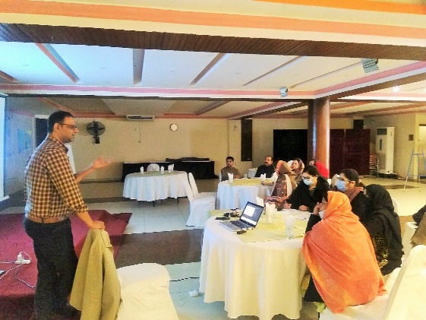
Welcome and Introduction
The participants were greeted by the lead trainer, Mr. Wajahat Ali for taking their time out and attending the training on the subject. A brief introduction of the trainer and NHN team was also provided by the trainer along with the overview and objectives of the training. In order to familiarize the participants with each other the participants were requested to introduce themselves along with providing a fun fact about themselves which acted as an icebreaker. The participants were also requested to fill out a pre training assessment during the session.

Case Study Discussion and Group Work
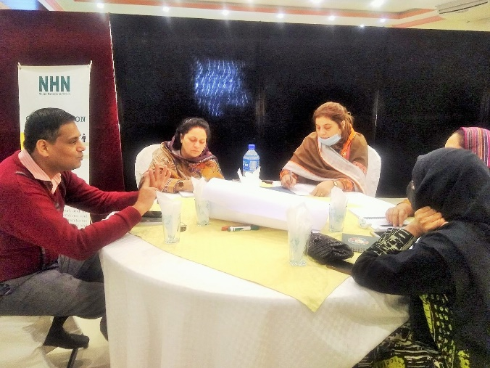
Before providing formal definitions of some of the key terms related to PSEA, a case study was presented to the participants. The case study presented a scenario where a male supervisor Ahmad, was extending sexual advances to his female subordinates. A particular case of a vulnerable subordinate Haleema was discussed in detail. The supervisor was providing undue favors to Halemma in order to get close to her. She being shy and vulnerable did not report or even objected to his behavior.
The participants were divided into three groups and were requested to discuss the following points among themselves and then present them to all the groups.
- Do you think Ahmad’s behavior can be termed as sexual harassment or exploitation? Why?
- Would it be termed sexual exploitation if Haleema submits to Ahmad’s advances?
- Why doesn’t Haleema complain? Should Haleema be blamed for keeping quiet?
- Are Haleema and Ahmad at par with each other/equally powerful in the given situation?
- Who can she complain to?
- What is the likely impact of Ahmad’s behavior on Haleema?
- How did you feel enacting your respective characters?

Group work Presentations
Each group presented their discussions to the participants. All the groups were clear that Ahmad’s behavior is not appropriate and it does fall under some form of harassment or abuse. The groups were however not clear on what constitutes as sexual harassment and what action fall under exploitation. The groups were also divided on the blaming Haleema for being quite on the matter. The groups were united on the possible impact of Ahmad’s behavior on Haleema as negative. Although most of the participants were not clear on the subject terminologies however, the discussions on the case study provided a ground setting where the participants were forced to recall their concept on the subject and relate them to a real life example.
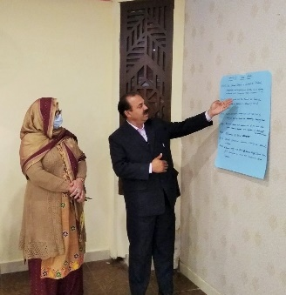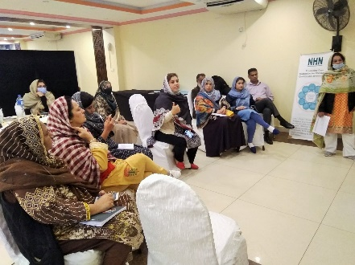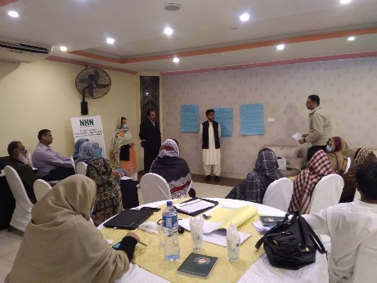

Definitions of Basic Concept
As the participants recalled their own understandings on the technical terminologies associated with PSEA in the previous case study. Theoretical definitions and their real life examples were presented in this section.
- Sexual harassment: Any unwelcome sexual advance, comment, expressed or implied sexual demand, touch, joke, gesture, or any other communication or conduct of a sexual nature, whether verbal, written or visual, by any person to another individual within the scope of organization work.
- Sexual exploitation: Pressuring or demanding individuals to provide sexual favors against their will, with the threat of denying project assistance, withholding work support, or any other negative repercussions in the work place or community.
- Sexual abuse: Any actual or threatened physical intrusion of a sexual nature, by force or under unequal or coercive conditions.
Gender-Based violence: Gender-Based violence refers to harmful acts directed at an individual based on their gender. It is rooted in gender inequality, the abuse of power and harmful norms.
Examples of Sexual Harassment, Sexual Exploitation and Sexual Abuse:
  - Offering special benefits in exchange for expressed, implied or demanded sexual favors.
  - Threats or insinuations that an individual’s refusal or unwillingness to submit to sexual advances
  - Verbal conduct such as sexually derogatory remarks, graphic verbal commentaries about an individual’s body or dress, sexually degrading words used to describe an individual, sexually suggestive or obscene letters, notes, emails or invitations, demeaning or inappropriate comments, name-calling, jokes, or sexual advances
  - Visual conduct such as staring, sexual gestures, displaying or distributing sexually suggestive objects or pictures, cartoons or magazines;
  - Actual or threatened physical contact or conduct, such as patting, pinching, blocking movements, or any other offensive touching.
Impact of sexual harassment, sexual exploitation and sexual abuse:
- Psychological - Guilt, stress, Anger, Shame, Anxiety, powerlessness, low self-image
- Physical - Headache, Nausea, insomnia, high BP, STDs/ STIs, HIV/AIDs
- Social - Social alienation due to loss of reputation, increased vulnerability
Obstacles Faced in reporting:
  - Fear of losing assistance
  - Fear of being disbelieved/blamed
  - Loss of reputation of self and/or family
  - Mistrust /lack of confidence in the system
  - Lack of information about the complaints mechanisms
  - Cultural norms and practices
  - Acceptance of behavior by minimizing or denying its impact
  - Fear of backlash on their family members.
  - Lack of information about the existing mechanisms to respond to such complaints.
  - Absence of family/ lack of support from family.
  - Limited or no economic opportunities
  - Inherent hierarchy between staff and clients
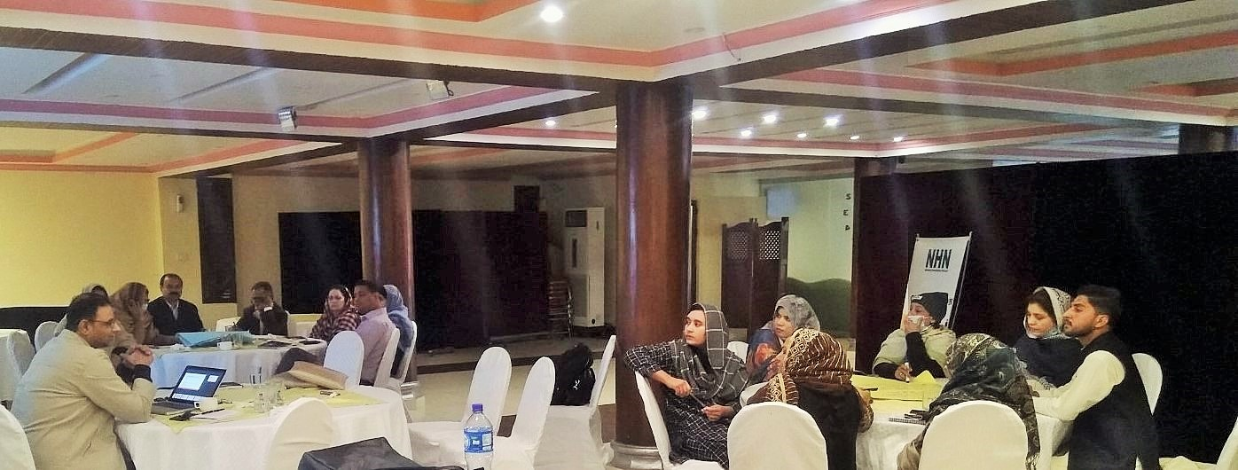

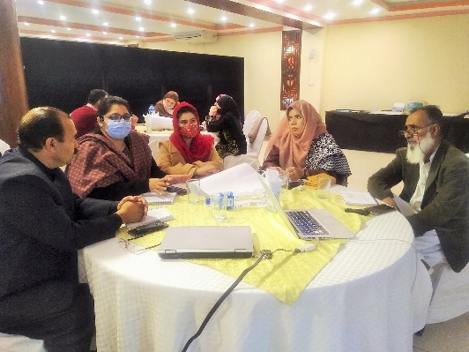
Group Work - Preventing SEAH in our Context
In order to enhance participant’s understanding on preventive measure that should be undertaken in three different settings, namely Office, Community and Community Centers; the participants were divided into three groups and were asked to discuss and present the preventive measures according to the following questions keeping in mind the organizational policies, country laws, code of conduct, Do’s and Don’ts and reporting channels.
  - What makes children / women and other vulnerable groups, vulnerable to sexual exploitation and abuse?
  - Who will prevent it?
  - How do we monitor?
  - What actions we may need to take, when and by whom?

Group Presentations:
Group 1 – Office
The group presented that their discussions through flipcharts. The group shared that the women and other vulnerable groups in an office setting feel more vulnerable to sexual exploitation and abuse if they are not accounted for in the organization’s policies and procedures. They also feel vulnerable if their complaints of misconduct are not taken seriously by the management.
All line managers are responsible to prevent any sexual abuse or exploitation within its team. If he/she suspects any such activity, he should speak to the victim and after his/her consent launch a formal complaint with the respective human resource department.
The human resource departments in an organization is responsible to monitor any cases of misconduct by the organization’s employees. This is done through encouraging staff to speak up and report about any incidents of exploitation and abuse.
The human resource department should orient all staff on PSEA policies in the organization at the time of their joining and on regular basis with the current staff in order to refresh the employee understanding and to remind them of possible repercussion of any misconduct related to SEA.
Group 2 - Community
The group presented their discussion answers through flipcharts. It was shared that the children, women and other vulnerable groups such as transgender and people with disabilities are normally excluded from any community decision making bodies. These individuals do not have access to the reporting channels or authorities where they can report with confidence and peace of mind. They also have less access to resources which compounds their vulnerability.
The field staff of the organization should keep an eye on any incidences of sexual exploitation and abuse by any of the organization staff. Any suspected incidents should be reported to the line manager or human resource department.
The monitoring and evaluation team of the organization should also monitor its field team for any suspected incidents of sexual exploitation and abuse through its monitoring mechanism.
The field staff shall orient community on the organizations PSEA policies and reporting channels. The community should be encouraged to report any suspected incidents to the organization through these channels.
Group – 3 Community Centers
The third group presented their findings about the Community centers. They explained that individuals belonging to vulnerable groups, children and women feel vulnerable if the environment provided in the community center is not comfortable and if the behavior of the staff members is not welcoming.
The community center staff is responsible to look after all community members coming to the center therefore they should be preventing such incidents in the community centers.
The community forum/committee overseeing the community center monitors all the activities of the center therefore they are also acting as monitors on any SEAH related incidents.
The staff members are oriented about the PSEA policy when they join the center. The reporting numbers and mechanism are well defined and displayed in the center including a suggestion / complain box.

Individual Actions to Respond to Incidents of Sexual Harassment, Exploitation and Abuse
The participants were briefed on the necessary action that the individuals must take in case a SEAH incident is reported. The person reporting should be taken into confidence by patiently listening to his/her complain without judging the complainant. The reporting channel should be explained to the complainant and the complaint should be launched immediately using those channels. The individual should be assisted in the best possible way to receive referral services that are required by him/her including psychological, legal and medical support whichever is appropriate in the situation. The incident and the report should be kept confidential and no loose talk or rumors should be spread about it.

Making a Complaint, Referral and Investigation
The participants were oriented on the steps that are to be taken if an incident of SEAH occurs. The first step is to launch a formal complaint by the victim or by any other individual on behalf of him/her by filling out the complaint form and submitting it to the reporting channel. It must be noted that if the complaint is launched on behalf of the victim then his/her consent is mandatory for the launch of such complaint.
The case is referred to the case management service providers for follow ups who refer the case to the investigating unit with-in 24 -36 hours. The investigation is conducted as per the internal procedures of the organizations. This normally contains interviews with the survivor, the harasser and witnesses if any. If there are not sufficient evidences in the case, then PSEA committee is convened to discuss and take the matter further.

Individual Responsibility to Prevent Sexual Harassment, Exploitation and Abuse
The participants were briefed on the responsibilities of an individual in prevention of SEAH. It was communicated that the an individual must build its own awareness on the subject in-order to develop an understanding on the main aspects of sexual harassment, exploitation and abuse. The individuals must also educate themselves on the appropriate manners to deal with such issues. The individuals must also familiarize themselves with the organization policies, law of the land and code of conduct of PSEA. Where ever possible informal discussion opportunities must be created with coworkers to dispel myths and misconceptions associated with issues related to SEAH. Most importantly an individual must act in a professional manner in compliance with the code of conduct of PSEA.

PSEA Milestones
The participants were given a detail background on the key incidents and corresponding steps/ milestones achieved relating to SEAH. It was informed that in 2002 an investigation by UNHCR and Save the Children into the child refugee sex scandal in West Africa surprised all humanitarian and relief personnel due to its scale and frequency. As a result, an IASC task force on PSEA in humanitarian crises was established in 2002. The Task Force was mandated to make recommendations aiming to eliminate sexual abuse and exploitation by UN and affiliated personnel and the misuse of humanitarian assistance, within the overall objective of strengthening and enhancing the protection and care of children and women in situations of humanitarian crisis and conflict. The Task Force identified three areas for action: common elements of a code of conduct and standards of behavior for field staff; mechanisms and capacity for protection against sexual exploitation and abuse; and improved mechanisms for delivering assistance.
In 2003 the UN Secretary General’s bulletin (SGB) listed down special measures for protection from sexual exploitation and sexual abuse by the humanitarian and relief workers. This special bulletin provided concrete steps for the UN agencies that should be taken to prevent SEA incidents including reporting and referral mechanisms.
The training participants were also briefed on the IASC complain and investigation model developed in March 2004 and the subsequent declaration of zero-tolerance policy by the UN. In 2008 IASC meeting developed a four pillar framework. In 2010 a global PSEA review was conducted where co-chair of IASC PSEA taskforce was provided to NGO. At this review a new dedicate website for the taskforce was also launched as www.pseataskforce.org.
It was informed that to this date the Inter-Agency Standing Committee (IASC) has established coordination and support functions for PSEA and sexual harassment, and hosts the IASC Championship on Protection from SEA and SH. In the reformed IASC architecture (2019), five time-bound Results Groups have been instructed to provide normative guidance on each IASC strategic priority. Results Group 2 (RG2), on ‘Accountability and Inclusion', is working to strengthen accountability to affected people (AAP), improve protection from and responses to SEA and SH, and apply accountability and inclusion standards, taking into account gender, persons with disabilities, and mental health and psychosocial support. It is co-chaired by UNICEF and UNHCR and involves all IASC members (UN entities, IFRC, and NGOs and NGO consortiums). In relation to PSEA and SH, RG2 (among other matters) seeks to harmonize related policy and guidance; build capacity and develop learning materials on protection from SEA and SH; promote initiatives that encourage a speak-up culture; and support country-level implementation of PSEA.

IASC’s Six Core Principles
The participants were briefed in detail on the six IASC principals related to SEA. These principals are as follows
- Sexual exploitation and sexual abuse constitute acts of serious misconduct and are therefore grounds for disciplinary measures, including summary dismissal.
- Sexual activity with children (persons under the age of 18) is prohibited regardless of the age of majority or age of consent locally. Mistaken belief in the age of a child is not a defense.
- Exchange of money, employment, goods or services for sex, including sexual favors or other forms of humiliating, degrading or exploitative behavior, is prohibited. This includes any exchange of assistance that is due to beneficiaries of assistance.
- Sexual relationships between United Nations staff and beneficiaries of assistance, since they are based on inherently unequal power dynamics are strongly discouraged.
- Where a [United Nations] staff member develops concerns or suspicions regarding sexual exploitation or sexual abuse by a fellow worker, whether in the same agency or not and whether or not within the United Nations system, he or she must report such concerns via established reporting mechanisms.
- [United Nations] staff are obliged to create and maintain an environment that prevents sexual exploitation and sexual abuse. Managers at all levels have a particular responsibility to support and develop systems that maintain this environment
The participants were informed that although these principals have been designed for UN personnel but they are also equally applicable to all humanitarian and aid workers. At the end of the session the participants were requested to review the code of conduct, policies and procedures of their respective organizations with the lens of these six principals and the SGB of 2002 and 2003 in order to assess that their organization’s policies are stronger or weaker than the international standards.

Day Two
The second day started with the recap of the previous day where participants shared their learnings of the previous day.

Group work
The participants were reshuffled into three groups and were given three different tasks for deliberation and presentation.
Group 1: Frameworks for Community Engagement, Prevention, Response, Management & Coordination with respect to PSEA.
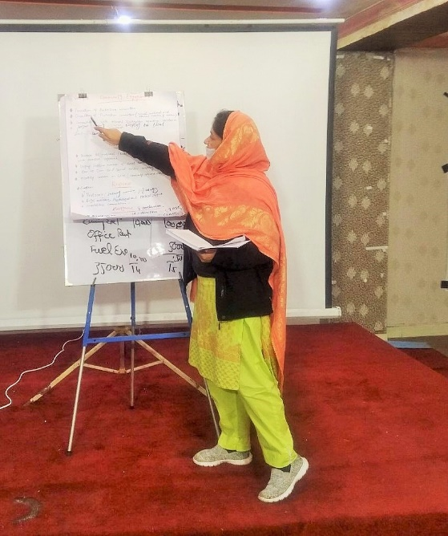
The group presented its working on the framework through flip charts by listing down the key measure for each of the above mentioned sections.
Community Engagement
The community engagement should consist of the following aspects.
- Formation of the protection committee
- Orientation of the committee on social, cultural, ethical norms and values of the local community.
- Consultations with relevant stakeholders regarding assistance
- Display of project documents in local language.
Prevention
- Develop IEC material in local language with simple pictorial representation.
- Display of hotline number on prominent places.
- Door to door and social media campaign.
- Monthly sessions of the community staff on community response mechanism with orientation on PSEA.
Response
- Establishment of complaint and response protocols including establishment of inquiry committee
- Provision of legal, psychological and medical support to the victim.
- Communication with stakeholders.

Management and coordination
- The management and coordination of PSEA incidents should be dealt with using the six IASC principals.
Group 2: Role of National Humanitarian Network (NHN) and its members in PSEA
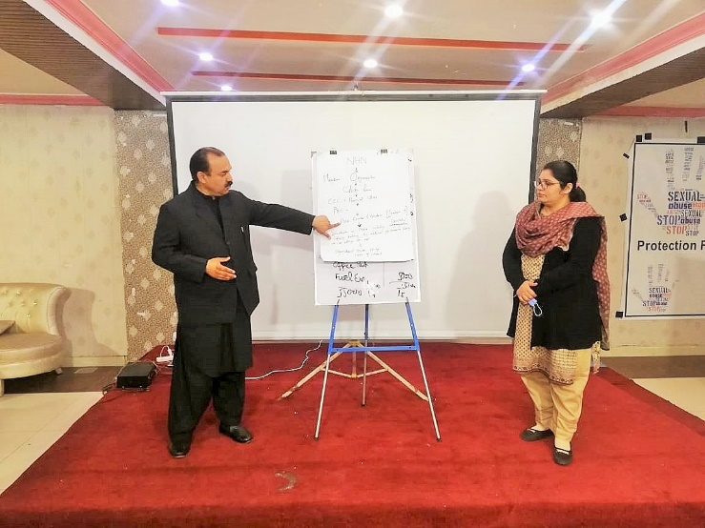
Group two presented the governance structure of NHN with roles and responsibilities at each level of governance. It was shared that NHN is membership based decentralized network with a democratic governance structure. NHN has a governance committee each at district (District Executive Committee (DEC)), provincial (Provincial Executive Committee (PEC)) and then at national level (Central Executive Committee (CEC)). Each of this committee elect a chairperson at the relevant level who is overall responsible for implementation of NHN policies and procedure at its respective administrative level.
At national level a PSEA committee can be established with volunteer members. This committee should be responsible for sensitization of members on PSEA including orientation, capacity building and development of IEC material for awareness raising. The NHN digital resource center could be utilized for the mass communication of these awareness materials.
Group 3: Systems of reporting, investigation and disciplinary actions.
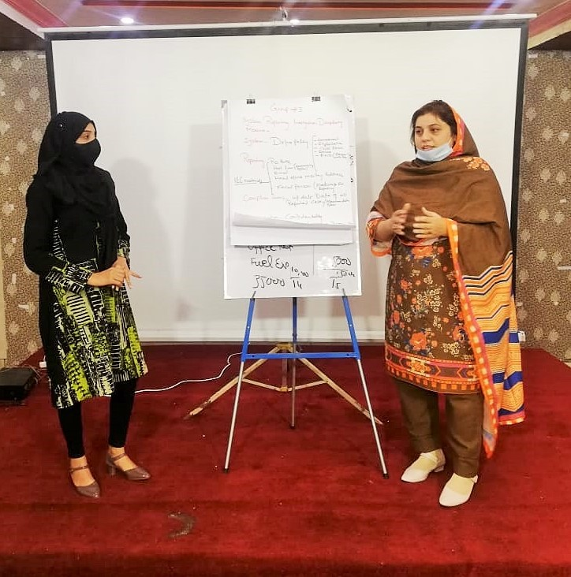
The third group presented its discussions and finding on the given topic through a systematic diagram of each of the steps.
System: Define a policy of harassment, exploitation, child abuse and people with disabilities.
Reporting: Display of Post box number, hotline numbers, email and postal addresses of head office, contact details of PSEA focal person. This information should also be circulated through IEC material. In addition, a complain register or database should also be maintained where record of all previous cases is saved.
Investigation: The investigations of each reported case should be done by a designated committee which should contain at least one female member. The TORs and JDs for the committee should be finalized along with notification of the committee members. All the proceedings of the case should be kept in confidence and only the concerned individuals should have access to the case. Any investigation must contain an undertaking from the victim and the accused to keep the proceedings confidential.
Disciplinary Actions and Measure: The findings of the investigation should be shared with the head of the organization who will be responsible to take the necessary action required as per the recommendation of the committee.

Minimum Benchmarking for PSEA Policies & Procedures for Organizations
The participants had deliberated on various roles and responsibilities of organizations in implementing the PSEA principals through group activities. The international minimum benchmarks for PSEA policies and procedures were shared with then so that they can compare their organization’s system against those standards. The benchmarks have been divided into the following eight sections.
- 1. Organizational Policy: An organization must have a signed document which states the PSEA policy and code of conduct for its employees. Each new staff should be provided a copy of this policy at their joining.
- 2. Organizational Management: The organization’s contracts and partnership agreements must include a standard clause requiring sub-contractors, to adopt policies that prohibit SEA and to take measures to prevent and respond to SEA.
- 3. Human Resources Systems: The vetting of each individual should be done against sexual misconduct through references. A declaration by each employee that they have never been subject to sanctions (disciplinary, administrative or criminal) arising from an investigation in relation to SEA, or left employment pending investigation and refused to cooperate in such an investigation.
- 4. Mandatory Training: The organization holds mandatory trainings (online or in- person) for all personnel on PSEA and relevant procedures.
- 5. Reporting: The organization has mechanisms and procedures for personnel, beneficiaries and communities, including children, to report SEA allegations that comply with core standards for reporting
- 6. Assistance and Referrals: The organization has a system to refer SEA victims to available support services available locally, based on their needs and consent.
- 7. Investigations: The organization has a process for investigation of allegations of SEA and can provide evidence.
- 8. Corrective Action: The organisation has taken appropriate corrective action in response to SEA allegations, if any.

Action Planning
One of the main objective of the TOT was to develop action plans for each individual for trickle down training in their respective areas. This would result in an exponential outreach of the learnings to communities and staff members of local NGOs. The participants were divided into six groups corresponding to their province/region. They were requested to plan out the following activities in their respective areas.
Province / Region | Targets
 | Staff Sessions | FGD | Community Sessions
Sindh | 6 | 1 | 10
Balochistan | 4 | 1 | 10
Khyber Pakhtunkhwa | 5 | 1 | 10
Punjab | 3 | 1 | 10
Azad Jammu and Kashmir | 1 | 1 | 10
Islamabad | 1
The distribution of the targets was based on the percentage of NHN members in the respective areas. The participants finalized among themselves a draft action plan by dividing the targets among themselves. Since there was only one participant from Balochistan therefore it was decided that the participant will first conduct a follow up training in its respective province to develop a pool of trainers who will then carryout the provincial targets. The action plan for Balochistan will be shared by the participants once the follow up training has been conducted.
Action Plan
Activity | Responsible Person | Time line | Province / Region | Location
Community Staff Training (CST) | Raja Iftikhar | 11/12/2021 | AJK | Muzaffarabad
Focused Group Discussion (FGD) | Raja Iftikhar | 14-12-21 | AJK | Jehlum
Community sessions | Bushra Tabassum | 16-12-21 | AJK | Village Satar karrian
Community sessions | Raja Iftikhar | 17-12-21 | AJK | Dupata
Community sessions | Raja Iftikhar | 17-12-21 | AJK | Khatpura
Community sessions | Ayesha | 18-12-21 | AJK | Nowshera
Community sessions | Ayesha | 18-12-21 | AJK | Charoot Ban
Community sessions | Bushra Tabassum | 22-12-21 | AJK | Batyara
Community sessions | Bushra Tabassum | 23-12-21 | AJK | Garhi Dupata
Community sessions | Raja Iftikhar | 24-12-21 | AJK | Awan Patti
Community sessions | Ayesha | 25-12-21 | AJK | Bandi Kokyal
Community sessions | Raja Iftikhar | 25-12-21 | AJK | Muzaffarbad City
CST | Khursheed Ahmed | 8/12/2021 | Balochistan | Quetta
CST | Rida -e- Zainab | 10/12/2021 | Punjab | Pattan Office Multan
CST | Rida -e- Zainab | 14-12-21 | Punjab | Pattan office Muzaffargarh
CST | Saira Shoukat | 10/12/2021 | Punjab | Lahore - RCDS Office
FGD | Saira Shoukat | 17-12-21 | Punjab | Lahore - RCDS Office
Community sessions | Rida -e- Zainab | 16-12-21 | Punjab | Multan
Community sessions | Rida -e- Zainab | 17-12-21 | Punjab | Multan
Community sessions | Rida -e- Zainab | 21-12-21 | Punjab | Multan
Community sessions | Rida -e- Zainab | 22-12-21 | Punjab | Muzaffragarh
Community sessions | Rida -e- Zainab | 23-12-21 | Punjab | Muzaffragarh
Community sessions | Saira Shoukat | 16-12-21 | Punjab | Lahore
Community sessions | Saira Shoukat | 17-12-21 | Punjab | Lahore
Community sessions | Saira Shoukat | 21-12-21 | Punjab | Lahore
Community sessions | Saira Shoukat | 22-12-21 | Punjab | Lahore
Community sessions | Saira Shoukat | 23-12-21 | Punjab | Lahore
CST | Sumera Javed | 24-12-21 | Islamabad | Islamabad - NHN Office
CST | Zaib -un-Nisa | 8/12/2021 | KP | Mardan
CST | Zaib -un-Nisa | 15-12-21 | KP | Nowshera
CST | Nazia Khan | 12/19/2021 | KP | Haripur
CST | Nazia Khan | 12/21/2021 | kp | Gandhool
CST | Naheed | 15-12-21 | KP | Bisham
FGD | Naheed | 18-12-21 | KP | Mansehra
Community sessions | Zaib -un-Nisa | 14-12-21 | KP | Peshawar
Community sessions | Zaib -un-Nisa | 14-12-21 | KP | Peshawar
Community sessions | Zaib -un-Nisa | 17-12-21 | KP | Peshawar
Community sessions | Zaib -un-Nisa | 17-12-21 | KP | Peshawar
Community sessions | Nazia Khan | 22-12-21 | KP | Mohandri
Community sessions | Nazia Khan | 23-12-21 | KP | Kawi
Community sessions | Nazia Khan | 12/24/2021 | KP | Kaghan
Community sessions | Naheed | 18-12-21 | KP | Mansehra
Community sessions | Naheed | 18-12-21 | KP | Mansehra
Community sessions | Naheed | 19-12-21 | KP | Mansehra
CST | Samina Riaz | 16-12-21 | Sindh | HWA Office- Saheed Benazirabad
CST | Mahkum Din Shah | 11/12/2021 | Sindh | AFBT- Nowsheroferoz
CST | Shabana Ansari | 14-12-21 | Sindh | GSF _ Sukkur
CST | Wali Muhammad | 19-12-21 | Sindh | GSF - Khairpur
CST | Wali Muhammad | 17-12-21 | Sindh | IDSO- Khairpur Mirus
CST | Wali Muhammad | 22-12-21 | Sindh | VDO - Sanghar- Shadadpur
FGD | Shabana Ansari | 15-12-21 | Sindh | Khajoor Mandi - Sukkur
Community sessions | Samina Riaz | 18-12-21 | Sindh | HWA Office- Saheed Benazirabad
Community sessions | Samina Riaz | 17-12-21 | Sindh | CDF - Shaheed Benazirabad
Community sessions | Samina Riaz | 21-12-21 | Sindh | NDF Office - Benazirabad
Community sessions | Mahkum Din Shah | 12/12/2021 | Sindh | Nosheroferoz
Community sessions | Mahkum Din Shah | 14-12-21 | Sindh | AFBT Office Nosheroferoz
Community sessions | Mahkum Din Shah | 16-12-21 | Sindh | Dharti Development Foundation - Nosheroferoz
Community sessions | Shabana Ansari | 24-12-21 | Sindh | GSF _Sukkur
Community sessions | Shabana Ansari | 23-12-21 | Sindh | Sukkur - District education office
Community sessions | Wali Muhammad | 15-12-21 | Sindh | GSF - Khairpur
Community sessions | Wali Muhammad | 15-12-21 | Sindh | Khairpur Mirus

Closing and Certificate Distribution
The TOT ended with a vote of thanks by the National Humanitarian Coordinator of NHN Mr. Muhammad Kamran. He thanked the lead trainer Mr. Wajahat Ali for parting the training to the participants. He also appreciated the efforts and dedication of the participants for attentively attending the training and for actively participating in the group activities. He wished them good luck in extending these trainings and awareness sessions in their local community. He ensured full support of NHN to the participants throughout the trainings. At the end, certificates were distributed to the participants.
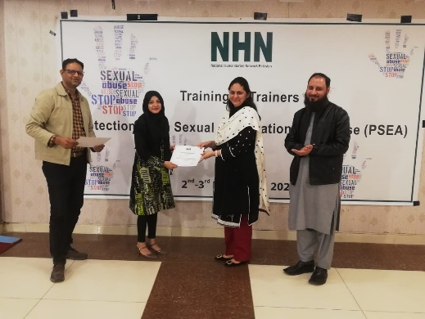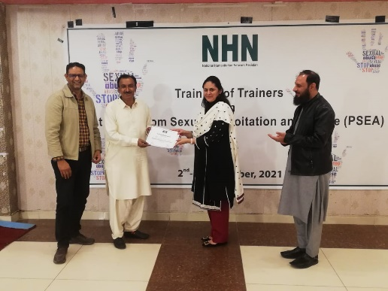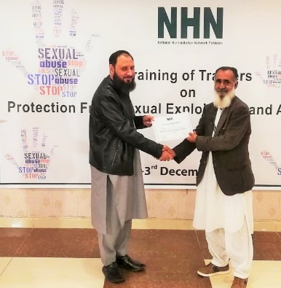

Participants list
PSEA TOT 2-3 Dec 2021
S. No. | Name | Gender | Organization | Designation | Province | Phone number | Email
1 | Ayesha | Female | Area Development Organization | Member of ADO Board | AJK | 0349-5463136 | az807173@gmail.com
2 | Bushra Tabassum | Female | SEEP | Social Mobilizer | AJK | 0342-9537550 | bushra.seep@gmail.com
3 | Raja Iftikhar | Male | Area Development Organization | Senior Programm Manager | AJK | 0345-6900712 | raja.mzd@gmail.com
4 | Kashif Sheikh | Male | Strengthening Participatory Organization | HR specialist | Islamabad | 0333-3332468 | kashif.sheikh@spopk.org
5 | Sumera Javed | Female | Hands Pakistan | Executive Manager | Islamabad | 0336-2427170 | sumera.javeed@hands.org.pk
6 | Naheed | Female | NIDA Pakistan | Gender Coordinator | KP | 0344-5242105 | needocbr@gmail.com
7 | Nazia Khan | Female | Welfare Association Jared | Program Coordinator | KP | 0336-9030734 | naziaanwarkhan79@gmail.com
8 | Zaib -un-Nisa | Female | IDEA | Gender Expert | KP | 0333-9851418 | zaib@idea.org.pk
9 | Rida -e- Zainab | Female | Pattan | Project Coordinator | Punjab | 0308-8593110 | rida@pattan.org
10 | Saira Shoukat | Female | RCDS | HR Officer | Punjab | 0333-8880474 | sairashoukat248@gmail.com
11 | Mahkum Din Shah | Male | AFBT | President | Sindh | 0302-3215527 | mahkumshah2011@yahoo.com
12 | Samina Riaz | Female | Hari welfare Association | Program Coordinator | Sindh | 0300-3229739 | saminagill76@gmail.com
13 | Shabana Ansari | Female | GSF | District Coordinator | Sindh | 0317-7118434 | shabana.ansri786@gamil.com
14 | Wali Muhammad | Male | Goth Seengar Foundation | Chairman | Sindh | 0300-8314374 | waligsf@yahoo.com
15 | Sofia Rehman | Female | Society of Collective Interests Orientation | Manager Gender | Balochistan | 0346-9101537 | r.sofia67@gmail.com
16 | Safaraz Yaqoob | Male | Society for Community Action Process | HR Manager | Balochistan | 0333-9516573 | sarfarz.yaqoob9@gmail.com
17 | Benish Sikandar | Female | Youth Organization | Capacity Development specialist | Balochistan | 0346-7179566 | beenish. sikandar@youth.org.pk
18 | Nasreen Abid | Female | Azat Foundation | Program Coordinator | Balochistan | 0321-9523762 | abidnas@gmail.com
19 | Sabir Yaqoob | Male | Society for Mobilization Advocacy And Justice | Project manager | Balochistan | 0334-5638233 | sabirkk77@yahoo.com
20 | Khursheed Ahmed | Male | Socio Pakistan | Board Member | Balochistan | 0318-8002329 | khursheedahmed837@gmail.com

