

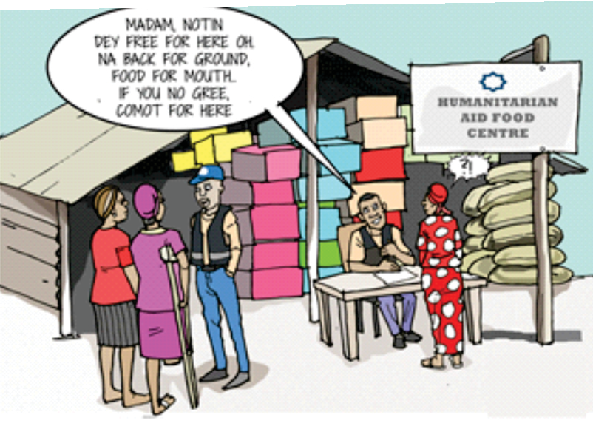


A SIMPLIFIED INCLUSIVE PIDGIN VERSION OF THE VIOLENCE AGAINST PERSONS (PROHIBITION)

(VAPP) ACT, 2015

Grassroots Initiative for Gender and Development

VIOLENCE AGAINST PERSONS (PROHIBITION) ACT, 2015
THE VAPP ACT, 2015

Di VAPP ACT na to comot violence for pesin private and public life, to stop all di type of violence wey dem dey do to pesin and e go give tight protection and solution for pipo wey don suffer violence and punish di pipo wey don commit violence; dem fit still use am for oda matters too wey concern violence.

Di National Assembly of the Federal Republic of Nigeria na dem do di VAPP ACT to be law.
Dis VAPP Act so, anybody, weda na woman, man, small pikin and pipo wey get disabilities fit use am take pursue and get justice for violence wey pesin don do dem.

1










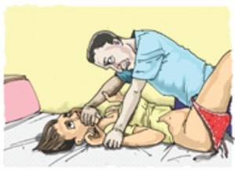
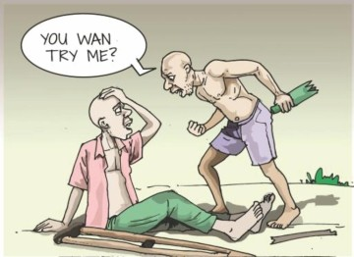


PART I - OFFENCES
Rape
Wen pesin use bad mind take enter di vagina, anus or even mouth of anoda pesin wit any part of im own body or any oda object and di oda pesin no gree or im use force, threat, or wuruwuru take sleep wit anoda pesin, dat pesin don commit offence
wey dem dey call RAPE. Di pesin dey go prison for di rest ofim life and im go pay di pesin wey dem rape (victim) moni for di rape dem don suffer for dier hand. Di pesin wey commit dis offence inn name go enter register wey people wey don commit dat offence dey enter and everybody go see wetin im do.

Physical Injury
- Any pesin wey use inn bad mind take injure anoda pesin wit weapon (like knife, gun, stick, razor blade, substance or anything wey fit cause wound) don commit offence. Di pesin dey go prison reach 5 years or im go pay fine wey reachN100,000 or e fit be both di moni and prison sef.
- Any pesin wey try wound anoda pesin wit weapon (like knife, gun, stick, razor blade, or substance) don commit offence. Di pesin dey go prison reach 3 years or im go pay fine wey reach N200,000 ore fitbe both di moni and prison sef.
- Any pesin wey dey help, support or ginga anoda pesin to injure pesin wit weapon (like knife, gun, stick, razor blade, or substance) don commit offence. Di pesin dey go prison reach 3 years or im go pay fine wey reach N200,000 or e fit be both di moni and prison sef.
- Any pesin wey cover, protect, or hide anoda pesin wey im know sey don injure pesin wit weapon
(like knife, gun, stick, razor blade, or substance) don commit offence Di pesin dey go prison reach 3 years or im go pay fine wey reach N200,000 or e fit be both di moni and prison sef.
2








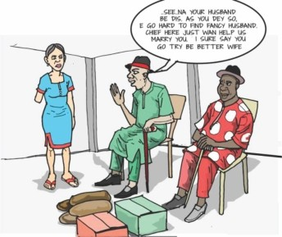
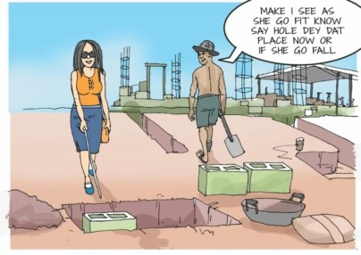


- Court sef fit make sure say dat pesin pay di pesin wey injure moni for wetin im don do am.

Coercion
Pesin wey tell anoda pesin make dem do sometin by force and im know sey dat tin go injure di person for body or for im mind, na offence be that. Di pesin dey go prison reach 3 years straight.

Willfully Placing a Person in Fear of physical Injury
- Any pesin wey make anoda pesin fear say im go injure, dat pesin don commit offence. Di pesin dey go prison reach 2 years or im go pay fine wey reach N200,000 or e fit be both di moni and prison sef.
- Any pesin wey try make anoda person fear say im go injure,
dat pesin don commit offence. Di pesin dey go prison reach 1 year or im go pay fine wey reach B200,000 or e fit be both di moni and prison sef.
- Any pesin wey help, support or ginga anoda pesin to make anoda pesin fear say inn go injure, dat pesin don commit offence. Di pesin dey go prison reach 1 year or dem go pay fine wey reach N200,000 or e fit be both di money and prison sef.
- Any pesin wey cover, protect, or hide anoda pesin wey im know wey don make anoda pesin fear say im go injure, dat pesin don commit offence. Di pesin dey go prison reach 1 year or dem go pay fine wey reach N200,000 or e fit be both moni and prison sef.

3



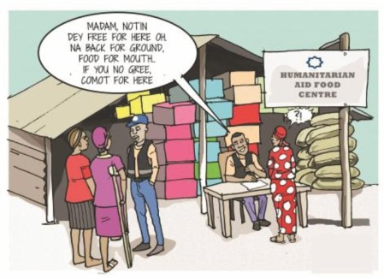
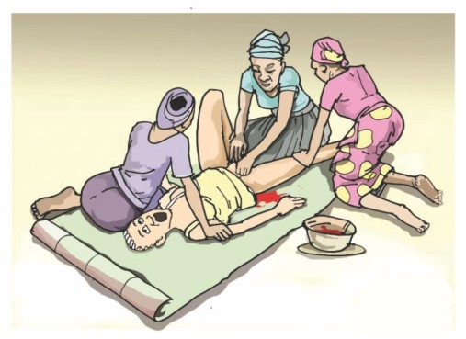
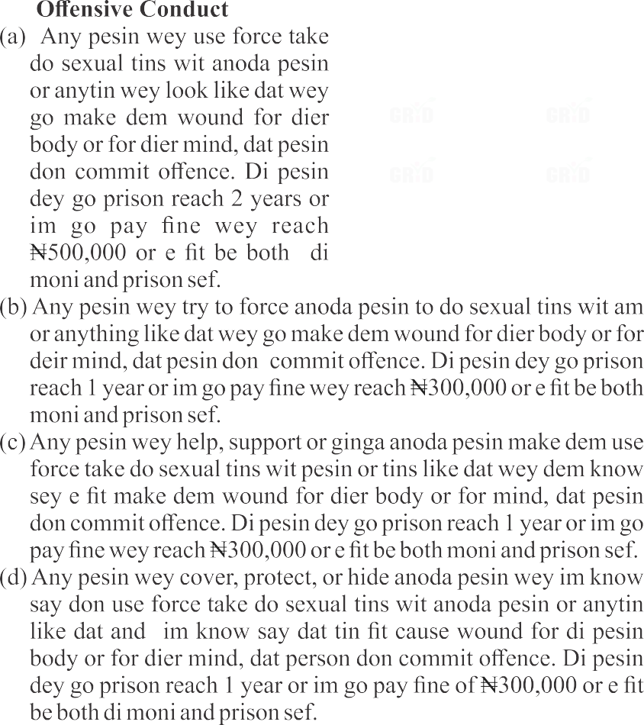
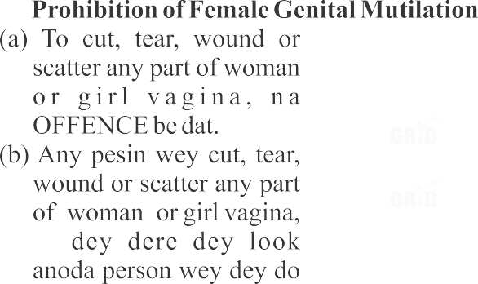





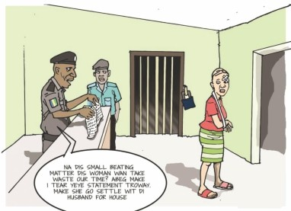
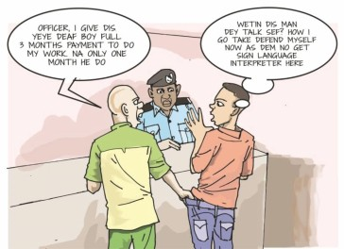



am, or let anoda pesin do am, Dem dey go prison reach 4 years or dem go pay fine wey reach B200,000 or e fit be both di moni and prison sef.
C Any pesin wey try cut, tear, wound or scatter any part of woman or girl vagina or dey allow make anoda pesin do am, Di pesin dey go prison reach 2 years or im go pay fine wey reachN100,000 or e fitbe both di moni and prison sef.
(d) Pesin wey help, support or ginga anoda pesin to cut, tear, wound or scatter any part of woman or girl vagina, Di pesin dey go prison reach 2 years or im go pay fine weyreachB100,000 ore fit be both di moni and prison sef.

Frustrating investigation
Any pesin wey destroy, scatter, or use fake document, book or even cloth wey fit serve as evidence, or do magomago wit investigation and punishment wey dem suppose give di pesin wey don commit any offence wey dey for this VAPPAct or any oda law wey dey on ground, dat pesin don
commit serious offence and di pesin dey go prison reach 3 years or pay fine wey reach N500,000 or e fitbe both di moni and prison sef.

Willfully Making False Statements Pesin wey use im clear eye and bad mind take tell lie weda na for mouth inn talk am or na for paper im write am make dem arrest anoda pesin wey innocent, dat pesin don commit serious offence. Di pesin dey go prison reach 2 years or im go pay fine wey reach N300, 000 or e fit be both di moni and prison sef.

Forceful Ejection from Home
- Pesin wey troway inn wife or husband comot for house or try block dem make dem no enter house don commit offence. Di
5



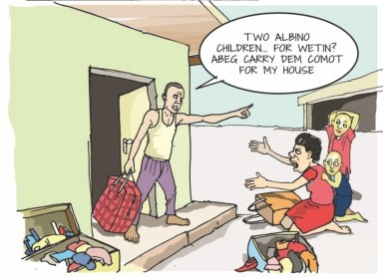
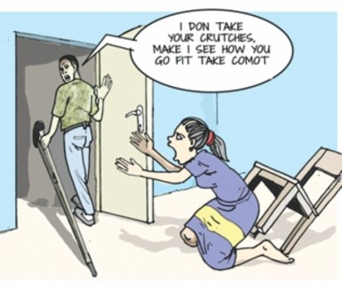
pesin dey go prison reach 2 years or im go pay fine wey reach N300,000 or e fit be both di moni and prison sef.

- Pesin wey try troway inn wife or husband comot for house or try block dem make dem no enter
house don commit offence. Di pesin dey go prison reach 1 year or inn go pay fine wey reach B200,000 or e fit be both di moni and prison sef.

- Pesin wey help, support or ginga anoda pesin make inn troway inn wife or husband comot for house or even try block dem make dem no enter house don commit offence. Di pesin dey go prison reach 1 year or im go pay fine wey reachN200,000 ore fitbe both di moni and prison sef.

- Pesin wey cover, protect, or hide anoda pesin wey im know say inn don troway im wife or husband comot for house or inn dey block dem make dem no enter house, don commit offence. Di pesin dey go prison reach 1 year or im go pay fine wey reach N200,000 ore fitbe both di moni and prison sef.

Depriving a Person of his or her Liberty
- Person wey take anoda person freedom wey e lock dem or hide dem wey no be court send dem to do am don commit offence. Di pesin dey go prison reach 2 years or im go pay fine wey reach N500,000 or e fit be both di moni and prison sef.
- Pesin wey try to take anoda person
freedom wey im lock dem or hide dem wey no be court send dem to do am don commit offence. Di pesin dey go prison reach 1 year or im go pay fine wey reachN200,000 ore fitbe both di moni and prison sef.
6



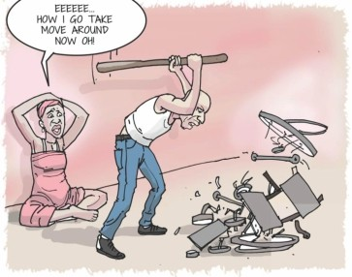
OC Pesin wey help, support or ginga anoda pesin make im take anoda person freedom wey e go lock dem or hide dem wey no be court send dem to do am don commit offence Di pesin dey go prison reach 2 years or inn go pay fine wey reach N300,000 or e fit be both di moni and prison sef.
(d) Pesin wey cover, protect, or hide anoda pesin wey im know say im don take anoda person freedom wey e lock dem or hide dem wey no be court send dem to do am don commit offence Di pesin dey go prison reach 1 year or inn go pay fine wey reach N100,000 ore fit be both di moni and prison sef.
Damage to Property with intent to Cause Distress
- Pesin wey destroy anoda pesin property sake of say im wan make di owner vex, dat pesin don commit offence. Di pesin dey go prison reach 2 years or im go pay fine wey reach N300,000 or e fit be bothdi moni and prison sef.
- Pesin wey try to destroy anoda pesin property sake of say inn wan
make di owner vex don commit offence. Di pesin dey go prison reach 1 year and im go pay fine wey reach N200,000 or e fit be bothdi moni and prison sef.
C Pesin wey help, support or ginga anoda pesin make im go destroy anoda pesin property sake of say im wan make di owner vex, don commit offence. Di pesin dey go prison reach 1 year or im go pay fine wey reach B200,000 or e fit be both di moni and prison sef.
(d) Pesin wey cover, protect, or hide anoda pesin wey im know say don go destroy anoda pesin property sake of say im wan make d owner vex don commit offence. Di pesin dey go prison reach 1 year or im go pay fine wey reach N200,000 or e fit be both di moni and prison sef.

Forced Financial Dependence or Economic Abuse
(a) Pesin wey force anoda pesin to dey depend on dem for moni and oda things wey dem need for dis life sake of say dem no wan

7



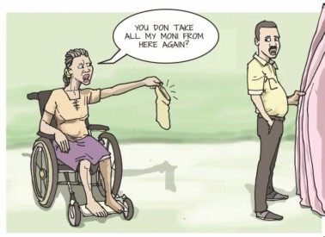
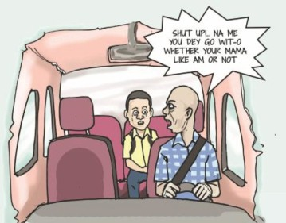
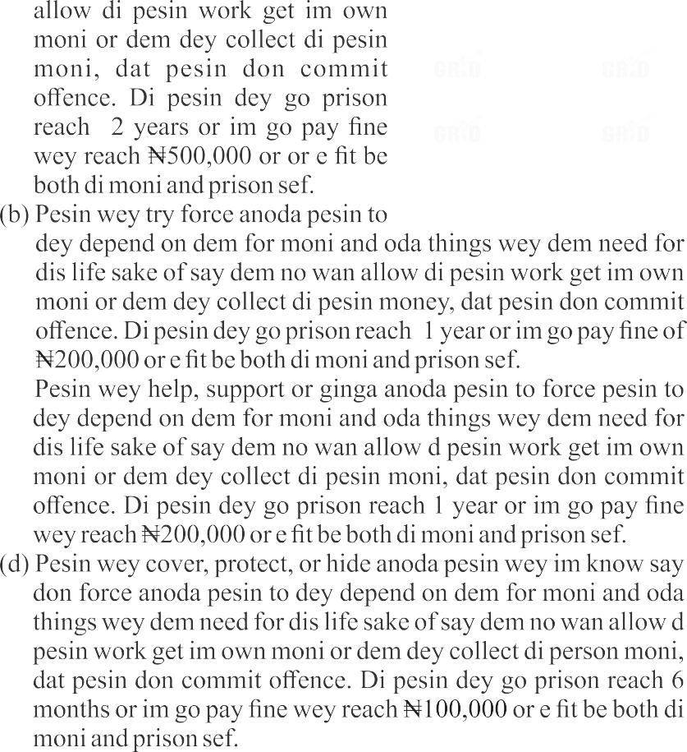
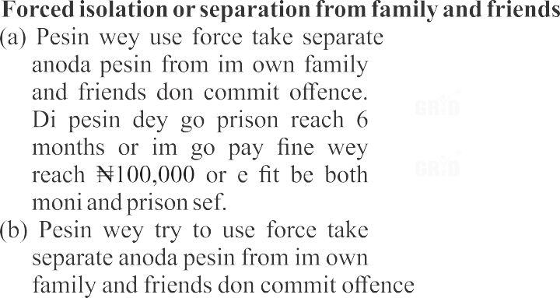





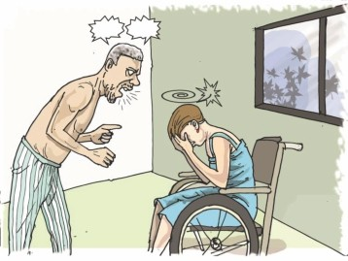
reach 3 months or inn go pay fine weyreachN100,000 ore fitbe both moni and prison sef.
(c) Pesin wey help, support or ginga anoda pesin to use force take separate anoda pesin from im own family and friends don commit offence. Di pesin dey go prison reach 6 months or im go pay fine wey reach N100,000 or e fit be both di moni and prison sef.
(d) Pesin wey cover, protect, or hide anoda pesin wey im know say im don use force take separate anoda pesin from inn own family and friends don commit offence. Di pesin dey go prison reach 3 months or im go pay fine wey reach N100,000 or e fit be both di moni and prison sef.

Emotional, Verbal and PsychoIogicaIAbuse
- Pesin wey dey use insult and bad mouth take cause anoda pesin pain everi time don commit offenceDi pesin dey go prison reach 1 year or inn go pay fine wey reach N200,000 or e fit be both di moni and prison sef.
- Pesin wey try to dey use insult and bad mouth take cause anoda pesin
pain everi time don commit offence. Di pesin dey go prison reach 6 months or inn go pay fine ofN100,000 or e fit be both di moni and prison sef.
C Pesin wey help, support or ginga anoda pesin to dey use insult and bad mouth take cause anoda pesin pain everi time don commit offence. Di pesin dey go prison reach 6 months or im go pay fine wey reach N100,000 or or e fit be both di moni and prison sef.
(d) Person wey cover, protect, or hide anoda pesin wey im know say dey use insult and bad mouth take cause anoda pesin pain everi time don commit offence. Di pesin dey go prison reach 6 months or im go pay fine wey reachN100,000 or e fit be both di moni and prison sef.

9



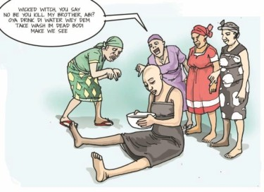
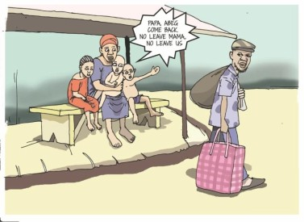
Harmful Widowhood Practices
- Pesin wey make woman wey inn husband don die to do those bad traditional tins wey dem dey force woman wey inn husband don die to do don commit offence. Di pesin dey go prison reach 2 years or inn go pay fine wey reach nt500,000 or e fit be both di moni and prison sef.
- Pesin wey try make woman wey im husband don die to do those bad traditional tins wey dem dey force woman wey inn husband don die to do don commit offence. Di pesin dey go prison reach 1 year or inn go pay fine wey reach N200,000 or e fit be both di moni and prison sef.
- Pesin wey help, support or ginga anoda pesin make woman wey im husband don die to do those bad traditional tins wey dem dey force woman wey im husband don die to do don commit offence. Di pesin dey go prison reach 1 year or inn go pay fine wey reach N200,000 ore fit be both di moni and prison sef.
- Pesin wey cover, protect, or hide anoda pesin wey im know wey don make woman wey im husband don die to do those bad traditional tins wey dem dey force woman wey inn husband don die to do don commit offence.. Di pesin fit go prison reach 1 year or im go pay fine wey reach N200,000 or e fit be both di moni and prison sef.

Abandonment of Children, Spouse and other Dependents
- Pesin wey waka leave im wife, husband, and pikin dem or oda people wey dey depend on am and come stop to dey take care of dem don commit offence. Di pesin dey go prison reach 3 years or im go pay fine wey reach B500,000 or e fit be both di moni and prison sef.
- Pesin wey try to waka leave im wife, husband, and pikin dem or oda people wey dey depend on am and come stop to dey take care of dem don commit offence. Di pesin dey go prison reach 2
10



years or inn go pay fine ofN200,000 or e fit be both di moni and prison sef.
C Pesin wey help, support or ginga anoda pesin to waka leave im wife, husband, and pikin dem or oda people wey dey depend on am and come stop to dey take care of dem don commit offence. Di pesin dey go prison reach or im go pay fine wey reach N200,000 ore fitbe both di moni and prison sef.
(d) Pesin wey cover, protect, or hide anoda pesin wey inn know say don waka leave im wife, husband, and pikin dem or oda people wey dey depend on am and come stop to dey take care of dem don commit offence. Di pesin dey go prison reach 2 years or im go pay fine wey reach N200,000 or e fit be both di moni and prison sef.

Stalking
- Pesin wey dey always follow anoda pesin wit close marking wey dey make di pesin dey fear or no dey comfortable don commit offence. Di pesin dey go prison reach 2 years or inn go pay fine wey reach N500,000 or e fit be both di moni and prison sef.
- Pesin wey dey try to always follow anoda pesin wit close marking wey dey make di pesin dey fear or no dey comfortable don commit offence. Di pesin dey go prison reach reach 1 year or im go pay fine wey reach N200,000 or e fit be both di moni and prison sef.
S Pesin wey help, support or ginga anoda pesin to always follow anoda pesin wit close marking wey dey make di pesin dey fear or no dey comfortable don commit offence. Di pesin dey go prison reach 1 year or inn go pay fine weyreach&200,000 ore fit be both di money and prison sef.
(d) Pesin wey cover, protect, or hide anoda pesin wey im know say im been dey always follow anoda pesin wit close marking wey dey make d pesin dey fear or no dey comfortable, don commit offence. Di pesin dey go prison reach 1 year or inn go pay fine weyreachN200,000 ore fitbe both di moni and prison sef.

11



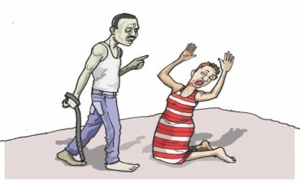


Intimidation
- Pesin wey dey show power on top anoda pesin body or im dey make anoda pesin dey fear don commit offence. Di pesin dey go prison reach 1 year or im go pay fine weyreachN200,000 ore fit be both di money and prison sef.
- Pesin wey dey show power on top anoda pesin body or im dey make anoda pesin dey fear don commit offence. Di pesin dey go prison reach 6 months or im go pay fine wey reachN100,000 or e fitbe both di moni and prison sef.
fi Pesin wey help, support or ginga anoda pesin to dey show power on top anoda pesin body or inn dey make anoda pesin dey fear don commit offence. Di pesin dey go prison reach 6 months or im go pay fine wey reach N100,000 or e fit be both di money and prison sef.
(d) Pesin wey cover, protect, or hide anoda pesin wey im know don show power on top anoda pesin head or im dey make anoda pesin dey fear don commit offence. Di pesin dey go prison reach 6 months or im go pay fine wey reach B100,000 or e fit be both di moni and prison sef.

Spousal Battery
- Pesin wey beat inn wife or husband don commit offence. Di pesin dey go prison reach 3 years or inn go pay fine wey reach N200,000 or e fit be both di moni and prison sef.
- Pesin wey try beat im wife or husband don commit offence. Di
pesin dey go prison reach 1 year or im go pay fine wey reach B100,000 ore fit be both di moni and prison sef.
fi Pesin wey help, support or ginga anoda pesin make im beat inn wife or husband, don commit offence. Di pesin dey go prison reach 1 year or im go pay fine wey reach N200,000 or e fit be both di moni and prison sef.
(d) Pesin wey cover, protect, or hide anoda pesin wey im know say inn don beat im wife or husband don commit offence. Di pesin dey go prison reach 1 year or im go pay fine wey reach N200,000 ore fit be both di moni and prison sef.
12



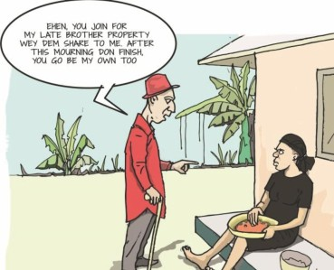
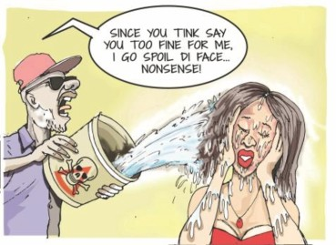
Harmful Traditional Practices
- Pesin wey make anoda pesin dey do all those bad traditional practice don commit offence. Di pesin dey go prison reach 4 years or im go pay fine wey reach N500,000 or e fit be both di moni and prison sef.
- Pesin wey try dey make anoda pes in dey do all tho se bad
traditional practice don commit offence. Di pesin dey go prison reach 2 years or im go pay fine wey reach &300,000 or e fit be both di moni and prison sef.
C Pesin wey help, support or ginga anoda pesin to make anoda pesin do all those bad traditional practice don commit offence. Di pesin dey go prison reach 2 years or im go pay fine wey reach N300,000 ore fitbe both di moni and prison sef.
(d) Pesin wey cover, protect, or hide anoda pesin wey im know say im don make somebody do all those bad traditional practice don commit offence. Di pesin dey go prison reach 2 years or im go pay fine wey reach N200,000 ore fitbe both di moni and prison sef.

Attack with Harmful Substance
- Pesin wey pour anoda pesin any dangerous liquid or chemical wey fit cause pesin to wound or fit kill pesin don commit offence. Di pesin dey go prison straight for di rest of inn life as option for fine no dey for dis wan.
- Pesin wey try to pour anoda pesin
any dangerous liquid or chemical wey fit cause pesin to wound or fit kill pesin don commit offence. Di pesin dey go prison reach 25 years and fine no dey for dis wan.
C Pesin wey help, support or ginga anoda pesin to pour pour anoda pesin any dangerous liquid or chemical wey fit cause pesin to wound or fit kill pesin don commit offence. Di pesin dey go
13


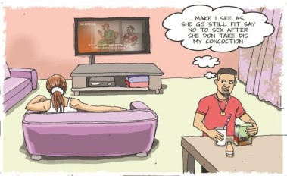
prison reach 25 years and fine no go dey for dis wan.
(d) Pesin wey cover, protect, or hide anoda pesin wey im know say im done pour anoda pesin dangerous liquid or chemical wey fit cause pesin to wound or fit kill pesin don commit offence. Di pesin dey go prison reach 25 years and fine no go dey for dis wan.

Administering a Substance with Intent Pesin wey give anoda pesin any substance wey dey solid, powder
or liquid form wey go make anoda pesin weak for body so im go rape am or do any oda tin wey no pure to di pesin don commit crime. Di pesin dey go prison reach 10 years
or im go pay fine wey reach B500,000 or e fit be both di moni and prison sef.

Political Violence
- Pesin wey injure or wound anoda pesin sake of say politics and elections dey involve for di mata don commit offence. Di pesin dey go prison reach 4 years or im go pay fine wey reach nt500,000 ore fitbe both di moni and prison sef.
- Pesin wey try injure or wound another pesin sake of say politics and elections dey involve for di mata don commit offence. Di pesin dey go prison reach 2 years or im go pay fine wey reach N200,000 ore fitbe both di moni and prison sef.
C Pesin wey help, support or ginga anoda pesin to injure or wound pesin sake of say politics and elections dey involve for d mata don commit offence. Di pesin dey go prison reach 2 years or im go pay a fine wey reach B300,000 or e fit be both di moni and prison sef.
(d) Pesin wey cover, protect, or hide anoda pesin wey inn know don injure or wound pesin sake of say politics and elections dey involve for di mata don commit offence. Di pesin dey go prison reach 2 years or im go pay fine wey reach N200,000 or e fit be both di moni and prison sef.
14



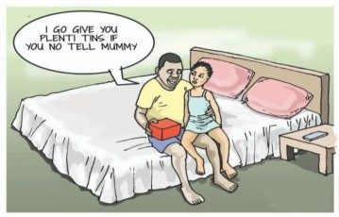
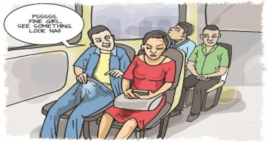



Violence by State Actors
- Any Government Official wey injure or wound anoda pesin sake of say politics and elections dey involve don commit offence. Di pesin go dey prison reach 4 years or im go pay fine wey reach N1,000,000 ore fitbe both di moni and prison sef.
- Any Government Official wey try to injure or wound anoda pesin sake of say politics and elections dey involve don commit offence. Di pesin go dey prison reach 3 years or inn go pay fine wey reach N700,000 ore fitbe both di moni and prison sef.
CAny Government Official wey help, support or ginga anodapesin to injure or wound pesin sake of say politics and elections dey involve don commit offence. Di pesin dey go prison reach 2 years or inn go pay fine wey reach N500,000 or e fit be both di moni and prison sef.
- Any Government Official wey cover, protect, or hide anoda pesin wey im know say don injure or wound pesin sake of say politics and elections dey involve don commit offence. Di pesin dey go prison reach 1 year or inn go pay fine wey reach N300,000 ore fitbe both di moni and prison sef.
- Di Government dey responsible for any offence wey im staff don commit and Court go make Government pay plenti moni to pesin wey dem injure.

Incest
Pesin wey sleep wit pesin wey be im family member (e fit be brother, sister, father, mother, cousin, or in-law) or anytin like dat wey no pure don commit offence. Dat pesin dey go prison and e fit reach 10 years and fine no go dey.

Indecent Exposure
Pesin wey open inn private part make im take attract anoda pesin, or make di oda person vex, or make di
pesin see or touch am, di person don
commit offence wev dem dey call
INDECENT EXPOSURE. Di pesin
dey go prison for time wey no _{gO} dey less than 1 year or llTl O pay fine wey ea 500,000 rn tbebothd prannand ni set.

15






PART II - JURISDICTION OF THE COURT
27. Any pesin wey dey under any threat of violence fit apply to di High Court of the Federal Capital Territory, Abuja, for order wey go protect am and inn get right to make criminal complaint against the pesin wey dey threaten am.
Protection Order
Application for order wey dey protect fit dey join, and the pesin wey dey complain go know about am, or anoda pesin wey sabi wetin dey happen fit help di pesin wey dey complain, e fit be police officer, or officer wey dey protect, counselor, teacher, or social welfare. In case of small pikin, di pikin or any oda pesin wey fit stand for di pikin, inn fit apply to court make dem go give di pikin order wey go protect amifdi pikin papa, mama or guardian no dey.
Police officer wey dem write complain give wey involve violence suppose help di pesin make im dey safe, help am go wia inn fit rest and take am go di nearest hospital so im go receive treatment. Di officer suppose explain im rights to di pesin and follow am reach inn domot ifim wan collect im things wey dey dier. Di police officer fit arrest di pesin sefwey dey cause di wahala.
Any pesin wey go against di order or disobey order wey dey protect anoda person dey guilty of offence and inn dey go prison reach 6 months or inn go pay fine wey reach N300,000 or e fit be both di moni and prison sef.

provide say the NationalAgency for Prohibition of Trafficking in Persons and Other Related Matters (NAPTIP) na the organization body dem we dey responsible to put eye for this mata of Violence Against Persons and to punish people wey commit offence under di Act and dem go join hands wit oda organizations take do dis work.

For more information, contact:
Grassroot Initiative for Gender and Development (GRID) 100 Effurun/Sapele Road, Effurun, Warri, Delta State - Nigeria.
07046472575 info@gridinitiative.org @GRID_Initiative @GrassrootsandDeveIopment

16




Dis booklet na from Grassroots Initiative for Gender and Development (GRID) and na wit support from di Interagency PSEA Outreach and Communication Fund.

Grassroots Initiative for Gender and Development

