Ererau a beiyo bi papyri eyi
fa O.I gbogula, kokodaba fiai ine bibi duo suo dou ibogha daba bei
yo bi duo seri

Baratua Kimi ama piri ngi fiai ware

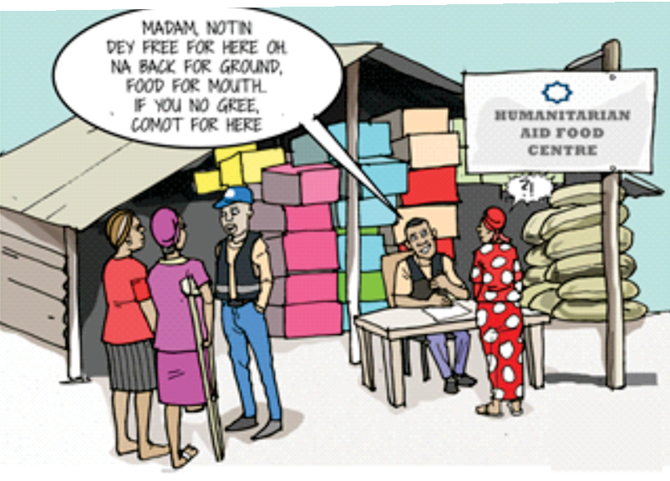

KIMI OVIRIMO KUMO E GBA FUN NI AKI IZON BELI BO WAI

GE YE BI (MIEKUMO) (VAPP) OLOKO, MA OGIZI OU SONRON FINI (2015)

Grassroots Initiative for Gender and Development

KIMI OVIRIMO KUMO (MIEKUMO) OLOKO, 2015) VAPP OLOKO BI, 2015
Bei VAPP OLOKO Bi kimiama ni o piri ovirimo yemi kimiama kimo ngi oloko, mani o zuo ngi oloko, mani oya pele aki na kimiama ovirimo yemi otumo piri ﬁ ngi oloko; mokpo, bei oloko bi aki na kimiama ovirimo mo leirumi seiyai mose daa tiemo ebe oloko.
Naijiria oloko mie wari kpo bara poudou
Bei VAPP oloko bi kimiama ni opiri ovirimodo kimimose, kala kpo okosu kpo owei kpo ere kpo, kurei la ni oro ovirimo ubo bi kori ogula wari gho mungimi.

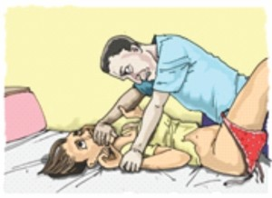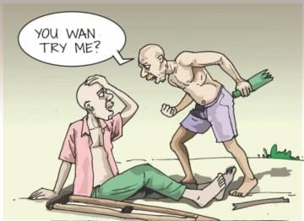BOLOU ANGA BI – SEIMO
KUROTORU ERE BUNU
- Kurotoru aki na ere kari bunu, anighakpo bibi bunu anighakpo bigen bunu anighakpo esisimo bara aki bei iyemo mie daba ubo oloko gho korodou. Seimie ubo bi ugoliwari duo pagha timi ﬁngemi, ubo ma bari okoba gbe o piri ovirimo ubo bi piri ngimi. Seimie ubo bi ere bi aki fun gho gee ngimi.

INOUN TUA ONGOMENI
  - Adein, sibeye, ogbolo, biledi, enighakpo kurei inoun tua ngimi iye se aki no zii ubo ongo gho inoun tuado aba, ubo oloko gho korodou. Eri igoliwari gho timi sonran kurai bai ngimi mani naira odozo gbe ngimi. Okobamo gbe mani igoli-wari gho nu kpo panimi.
  - Adein, sibeye, ogbolo, biledi anighakpo kurei inoun tua ngimi iye se aki kimi gho inoun tua dou daba ubo oloko gho korodou. Ubo tara kurai aki igoliwari gho kaingimi ma naira ma odozo gbe ngimi, anighakpo okobamo gbe bari igoliwari kpo mu.
  - Kimi zinibo kuromo weri adein, sibeye, ogbolo, biledi anighakpo kurei inoun tua ngimi iye se aki kimi gho inoun tua dou daba ubo oloko gho korodou. Ubo tara kurai igoliwari gho timingimi ma Naira ma odozo gbe, enighakpo okobamo gbe bari igoliwari kpo mu.
  - Adein, sibeye, ogbolo, biledi, anighakpo kurei inoun tua ebe iye aki zinikimi gho inoun tua ubu

sowei kimise, ubo oloko gho korodo. Bias kimi bi tara-kurai igoliwari gho kai timi ngimi mani Naira ma odozo gbe anighakpo okobamo gbe bari igoliwari kpo mu.
  - Ogulawa bi kurei seimie ubo bi mie okoba gbe ovirimo pringimi diseya.

2

Ari I dadi ki douyema

- KUROTORU GHO IYE MIE Kimiama serimo kurotoru kimi ovirimo nda ubo kpo nimiame ovirimo ubo bi ongomo tememo seimo ngimi bara mie dese ubo oloko gho korodo ubo tara-kurai aki igoliwari gho kaigimi.

Ari beimi bi I ta ee. Ebi yei dou gho sei mink kemi.
Bei alaoweI︣ bi wo bari I nana ki douyemi.
Ari ebi ere ko paa ngimi.

IKISATUA KIMI USISIMO MANI UBOMIESERIMOSE IYE ESIN TIMI IYELANGI MALAFA

  - Kimi usisimo ubose oloko g h o k o r o d o u . U b o makurai aki igoliwari, gho kai timingimi enighakpo Naira ma odozo gbe enighakpo okobamo gbe ma bari igoliwari kpo mu
  - Inoun tua aki kimi usisimo 1 kimise oloko gho karodo ubo Naira ma odozo gbe

Ogugu bolou bo emi bara arau mo nimigi bari mo eri ngimi

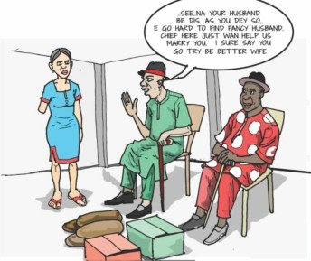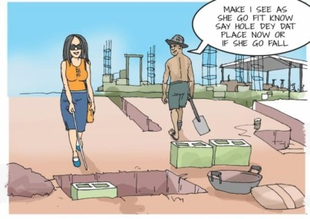mani keni igoliwari gho kai anighakpo okobamo gbe bari igoliwari gho kai.
  - Kimiserimo anighakpo baratua zinikimi piri da ubo inoun tua aki kimi usisimo daba ubo oloko gho korodo. Ubo keni kurai aki igoliwari gho kai ma Naira ma odozo gbe enighakpo okobamo gbe bari igoliwari kpo mu.
  - Kimi osisimo kimi sowei ubose inoun tua aki anighakpo ari iye ni i mie ngi me e gba kimi sowei ubose oloko gho korodo. Eri igoliwari keni kurai kai ngimi anighakpo Naira ma odozo gbe anighakpo okobamo gbe mani igoliwari kpo kai.

SEI IYERIN BUO
  - Kurotoru ere bunu mo lei iye see inyerin bi maru o momo lei iye see kpo mie ubo see oloko gho ikorodo. Ubo ma kurai ko igoliwari go timi ngimi enighakpo Naira sonran odozo gbe anighakpo okobamo gbe mani igoliwari gho mu.
3

  - Kurotoru kimi bunu iyemo lei iye mie ubo see oloko gho korodo, bias ubo bi keni kurai gho igoliwari gho timi ngimi enighakpo Naira tara odozo gbe enighakpo okobamo gbe mani igoliwari kpo mu.
  - Kimine zinibo kuro-mo enighakpo baratua ubo piri weri kurotoru gho kimi bunu iye mie daba ubo oloko gho korodo bisa ubo bi keni kurai gho igoliwari gho timi ngimi enighakpo Naira taro odozo gbe enighakpo okobamo gbe mani igoliwari, kpo mu.
  - Kurotoru kimi bunu kimi sowei

ubose oloko gho korodo eni kimibikeni kurai gho igoliwari gho timi ngimi enighakpo Naira tara ozozo gbe enighakpo okobamo gbe ma igoliwari kpo mu.

ERE ARAU BENIKORO SEI
Ererau a beiyo bi papyri eyi fa O. I gbogula, kokodaba fiai ine bibi duo suo dou ibogha daba bei yo bi duo seri.
BARATUA KIMI AMA PIRI NGI FIAI WARE

  - 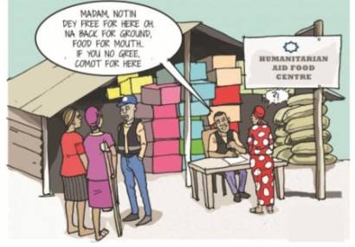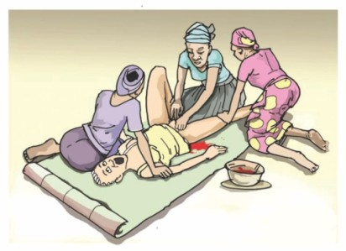Ere arau beniko enighakpo ongo pu walai bi oloko gho koro iye.
  - Kimine ere arau enighakpo ereabau benikoromo, ongo pu walai, eniaghakpo tie timi di yemi kimi eniaghakpo zinikimi pebi bei iyemo mie kimimose oloko gho korodo. Bei kimimo noina kurai igoliwari gho timi ngimi
enighakpo okobamo gbe mani igoliwi kpo mu.
  - Bei gba iyemo mie dou kimise oloko gho koro do. Bisa kimi bi ma kurai igoliwari, gho kai enighakpo Naira ma odozo gbe enighakpo okobamo gbe mani igoliwari kpo mu.
  - Kimine zinikimi kuromo bei
benikoromo enighakpo ongo pu walai walai iyebi mie kimise bisa kimibi oloko gho korodo. Bisa kimi bi ma kurai igoliwari gho kari enighakpo Naira keni odozo gbe enighakpo okobamo gbe mani igoliwari kpo mu.

4

IYE GHO TUDO KIMO
Kimini esri iye seimo, walaka, enighakpo aki iye gho tudo kimo daba seimie kimi bi oya gho peletei bimeini, bisa kimibi oloko gho korodo. Bisa kimibi tara kurai igoliwai kai ngimi enighakpo Naira sonran odozo gbe enighakpo okobamo gbe enighakpo okobamo gbe mani igoliwari kpo mu.

NIMIWERI IKPE EGBERI GBA
Ikpe egberi gba iye gho tunimigha

Bei kala famy ki bimeine bei erema wo ifie famo douyema.
Bei iyekpo gho suogha fun bi ari mo kpukan di arau wari gho mu yei mo dudu na.

Kimi-koro-owei a,

Kimi bi tei iye

kimi gbainmo kimise, fun ko ge enighakpo bibi ko gba kpo, eni kimibi oloko gho korodo. Bisa kimi bi ma kurai igoliwari gho mu ngimi enighakpo Naira tara odozo gbe enighakpo okobamo gbe mani igoliwari kpo mu.

WARI GHO KIMI DUWO PAAMO
  - Ere ikpese enighakpo yei ikpese wari duo gbein paamo enighakpo wari duosuo kimo kimi bi oloko gho korodo. Bisa kimi bi ma kurai igoliwai gho kai ngimi enighakpo Naira tara odozo gbe ngimi enighakpo okobamo gbe mani igoliwari, kpo mu
  - Kimini ere ikpese enighakpo yei
ari bei iye kpo gho suogha eni tobo bi tara akalu gbe aki na
u gbe ya eri. Keni akalu firi botibi ki weni mi.
ki gbayema? Lelei boomo Kimi bei fa bi ari tebara ki akin a ongo zou ngima.

ma gerigeri pina owou ama kpo, pa sisei oro, aki na ine wari bi duo pa

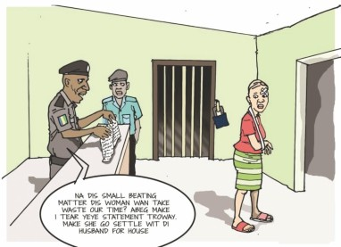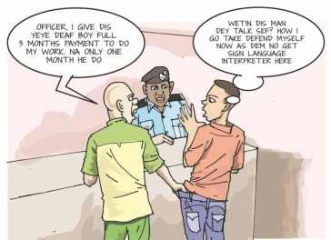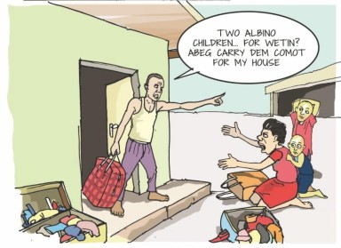ikpese gbein paamo enighakpo wari duo suo kimo kimi bi oloko gho korodo. Bisa kimi bi keni kurai igoliwari gho kai ngimi enighakpo Naira ma odozo gbe ngimi enighakpo okobamo gbe mani igoliwari kpo mu.
  - Kimi ni zinikimi kuromo enighakpo baratua weri kimi ikpese
5

ama gbein paamo enighakpo wari duosuo kimo bi oloko gho korodo. Bisa kimi bi keni kurai igoliwari gho kai ngimi enighakpo Naira ma odozo gbe ngimi enighakpo okobamo gbe mani igoliwari kpo mu
  - Kimini ere ikpese, yei ikpese gbein paamo enighakpo wari duosuo kimo kimi sowei daba eri oloko gho korodo. Bisa kimi kurai igoliwari gho kai ngimi enighakpo Naira ma odozo gbe ngimi enighakpo okobamo gbe mani igoliwari kpo mu

FOMU NA KIMI PIRIGHA

  - K i m i n i z i n i k i m i s o w e i enighakpo iyo gho kai oloko- gba-wari kpo bisa kimi firimogha bara bi, bisa kimi bi oloko gho korodo. Bisa kimi bi ma kurai gho igoliwari gho kai enighakpo N a i r a s o n r a n o d o z o g b e enighakpo okobamo gbe mani igoliwari kpo mu
Ine akolo bi ari mo suboakido, meni I ma la weni bara ari mo eri ngimi

  - 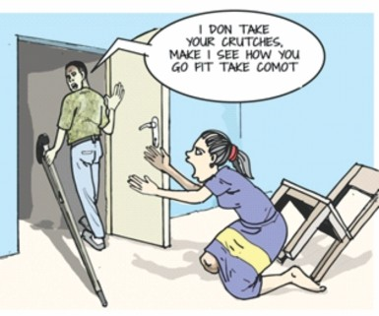Kimi ni zini kimi fomu akin a kai enighakpo sowei do enia enia oloko-gbawari kpo firimogha bara bi, bisa kimi bi oloko gho korodo. bisa kimi bi keni kurai igoliwari gho kai enighakpo Naira ma odozo gbe enighakpo okobamo gbe mani igoliwari kpo gho mu
  - Kimi ni zini kimi kuromo, bari enighakpo ubo serimo zini kimi fomu aki sowei enighakpo kai, olokogbawari kpo firimogha bara bi, bisa kimi bi ma kurai igoliware gho kai enighakpo Naira tara odozo gbe enighakpo okobamo gbe mani igoliwari kpo mu
  - Kimi ni zini kimi fomu kai enighakpo sowei kimi bi sowei, terimo, enighakpo zuo kimi bi oloko gho korodo, olokogbawari kpo firimogha bara bi. Bisa kimi keni kurai igoliwari kai enighakpo Naira keni odozo gbe enighakpo okobamo gbe mani igoliwari kpo gho mu

KIMI IKISA BIMEINE ZINI KIMI IKPESEMO SEIMO
  - Zini kimi ikpesemo seimo da ubo ni bolou koun mo kimi se oloko gho korodo. Bisa kimi bi ma, kurai igoliwari gho kai enighakpo
6

Naira tara odozo gbe enighakpo okobamo gbe mani igoliwari kpo gho mu
  - Zini kimi ikpese seimo dou do kimi eniki kimi bi mie bolou koun dou kimi bi oloko gho korodo. Bisa kimi bi keni kurai igoliwari gho kai enighakpo Naira ma odozo gbe
Eeeee Ari ma weni ngi barafa o

enighakpo okobamo gbe mani igoliwari kpo gho mu
  - Kimi ni baratua enighakpo ubo serimo zini kimi ikpese seimo kimi bi oloko gho korodo. Bisa kimi bi keni kurai igoliwari gho kai ngimi enighakpo Naira ma odozo gbe enighakpo okobamo gbe mani igoliwari kpo gho mu
  - Zini kimi ikpese seimo kimi sowei, zuo enighakpo terimo kimi bi keni kurai gho igoliwari gho kai ngimi enighakpo Naira ma odozo gbe enighakpo okobamo gbe mani igoliwari kpo gho mu

KIMI BOOMO OKOBA DOGHA INDA KIMI KI GHO SESEREI

  - Kimi ni zini kimi boomo okoba do g h a e n i a k p o u b o b o o m o ﬁriwenigha, ongo tolomo ngi borakpo fa, enighakpo ubo nana okoba dolo kpo kori naki kimi bi, ubo oloko gho koro-do. Bisa kimi bi ma kurai gho igoliwari gho kai timi ngimi enighakpo Naira

Ari mani ine okobamose bei bulu duo ni seri na akido

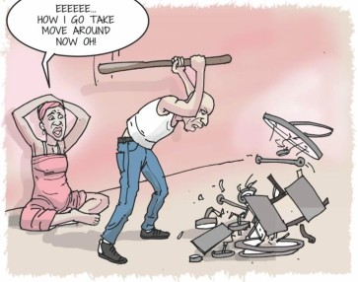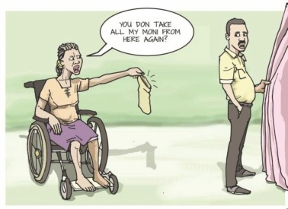sonran odozo gbe ngimi enighakpo okobamo gbe mani igoliwari kpo gho mu
  - Kurotoru gho zini kimi mie a kimi gho seserei da ubo douyemi iye kpo nana ngi barafa, ubo boomo firi kpo wenigha, mani ubo nana iye dolo kpo kori n'aki. Bisa kimi bi oloko gho korodo. ubo keni kurai gho igoliwari gho kai timi ngimi enighakpo Naira ma odozo gbe ngimi enighakpo okobamo gbe mani igoliwari kpo gho mu.
  - Kimi ni baratua enighakpo zini kimi kuro weri kurotoru gho zini kimi mie kimi gho seserei da ubo douyemi iye kpo nanagha ubo
7

kpo pebi firi wenigha, mani ubo nana iye dolo kpo korinaki daba bisa kimi bi oloko gho korodo. ubo keni kurai gho igoliwari gho kai timi ngimi enighakpo Naira ma odozo gbe ngimi enighakpo okobamo gbe mani igoliwari kpo gho mu
  - Kurotoru gho zini kimi pebi emene okobadogha, firi kpo wenigha eniki ubo wo gho seserei ngi bimeine, enighakpo ubo nana iye dolo kpo kori n'aki ubo bi terimo enighakpo zuo kimise oloko gho korodo ubo sondia akalu akin a igoliwari gho kai timi ngimi enighakpo Naira gho keni odozo gbe mani igoliwari kpo gho mu.

KUROTORU GHO BINAOTUMO IKIYAOTUMO TORUYO DUO SOWEI FAMO
  - Kimi ni kurotoru gho zini kimi aki

na binaotu enighakpo ikiyaotu enighakpo ubo wari duo sowei famo daba, bisa kimi bi oloko gho korodo. Bisa kimi bi sonda akalu akin a igoliwari gho kai timi ngimi enighakpo Naira keni odozo gbe ngimi enighakpo okobamo gbe mani igoliwari kpo gho mu.
I dou mo I yengi mo disemo o disegha o ari imomo ki mu yemi. kpain

  - 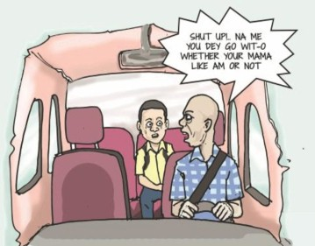Kimi ni kurotoru gho zini kimi aki ubo wari enighakpo ikiya-otu toruyo duo sowei famo bara mie dou kimi bi oloko gho korodo. Bisa kimi bi tara akalu aki na igoliwari gho kai timi ngimi enighakpo Naira gho keni odozo gbe ngimi enighakpo ubo okobamo gbe mani igoliwari kpo gho mu.
  - Kimi ni baratua, kuromo enighakpo kurotoru zini kimi aki na ubo wari enighakpo ikiya-otu toru duo sowei famo bara mie dou kimi terimo eniakpo sowei kimi bi oloko gho korodo. Bisa kimi bi sondia akalu aki na igoliware gho kai timi ngimi enighakpo Naira keni odozo gbe nigimi enighakpo okobamo gbe mani igoliwari kpo gho mu
  - Kimi ni zini kimi aki na ubo wari enighakpo ikiyaotu enighakpo binaotu toruyo duo sewei famo bara mie kimi sowei enighakpo terimo do aba eni kimi bi olokogho korodo, ubo tara akalu aki na

8

igoliwari gho kai timi ngimi enighakpo Naira keni odozo gbe ngimi enighakpo okobamo gbe mani igoliwari kpo gho mu

ERE BIBI ENIGHAKPO IKIYO SEIMO BARA AKI NA KIMI DISEIMO
  - Sei erebibi mo weri mo aki na kimi mie dounmo kimi bi oloko gho korodo. Ubo keni kurai aki na igoliwari kai timi ngimi enighakpo N a i r a m a o d o z o g b e n i g m i enighakpo okobamo gbe mani igoliwari kpo mu
  - Kimi ni iﬁemosesei erebibi aki na
zini kimi mie boloukoun yemi kimi bi oloko gho korodo. Ubo sondia akalu aki na igholiwari gho kai timi ngimi enighakpo Naira keni odozo gbe ngimi enighakpo okobamo gbe mani igoliwari kpo gho mu
  - Kimi ni baratua, zini kimi kuromo da ubo sei erebibi aki na iﬁemose zini kimi mie bolou kounmo yemi kimi bi oloko gho korodo. Bisa kimi bi sondia akalu aki na igoliwari gho kai ngimi enighakpo Naira keni odozo gbe ngimi enighakpo okobamo gbe mani igoliwari kpo gho mu
  - Kimi ni sei ere bibi aki na zini kimi mie bolou kounmo yemi ubo bi terimo, sowei yemi kimi bi oloko gho korodo. ubo sondia akalu aki na igoliware gho kai timi ngimi enighakpo Naira keni odozo gbe ngimi enighakpo okobamo gbe mani igoliwari kpo gho mu

DU-EREMO UYAMO IYERIN BUO-AMA
  - Kuro toru gho eremo leimo mie mo

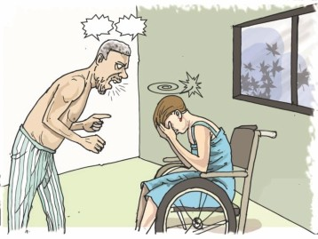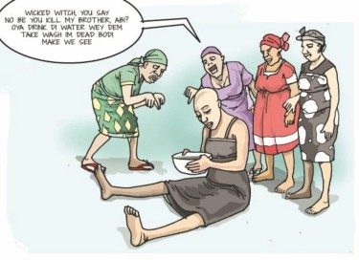egbeigha iye mie kimi se oloko gho korodo. Bisa kimi bi ma kurai aki na igoliwari gho kai timi ngimi enighakpo Naira gho sonran odozo gbe enighakpo okobamo gbe mani igoliwari kpo gho mu
  - Kuro-toru aki na du-eremo mie aki

9
Ari ine binaowei bi baa ki gbame, Meni duwei soro beni bi dou da we ere.

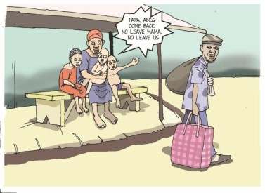na sei iyerin buomo tu duo do kimise ubo oloko gho korodo. Bisa kimi bi keni kurai aki na igoliwari gho kai ngimi enighakpo Naira gho ma odozo gbe ngimi enighakpo okobamo gbe mani igoliwari kpo gho mu
  - Kimi ni zini kimi kuromo, serimo enighakpo bari na duere mien sei iyerin bou da ubose ubo oloko gho korodo. Bisa kimi bi keni kurai aki na igoliwari gho kai timi ngimi enighakpo Naira ma odozo gbe ngimi enighakpo okobamo gbe nani igoliwari kpo gho mu
  - Kimi ni duere leimo na sei iyerin buo kori weni, eni kuro toru gho dueremo penimo weri mie yemi sei iyemo terimo, sowei enighakpo zuo kimise ubo oloko gho korodo. Ubo keni kurai aki na igoliwari gho kai timi ngimi enighakpo Naira ma odozo gbe nigimi enighakpo okobamo gbe mani igoliwari kpo gho mu

OWOUMO MO DU UBOMO MANI ZINI BINAOTUMO GBEINKOROMO IYERIN BI
  - Kimi ni du ubo bi Mo owoumo mani Zini ubo gho seserei yemi otumo gbeinkoromo kimise ubo oloko gho korodo. Bisa kimi bi tara kurai aki na igoliwari gho kai timi ngimi enighakpo Naira s o n r a n o d o z o g b e n g i m i enighakpo okobamo gbe mani igoliwari kpo gho mu.
  - Kimi ni emene ta, yei enighakpo owoumo gbein koromo do toru tua ni o digha kimi bi oloko gho korodo. Bisa kimi bi ma kurai aki na igoliwari gho kai timi ngimi enighakpo Naira ma odozo gbe ngimi enighakpo okobamo gbe mani igoliwari kpo gho mu
  - Kimi ni baratua, enighakpo zini kimi kuromo weri wo ta, yei enighakpo owouama gbeinkoromo da torutua ni o digha kimi bi oloko gho korodo. Bisa kimi bi igoliwari gho kai timi nigimi enighakpo Naira okobamo gbe mani igoliwari kpo gho mu
  - Kimi ni emene ta, yei enighakpo owouama gbeinkoromo da torutua ni o digha kimi bi terimo, sowei enighakpo koromo yemi kimi bi olokogho korodo. Bisa kimi bi ma kurai aki igoliwari gho
10

kai timi ngimi enighakpo okobamo gbe mani igoliwari kpo gho mu

KIMI ESISIMO
  - Kimi ni iﬁemose zini kimi esisimo da ubo doo kpo ma managha bara bi Bisa kimi bi oloko gho korodo.Bisa kimi bi ma kurai na igoliwari gho kai kimi ngimi enighakpo Naira gho sonran odozo gbe ngimi enighakpo okobamo gbe mani igoliwari kpo gho mu
  - Kimi ni kimi esisimo yemi kimi bi tuduo kimi kpo oloko gho korodo. Bisa kimi bi keni akalu aki na igoliwari gho kai timi ngimi enighakpo Naira ma odozo gbe ngimi enighakpo kpo gho mu
  - Kimi ni iﬁemose kimi esisimo da ubo doo ma nanagha kimi bi kuromo serimo, sowei enighakpo bari yemi kimi bi oloko gho korodo. Bisa kimi bi keni kurai akin a igoliwari gho kai timi ngimi enighakpo Naira ma odozo gbe ngimi enighakpo okobamo gbe mani igoliwari kpo gho mu
  - Kimi ni zini kimi esisimo yemi e nimi-wonimi kimi bi terimo, sowei enighakpo kokoyemi kimi bi oloko gho korodo. Bisa kimi bi keni kurai aki na igoliwari gho kai timi ngimi enighakpo Naira ma odozo gbe ngimi enighakpo okobamo gbe mani igoliwari kpo gho mu.

KIMI AKPAKPAMO
  - Kimi akpakpamo yemi kini bi oloko gho korodo. Bisa kimi bi keni kurai akin a igoliwari gho kai timi ngimi enighakpo Naira ma odozo ngimi enighakpo akobamo gbe mani igoliwari kpo gho mu
  - Kimi akpakpamo yemi kimi inda ubo mie malafamo yemi kimi bi oloko gho korodo. Bisa kimi bi sondia akalu aki na igoliwari kai timi ngimi enighakpo Naira gho keni odozo gbe ngimi enighakpo okobamo gbe mani igoliwari kpo gho mu
  - Kimi ni kimi akpakamo yemi kimi bi sowei, koko, zuo enighakpo kuromo yemi kimi bi olokogho korodo. Bisa kimi bi sondia akalu aki na igoliwari gho kai timi ngimi enighakpo Naira gho keni odozo gbe ngimi enighakpo okobamo gbe mani igoliwari kpo

11

gho mu
  - Kimi ni baratua, kuromo enighakpo serimo da kimi akpkpamo yemi bi kimi bi piri kimi bi oloko gho korodo. Bisa kimi bi sondia akalu akin a igoliwari gho kai timi ngimi enighakpo Naira gho keni odozo gbe ngimi enighakpo okobamo gbe mani igoliwari kpo mu

ERE ENIGHAKPO YEI BAI
  - Emene ere enighakpo yei bai ubo se oloko gho korodo. Ubo tara kurai akin a igoliwari gho kai
timi ngimi enighakpo Naira gho ma odozo gbe ngimi enighakpo okobamo gbe mani igoliwari kpo gho mu
  - Emene ere enighakpo yei bai dou ubo bi oloko gho korodo. Ubo keni kurai akin a igoliwari gho kai timi
ngimi enighakpo Naia keni odozo gbe ngimi enighakpo okobamo gbe mani igoliwari kpo gho mu
  - Kimi ni zini kimi serimo, kuromo da ere bai enighakpo yei bai ubo bi oloko gho korodo Bisa ubo bi keni kurai aki na igoliwari gho kai timi ngimi enighakpo Naira ma odozo gbe ngimi enighakpo okobamo gbe mani igoliwari kpo gho mu
  - Kimi ni ere enighakpo yei bai ubo bi terimo, koko, enighakpo sowei ubo bi oloko gho korodo. Bisa ubo bi keni kurai akin a igoliwari gho kai timi enighakpo Naira ma odozo gbe ngimi enighakpo okobamo gbe mani igoliwari kpo gho muEhen...Ari Kpo ine ﬁdou binaewei iyemo gho keni . Duu iﬁe bi boodou aba ari kpo inei ko padou.

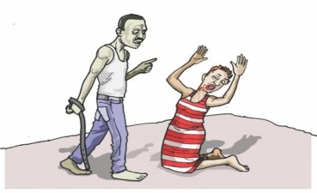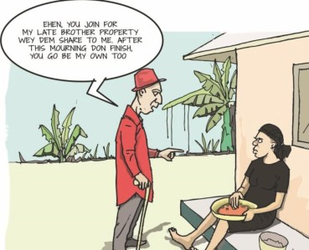S E I A M A M I E M I E B A R A IYERIN BOU AMA
  - Kimi ni zini kimi leimo bei sei iyeri buomo kori iyerin ubo bi oloko gho korodo. Bisa kimi bi noina kurai akin a igoliwari gho kai timi ngimi enighakpo Naira

12

Ehen...Ari Kpo ine fidou binaewei iyemo gho keni . Duu ifie bi boodou aba ari kpo inei ko padou.

sonran odozo gbe ngimi enighakpo okobamo gbe mani igoliwari kpo gho mu
  - Kimi ni zini kimi serimo bei sei iyerin buomo mie kimi bi olokogho korodo. Bisa kimi bi ma kurai akin a igoliwari gho kai timi ngimi enighakpo Naira tara odozo gbe ngimi enighakpo okobamo gbe mani igoliwari kpo gho mu
  - Kimi ni bei sei iyerin buo mo kori mie ubo bi sowei, kuromo sowei enighakpo terimo kimi bi oloko gho korodo. Bisa ubo bi ma kurai aki na igoliwari gho kai timi ngimi enighakpo Naira ma ozozo gbe ngimi enighakpo okobamo gbe mani igoliwari kpo gho mu.

SEI IYE AKI NA KIMI AGBAMO
  - Kurei kimi ba, kimi mie Inoun suo enighakpo k u r e i k i m i uyamo ngi iye akin a zini kimi

dosimo kimi bi oloko gho korodo. Bisa kimi bi mapabogha igoliwari gho kai timi ngimi okoba kpogha ngimi.
  - Sei diri beni enighakpo kurei kimi ba enighakpo kimi uyamo ngi iye aki na zini kimi dosimo dou ubo bi oloko gho korodo. Bisa ubo bi

Ari ebikami ki ari mo ororo yemi, ari ine koro bi seimo ngimi ﬁdi-ﬁdi.

kurai gho ma oi sonron fini kuraimo aki na igoliwari gho kai timi ngimi okoba kpo gbeghafa ngimi.
  - Kimi ni zini kimi kuromo, serimo enighakpo baratua ubo piri bei sei kimi ba ngi iyemo akin a zini ubo agbamo ubo bi oloko gho korodo. Bisa kimi bi kurai gho ma oi sonron fini aki na igoliwari gho kai timi ngimi okoba kpo gbe gbeghafa ngimi.

KIMI MIE BUNUMO DIRI PIRI

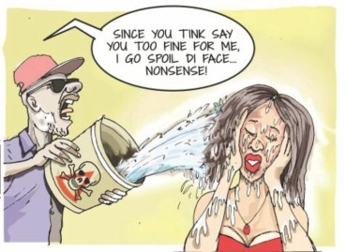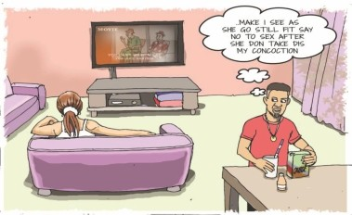Kurotoru akin a kimi bunu do enighakpo sei iye aki na kimi mie dou bemeine kimi bunumo diri aki zini kimi piri ubo bi oloko korodo. Bisa ubo bi oi a kurai aki na igoliwari gho kai timi ngimi enighkpo
13
Bei diri bi arau mo bou daba arau i pini bunugha afa bara ari mo eri ngimi.

Naira gho sonran odozo gbe ngimi enighakpo okobamo gbe mani igoliwari kpo gho mu Bei

POLITICS IGBURUKU GBEIN
  - Kimi sele'ye bemeine zini kimi gho inountua kimi bi oloko gho korodo. Bisa ubo bi ma kurai aki na igoliwari gho kai timi ngimi enighakpo Naira sonran odozo gbe ngimi enighakpo okobamo gbe mani igoliwari kpo gho mu
  - Kimi ni kimi sele'ye bemeine zini kimi gho inoutua dou do kimi bi oloko gho korodo. Bisa kimi bi ma kurai aki na igoliwari gho kai timi ngimi enighakpo Naira gho ma odozo gbe enighakpo okobamo gbe mani igoliwari kpo gho mu
  - Kimi sele'ye bimeine zini kimi serimo, kuromo enighakpo baratua kimi pirida zini kimi gho inoun tua dab a ubo oloko gho korodo. Bisa kimi ma kurai akin a igoliwari gho kai timi ngimi enighakpo Naira gho tara odozo gbe ngimi enighakpo okobamo gbe mani igoliwari kpo gho mu
  - Kimi sele'ye bimeine zini kimi gho inountuado kimi sowei, terimo, enighakpo koko ubo bi oloko gho okorodo. Bisa ubo bi ma kurai akin a igoliwari gho kai timi ngimi enighakpo Naira gho ma odozo gbe ngimi enighakpo okobamo gbe mani igoliwari kpo gho mu

GOMETI FIRIWENI OTU IGBURUKU GBEIN
  - Gometi firiweni kimi inou aki na zini kimi gho tua kimi sele'ye bimeine ubo bi oloko gho korodo. Bisa kimi bi noina kurai aki na igoliwarn gho kai timi ngimi enighakpo Naira gho keni ogizi gbe ngimi enighakpo okobam gb mani igoliwari kpo gho mu
  - Gometi firiweni kimi ni inoun aki zini kimi gho tua dou kimi sele'ye bimeine ubo oloko gho korodo. Bisa kimi bi tara kurai akin a igoliwari gho kai timi ngimi enighakpo Naira gho Sonoma ozozo gbe ngimi enighakpo okobamo gbe mani igoliwari kpo gho mu
  - Gometi firi-weni kimi ni kimi sele'ye bimeine zini kimi bari, kuromo enighakpo baratua piri da zini kimi gho inoun tua dab a, bisa kimi bi oloko gho korodo. Bisa kimi bi ma kurai aki ma

14

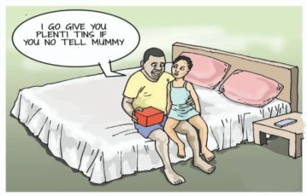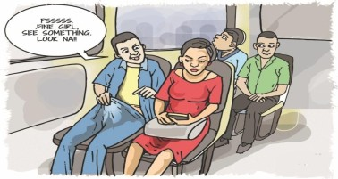igoliwari gho kai timi ngimi enighakpo Naira gho sonran odozo gbe ngimi enighakpo okobamo gbe mani igoliwari kpo gho mu
  - Gometi firiweni kimi ni kimi sele'ye bimeine inoun aki na zini kimi gho tuado kimi terimo, sowei enighakpo koko kimi bi oloko gho korodo. Bisa kimi bi keni kurai aki na igoliwari gho kai timi ngimi enighakpo Naira gho tara odozo gbe ngimi enighakpo okobamo gbe mani igoliwari kpo gho mu
  - Gometi firiweni zini kimi gho inountua dab a gometi bi ki kori ngimi. Gometi bi bin okoba-ama gbe iye la ubo bi piri ngimi

- EMINI TOBO BUNU KIMI Kimi ni binaowei, binaarau, day, yingi, yabi, enighakpo fuo ubo mo bunu kimi bi oloko gho korodo. Bisa ubo bi oi a kurai aki na igoliwari gho kai timi ngimi. Okoba gbegha bara gho.

EGBEIGHA BARA ONGO FINI
Egbeigha bara aki na emene ongo ﬁni

Ari oroba am ni i piri ngimi, i gbo n i yengi pirigha fa ngimi aba.

zini kimi dia da ubo disemo da ubo gbele ngi bimeine bisa kimi bi EGBEIGHA BARA ONGO FINI
oloko gho korodo. Bisa kimi bi keni kurai akin a igoliwari gho kai timi ngimi enighakpo Naira gho sonran
Psssss. Ebi ere
abau iye diee.

odozo gbe ngimi, enighakpo okobamo gbe mani igoliwari kpo gho mu/

MAMU KARAMO PARAI BI – OLOKOGBAWARI KURO BI
- Epere esisimo enighakpo akpakpamo yemi ubo se kurei ugula aki na esisimo yemi ubobi tin ngimi ugulagbawari bo gho,eni serii ugulagbawari ni ibe tibia ma bi ni Abuja bo emi ye bi, eniki ugulagbawari bi ubo kimo ngimi

KIMO KURO OLOKO
Ugula gho zini kimi esisimo enighakpo akpakpamo yemi kimi bi tinyemi ubo bi kurei kimo kuro kpo bingimi Bei iyemo gho suo tuu-
15

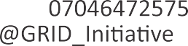nimi wonimi kimi kurei baratua epiri esisimo yemi ubo bi piri ngimi, alagba kimi enighakpo, kimo kimi enighakpo, tolumo-kimi, enighakpo ekiyo-piri kimi enighakpo baratua iye budoun kimiama piri yemi firi weni kimi ebe kpo. Epiri esisimo yemi ubo bi kalatobou aba dubadei kimi kurei tie piri ngimi, bisa baratua piri yemi kimi bi kurei ugulagbawari bo gho kimo kuro bi na kalatobou bi piri ngimi, kalatobou doumo yengimo fagha daba.
fagha daba.
Alagbakimi bi eri ne paa iye bi aki fun gho gee ngi kimi bi baratua opiri uyamo yemi ubo bi piri ngimi, ubo koko mani ubo aki na dounzuowari gho mu, botei bi, ubo gbali mu ubo wari la. Botei bi alagba kimi bi kuro nana weri igburuku gbein ubo bi kori ngimi.
Bei kimo oloko bi beinmogha kimi se oloko gho korodo. Ubo sondia akalu aki na igoliwari gho kai timi ngimi enighakpo Naira gho tara odozo gbe ngimi enighakpo okobamo gbe mani igoliwari kpo gho mu.

KORIMOYEMI ITU BI
Bei VAPP oloko bi kuro aki na kimi furu tei zini ibe gho mukumo e oloko kekere yemi itu bi (NAPTIP) pirido. Omini bei oloko bi seimo kimimose aki na ugula gho mu kuro bi nanado.

MO-KPO I SUOTUNIMIDOU YERMI ABA BEI IYOMO DOU MU

16

Bei fun bi Grassroots Initiative for Gender and Development (GRID) bara ki duo bo mi Interagency PSEA Outreach and Communication Fund ebe ogbo bi ki baratua ni o piri mi.

Grassroots Initiative for Gender and Development

