Funded by: Implemented by:
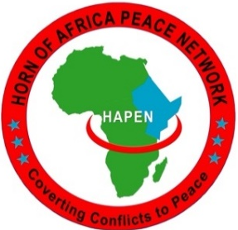
Interagency PSEA
Community Outreach and
Communication Fund

Project:
Interagency Community Outreach and Communications Fund on
Protection from Sexual Exploitation and Abuse (PSEA)

Location:
Kismayo, Jubaland State

Duration: 1st September – 31 December 2021

