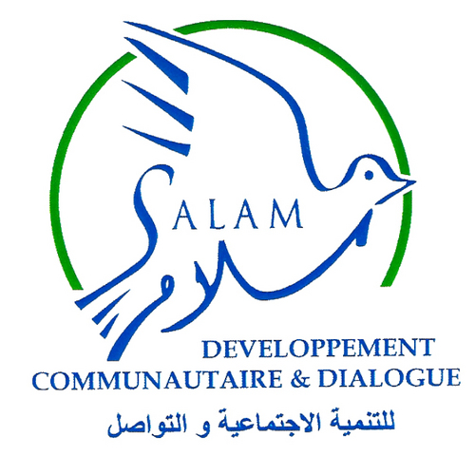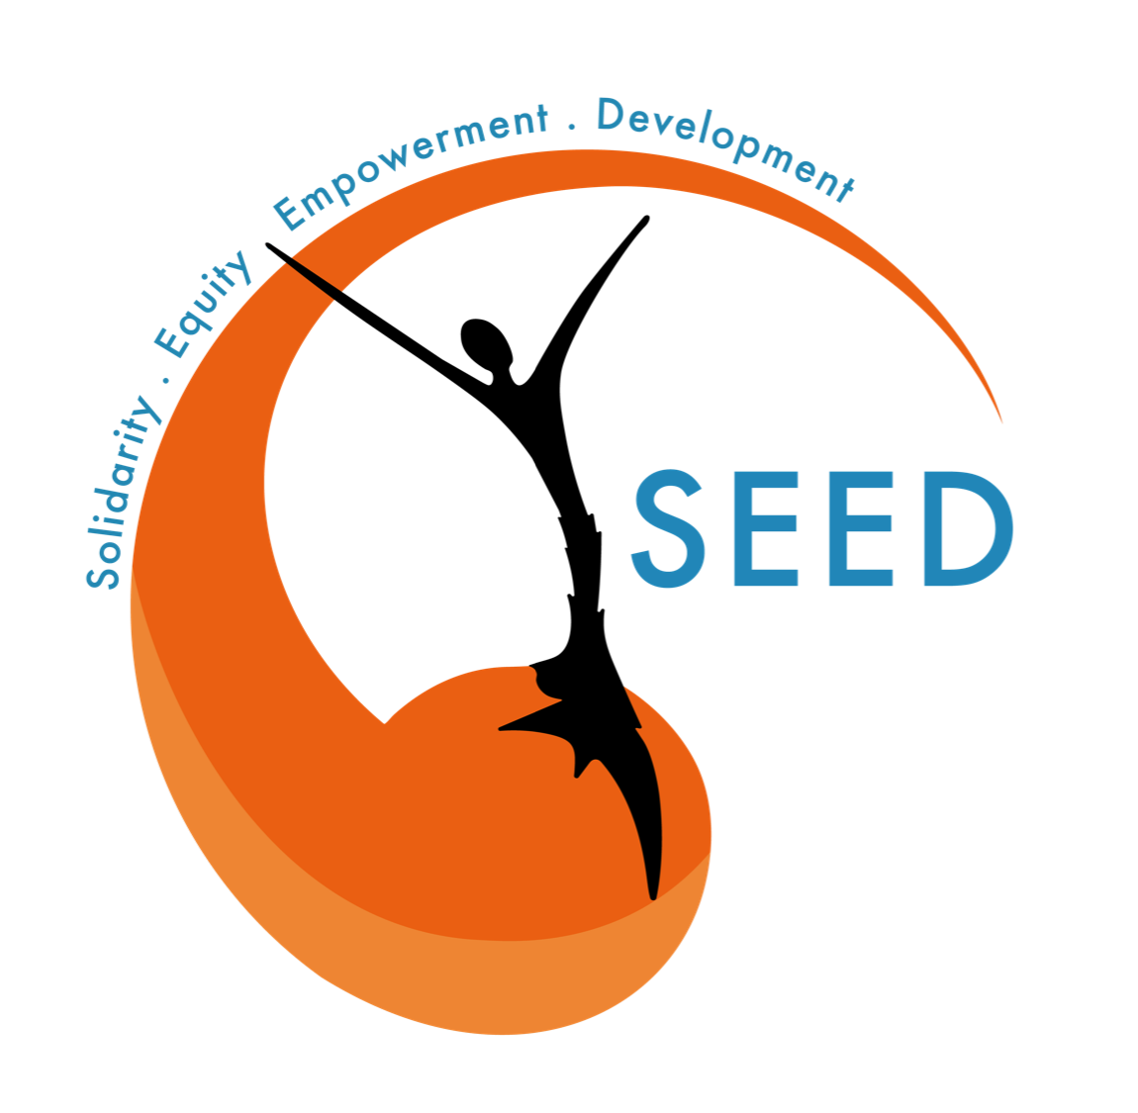

|  |  |  |  |  |  |
| --- | --- | --- | --- | --- | --- |
| **AWARENESS SESSION FOR MEN** | | | | **120 MIN** | |
| GOALS | Raise awareness and empower men in the reduction of the whole community’s exposure to Sexual Exploitation and Abuse risk. | | | | |
| GLOBAL RESULTS | Participate in integrating men, the “missing component” in SEA risk reduction;  Establish a more equal power ratio between local communities and the aid systems by giving relevant information and tools to local communities . | | | | |
| MATERIALS | * flip chart and markers (different colors); * Personal Protective Equipment (masks, gel...) if needed; | | | | |
| HUMAN RESOURCES | * 1 man / 1 woman only; * at least 1 staff person for 5 participants; * a maximum of 15 participants (3 staff members); * an additional person in case of a referral. | | | | |
| PLACE | See “Do no harm policy” (PSEA - HOW TO ACT IN CBA ACTIVITIES) | | | | |
| NOTA BENE | * All session times are indicative. Of course it is possible to take more time for each awareness session step, depending on the time devoted to activity organization. It is also possible to divide the awareness training into several sessions in order to take more time to deliver messages and to interact with participants : | | | | |

|  |  |  |  |  |  |
| --- | --- | --- | --- | --- | --- |
| **INTRODUCTION TO AWARENESS SESSION** | | | | **10 MIN** | |
| GOALS | Introduce the work that will be done during the awareness session and the way it will be conducted. | | | | |
| INFORMATION | * People in charge of the awareness session present themselves and ask participants to present themselves ; * They thank participants for their participation to the session and for the time they dedicate to the activity; * The focus group subject is introduced : the awareness session is a step of the project called “Enter the Fight”, which aims to raise awareness and train local communities to SEA risk committed by humanitarian aid workers for whom they work. Focus groups will be organized with women, men, and family. One session is designed for men focus groups. This focus groups, which will be run through a community based approach, aim to integrate men in a way to reduce the whole community’s exposure to SEA. Indeed, we think men have a real role to play in community’s risk reduction. We think also that local communities have a really precious knowledge from usage and could know better than external people ways to protect themselves and reduce their exposure. The goal of the focus group work is to empower the awareness session with local communities knowledge, to give data and information as relevant as possible. * Trainers explain that they are conscious of the sensitive aspect of the subject, that is why they inform participants that they are not obliged to talk if they do not feel comfortable. They remind participants that any information given during the focus group will be strictly confidential, and the idea is to discuss this subject as a group. Participants are not obliged to speak about personal experiences, the idea is to talk in a general way. Safe and calm places are open to participants in order to talk about personal experiences if they needed it ; * If you want to take photos during the session ask participants if they consent beforehand. * Explain you have a place next to the training room for private discussions if any participant would like to talk one-on-one during the focus group session. If you are uncomfortable with any ideas, concepts or information, feel free to speak up ; * At the beginning of every activity, explain to the whole group of participants the objectives and goals of the session, and the results you are looking for ; * Tell the participants that if they have any questions or comments before the session starts, they are welcome to share them ; * If any questions/comments before the beginning of the session, please do not hesitate. | | | | |

|  |  |  |  |  |
| --- | --- | --- | --- | --- |
| **ACTIVITY N°1** | **UNDERSTAND THE RISK (PREVENTION)** | | **20 MN** | |
| SPECIFIC OBJECTIVES | Empower participants by giving them definitions and helping them to understand SEA. | | | |
| SPECIFIC RESULTS | Participants get the right information and key messages about SEA risks and are empowered on this notion. | | | |
| MATERIAL NEEDED | * flip chart and markers (different colors); * Personal Protective Equipment (masks, gel...) if needed; | | | |
| **CONDUCTING THE SESSION** | | | | |
| Explain to the participants that the aim of the session is support them to get the right information about SEA risks. Sessions have been done with women, as a vulnerable group, about the same subject, in order to empower them. Try to involve every participant in the discussion, and specify that if anything is not clear, participants are invited to ask the trainer to clarify the concepts and definitions.  **WHAT IS SEXUAL EXPLOITATION AND ABUSES (SEA)?**  *Sexual Exploitation and Abuse (SEA) relates to the behavior of NGO staff towards local communities, implying acts of sexual exploitation and abuses. It represents a fundamental failure of protection. It brings harm to those whom NGO staff are mandated to protect.*  **Explain to participants** that most of the time, men from the NGO’s staff are responsible for the SEA cases. SEA cases are more numerous during crisis time (economical/political/social/sanitarian crisis), when local communities needs’ increase, and thereby, humanitarian intervention increases too. | | | | |
| **WHAT IS THE DIFFERENCE BETWEEN SEA AND GBV (GENDER BASED VIOLENCE)?**   1. *Gender-Based Violence (GBV) also known as Sexual and Gender Based Violence (SGBV) refers to harmful acts directed at an individual based on their gender. It is rooted in gender inequality, the abuse of power and harmful norms. Gender-based violence can include sexual, physical, mental and economic harm inflicted in public or in private. It also includes threats of violence, coercion and manipulation.* 2. **Explain to the whole participant group** that SEA is part of Gender Based Violence, but perpetrated only by people belonging to the humanitarian system. The term “SEA” is an internal classification of NGO and humanitarian organizations, and therefore responding to particular standards and mechanisms that it is important to master in a way to decrease vulnerability to it. SEA, like any kind of Sexual and Gender Based Violence, are unacceptable and no human beings should be subjected to it. 3. **Ask participants** if the difference between SEA and GBV is clear and if someone needs a clarification on those concepts. 4. **Remind the whole group** that this awareness session will be focusing on SEA risk. 5. Do they have suggestions, comments, remarks, questions, ...? | | | | |
| **WHAT IS PSEA (PROTECTION FROM SEXUAL EXPLOITATION AND ABUSE)?**   1. *Protection from Sexual Exploitation and Abuse refers to standard operating procedures which are in place for submission and receipt of complaints, reporting, investigation and victim assistance.* 2. **Explain to the whole participant group** that PSEA are specific procedures, complaints and assistance mechanisms that victims could have access in case of SEA. That is why it is important to know these procedures. 3. **Ask participants** if all the definitions are clear and take time to clarify if someone needs it. Do they have suggestions, comments, remarks, questions, ...? | | | | |
| **WHAT DOES “CONSENT “MEAN?**   1. **Explain to participants** that consent refers to the state of agreeing with someone or something, which could be considered strictly as one of those two statements: “yes” and “no”. To be effective, consent has to be **free, prior and informed,** that is **given voluntarily and absent of coercion, intimidation or manipulation**, sufficiently in advance of any authorization or commencement of activities, and with awareness considering every element which could affect the situation; 2. **Explain**: therefore, it is really complicated to be sure consent is complete and responds to those three pillars, even more when an individual is unknown or barely known: **a “no” has to be understood as such, but a “yes” has always to be questioned regarding context.** 3. **Ask participants** if the definition is clear, and take time to clarify if someone needs it. Do they have suggestions, comments, remarks, questions, ...? | | | | |
|  | | | | |
| **Involve participants** in the identification of the most vulnerable people to SEA in the whole community, following several steps.  **WHO ARE THE MOST VULNERABLE TO SEA?**   1. **Women and girls**  * Insist on the fact that the first consideration is gender; * Explain that regarding SEA and GBV, mainly women and girls are concerned, and some of them are more even vulnerable because of their living conditions or social situation; * Specify that international studies highlight that there is disproportionate violence against women and girls (99% female survivors); * Remind everyone that, although women are a vulnerable group, they still have a role to play in community protection regarding SEA risks: everyone could trust their protective role in the community, and more precisely for the most vulnerable.  1. **Children /elderly people**  * Explain that the second consideration is age. Mainly children but also eldery people;  1. **Disabled people**  * Explain that the third consideration is “full and entire physical and mental capacity”: Persons with physical and/or mental disabilities are generally more vulnerable to SEA because they are considered more **dependent on aid**. It is more complicated to be sure that consent is free, prior and informed for persons with mental/physical mentalities because of a lack of full and entire capacities.   Introduce the idea that **men are not part of the vulnerable group** of the community, that is why men have a role to play in the protection of vulnerable groups. Men can share the protective role of the vulnerable groups with women.  **Ask participants** if they agree about this? Do they have any comments, remarks, …? | | | | |
|  | | | | |
| Involve participants in the identification of abusers/perpetrators.  **WHO ARE THE ABUSERS/PERPETRATORS OF SEA?**  **Clarify the definition** of the term “perpetrator”: a *person who carries out a violent or harmful act, who is in a position of real or perceived power, decision-making and/or authority and can thus exert control over their victims; When it comes to SEA, perpetrator is understood as any person belonging to humanitarian system and perpertrating sexual violence on any member of the local community receiving the aid.* | | | | |
| **HOW ARE PEOPLE BEING ABUSED?**  **Explain to the whole group** that abuse concerns sexual violence, and refers to behaviour intended to harm someone in any way;  **Specify that** violence could involve physical force, but could also be verbal, psychological, economical, social. Violence could be done through physical ways (in the other person’s presence), or dematerialized ways (sending messages ...). It can refer to harrassment, assault, abuse, exploitation, sexual slavery, etc. | | | | |
|  | | | | |
| **KEY MESSAGES**  When all the concepts and definitions are clear for participants, **provide them with the following key messages:**   * **Human rights are rights inherent to all human beings**, regardless of race, sex, nationality, ethnicity, language, religion, or any other status. Human rights include the right to life, liberty, independance, physical and mental integrity and many more, including the right to dispose of one's own body (cf. UN). **SEA is a violation of human rights;** * Any person living on Lebanese soil, even as a refugee (refugee status), is subject to Lebanese laws which condemn sexual harassment. **Perpetrators are punished by Lebanese law**: the sentence ranges between at least one month and one year and/or fine between three and 10 times the minimum wage (80$/month) to two and four years in prison and a fine of between 30 and 50 times the minimum wage for perpetrators who have “material or moral” power over the victim (harshest penalty); * **Consent:** a “no” has to be understood as such, but a “yes” has always to be questioned regarding context. People will never be responsible for a consent taken from them even if they did not express any kind of physical or verbal opposition ; * **Aid workers are here to help and protect**, they have no right to exchange the aid they are providing, it is simply illegal regarding law and regarding organization internal SOP. People have the right to assistance, no one can take this away from them. No aid worker can ask for any favour of any kind from a beneficiary ; * **Sexual Exploitation and abuses** (SEA) as well as any other type of gender based is are inacceptable. People and communities should **refuse and report** any sign or type of assault, violence or harassment even if it seems “not that bad”: every deviant behaviour should be **reported and punished**, including insults, physical violence and inappropriate behaviour. Harassment may begin with a bad word or a wrong gesture, and no one should be subjected to it ; * **Vulnerability is not responsibility.** If someone experiences any kind of sexual violence or abuses, it is never that person’s fault; it is the fault of the person who commits this act. **Perpetrators are the only ones responsible** for these acts; * **Any sexual activity** with anyone under the age of 18 is prohibited, regardless of consent; * **Victim has the right to be informed** about services and assistance being provided in their living area, to complain and to report any inappropriate behavior, sexual exploitation or abuse by any humanitarian or development worker, regardless of who they work for; * **Victim has the right to access protection, and medical, psychosocial and other support;** * **Men have a role to play in supporting vulnerable people in the community**: as legal guardians for children (under 18 years), as pillars of their family, as women are also, and as specific supporters of woman experts in safeguarding, and as supporters of women who are more vulnerable than men to SEA risks; * **These rules apply to all these stakeholders:** the UN, national and international NGO staff, partners, consultants, community volunteers and contractors. | | | | |

|  |  |  |  |  |
| --- | --- | --- | --- | --- |
| **ACTIVITY N°2** | **MITIGATION** | | **30MN** | |
| SPECIFIC OBJECTIVES | Empower participants by giving relevant information to local communities concerning possibilities of mitigating SEA risks for the whole community. | | | |
| SPECIFIC RESULTS | Participants get information concerning mitigating SEA risks. | | | |
| MATERIAL NEEDED | * flip chart and markers (different colors); * Personal Protective Equipment (masks, gel...) if needed; | | | |
| **CONDUCTING THE SESSION** | | | | |
| **WHERE AND WHEN SEA OCCUR?**  **Ask participants** if they have ideas where and when vulnerable people are more exposed to SEA risks? Do they know why? Collect their propositions written down on the paperboard. Synthesize their propositions and justifications.  **Add the following points** if needed regarding the participant propositions:   1. WHERE  * **Explain to the whole group participants** that SEA are linked to aid sectors:  *protection, shelter, wash, food security,education, livelihood and social cohesion, basic needs, access to energy, health,* and to the nature of specific aid activities (*referral / distribution / assessment / case management / consultation / focus group / emergency intervention / training and awareness session / food for work / cash for work / cash distribution / PSS session / class / intervention*) ; * In these activities, not only humanitarian aid workers are implied regarding SEA: people employed by NGOs (example: taxi drivers, shopkeepers, …) are also considered as participating in the humanitarian system, and that is why they are also identified as potential perpetrators ; * SEA can occur at home (tent/building), in the settlement, and outside the settlement (roads, other neighbourhoods, etc.) ; * The most risky situation regarding SEA is being alone in a close space with a humanitarian aid worker (man especially), especially if the situation implies material or monetary exchanges.  1. WHEN  * **Explain to all participants** that time is an issue when it comes to SEA ; * In winter, needs are higher (example: food distribution, fuel, etc.) so humanitarian aid is more intense, exposing people to SEA. Also, social/economical/political/sanitarian crise (example: Covid-19) or emergencies (Beirut blast) are increasing the local community exposition to SEA, because of an increase in humanitarian intervention ; * There is also some moments in the day or the year where SEA risk rises : at night or during the winter season where there is less light and more indoor activities; | | | | |
| **WHAT CAN LOCAL COMMUNITIES ASK NGOs FOR IN ORDER TO MITIGATE SEA RISK?**   1. **Introduce the fact that**, because SEA concerns NGOs’ work and interventions, it is possible to ask NGOs to adapt their intervention and activities to the will of the local community. Trust is not a given; it has to be earned. Men have a role to play in supporting all members of the community and a responsibility in reinstating the power ratio between local communities and NGOs. 2. **Make the following points:**  * Any time a new NGO comes, local communities should **ask for the PSEA channel report information**, also to have training about it. This is a way to ensure that people get reliable information, but also to show that the community is empowered and people know about their rights and PSEA procedures. Normally every local organization and NGO intervening in the humanitarian system, helping local communities has to ensure that a safe, confidential, transparent, and accessible complaints system is established so that all potential complainants know where and how to submit a complaint ; * **Ask to have a PSEA focal point** that comes in person for people to know him/her; * **Ask for mixed staff gender** when it comes to work inside the tent, or case management. Ask for woman workers when it is case management related to gender (PSEA, GBV, sexual discussions and issues, …); * **Ask to reduce the NGO staff intervention frequency**  inside apartments or tents and ask for one full intervention; | | | | |
| **WHAT CAN LOCAL COMMUNITY MEMBERS DO IN ORDER TO REDUCE THEIR EXPOSURE TO SEA RISK?**   1. **Take time to explain to participants** that it is really important to be conscious that local communities, by themselves, can mitigate SEA risks. Men have a role to play in the mitigation of these risks to protect and ensure lower risk for vulnerable groups. 2. **Make the following points:**  * It is recommended that people in vulnerable groups (women, children, etc.) **do not go out alone by night** and be always accompanied. **Men could accompany someone to go outside** or could **propose to in someone’s place if possible;** * **Ensure that nobody is staying alon**e when NGO staff is intervening in your place. Thus, you avoid aggravating SEA risks for other persons; * Report any behaviour that seems inappropriate for other persons (example - a humanitarian aid worker’s hand on the shoulder of a women/girl, etc.); * **Organize an alternative**  if you feel that the NGO proposition could be unsafe for you (example - drive a member of your family or friends to a distribution point, avoiding to obliged him/her to take alone a taxi); * **Be confident in women and girls as experts in contextual safeguarding** and actively engage vulnerable groups and people in their own safety and protection mechanisms; * **Engage SEA-risk discussions within the local community**, and also in your family, in order to transmit information and knowledge about situations that could further expose vulnerable people to SEA risks. Be in a “listening posture” at home, in order to detect some abnormal situations that can affect members of your family. | | | | |

|  |  |  |  |  |
| --- | --- | --- | --- | --- |
| **ACTIVITY N°3** | **PREPAREDNESS** | | **15MN** | |
| SPECIFIC OBJECTIVES | Empower participants by giving them relevant information and proposals in order to prepare them for SEA risks. | | | |
| SPECIFIC RESULTS | Participants get tools and information to prepare themselves to SEA risks. | | | |
| MATERIAL NEEDED | * flip chart and markers (different colors); * Personal Protective Equipment (masks, gel...) if needed; | | | |
| **CONDUCTING THE SESSION** | | | | |
| **Explain to the whole group** that the main part of preparedness is about understanding. In fact, to know the different steps of risk reduction, and SEA matters, as humanitarian aid system matters is a way to be prepared.  **Explain to the whole group** that transmitting information that participants know about SEA and risk reduction are essential to prepare community or family members for SEA matters. It could avoid some reactions and behaviour, and raise awareness within the local community, even it could be difficult to talk about it and that awareness sessions are provided. Raise awareness is a way to protect vulnerable groups, in a long-term way. | | | | |

|  |  |  |  |  |
| --- | --- | --- | --- | --- |
| **ACTIVITY N°4** | **DISASTER** | | **20MN** | |
| SPECIFIC OBJECTIVES | Empower participants by giving them relevant information and key messages concerning SEA acts. | | | |
| SPECIFIC RESULTS | Participants get information concerning SEA acts. | | | |
| MATERIAL NEEDED | * flip chart and markers (different colors); * Personal Protective Equipment (masks, gel...) if needed; | | | |
| **CONDUCTING THE SESSION** | | | | |
| **Involve people** to bring up the topic of sexual and exploitation abuse when it occurs to a member of the community.  **WHICH ACTS REFER TO SEA?**  *Nota Bene : This subject could be very uncomfortable to talk about:* ***warn participants*** *about the sensitive content in this part.*   1. Give the following list if the items didn’t pop up during the participation period:  * trading sex for foods and other non monetary items or services * forced sex / rape * verbal sexual abuse / use of indecent word * prostitution: you pay for sexual activity * forced pornography * sexual slavery * sexual assaults * people trafficking * harassment * cyber exploitation * physical abuse: touching ;  1. **Ask participants** if they have other cases in mind, and be sure that everyone is agree with this list. | | | | |
| **CASE STUDIES**   1. **Present to** the whole group participants these situations. For each, ask what participants think about it and ask them “who is responsible in this case”? **Discuss with participants about it :**  * Humanitarian staff proposes to a young girl (less than 18 years) to come with him alone in a tent during a food distribution and the young girl accepts: the humanitarian staff is responsible for the physical/sexual abuse ofthe young girl (remind participants about the “consent concept”); * Humanitarian staff proposes to give an additional food box to a women, mother of 3 kids, in exchange for sex, and she accepts : humanitarian staff is responsible for the sexual abuse on the woman; * Humanitarian staff proposes to a woman to give him her phone number, and the woman accepts. After, the humanitarian staff send messages to the woman, including pictures and sex messages : humanitarian staff is responsible for the sexual harassment.  1. **Explain why** in each of these cases, humanitarian staff is always the one responsible for abusing women/girls,... 2. **Ask the whole group** if they have any questions, remarks, comments... | | | | |
| **KEY MESSAGES**   * **Victims always have the choice of reporting SEA or not**. No one can force the victim to report this experience to anyone or any structure even if you are a witness to the situation or if the victim told you the situation. Even if survivors are aware about what to do, it is still difficult to refer when you have to. You can only remind the victim about what you know concerning referral and ways to respond (content of the next part of this session) ; * **Vulnerability does not mean responsibility**: remember that the only person responsible for this act is the abuser/perpetrator; | | | | |

|  |  |  |  |  |
| --- | --- | --- | --- | --- |
| **ACTIVITY N°5** | **RESPONSE** | | **25MN** | |
| SPECIFIC OBJECTIVES | Empower participants by giving them information that matches the local situation, relevant regarding the local context, and which bring practical solutions for victims, witnesses, and communities. | | | |
| SPECIFIC RESULTS | Participants get relevant information regarding the context where they live and relevant tools to react after SEA. | | | |
| MATERIAL NEEDED | * flip chart and markers (different colors); * Personal Protective Equipment (masks, gel...) if needed; | | | |
| **CONDUCTING THE SESSION** | | | | |
| *Remind everyone that knowing this information is a way to reinforce capacities and knowledge on the humanitarian system, as well allow victims and witnesses to identify the right pathways to make a referral. Knowing the following information is a way to support vulnerable groups in their response to the disaster: their own children, their wife, etc.*  **WHAT IS A REFERRAL?**   * **Explain to the whole participant group** that normally every local organization and NGO intervening in the humanitarian system, helping local communities, has to ensure that a safe, confidential, transparent, and accessible complaints system is established so that all potential complainants know where and how to submit a complaint. The following complaint-handling process is established to receive allegations, assess and refer for immediate assistance, separate SEA from non-SEA allegations, refer all complaints for further action including investigation, and offer follow-up; * **Remind participants** that normally, all reporting will be treated safely and confidentially. Reporting will not prevent you from getting assistance or services. All reports of misconduct, including sexual exploitation and abuse, are taken extremely seriously and will be independently investigated. If proven, severe sanctions could be taken against perpetrators. The safety, protection and wishes of the victim of sexual exploitation and abuse is central to any investigation process. During the referral you have the right to keep your identity secret and it is only with your consent that the NGO will proceed to case management. As a witness, you have the right to be protected by the NGO; * **Explain to participants** that referrals have to enable victims to receive social, economical, sanitary, legal, psychological aid; On the contrary, referrals cannot ensure punishment of the perpetrator, but it still remains the way to get the perpetrator sanctioned. | | | | |
| **HOW DO REFERRALS WORK?**  **Explain each step of a referral mechanism:**   * + SEA complaints will come to the PSEA Focal Points via multiple entry points: protection focal points, CP Focal points, GBV focal points, info-Hubs, feedback and information centres, help desks, hotlines, and other complaint and feedback mechanisms;   + The PSEA Focal Points will analyse the case and send the complaint to the respective investigative unit for follow-up and will ensure that the victim is provided with immediate referral to the relevant services liaising with the GBV Focal Point;   + The PSEA Focal Point will also share information related to the case with the PSEA Network Coordinator. In the event the PSEA Focal Point is unknown, or it is not possible to trace the concerned agency, the complaints must be reported to the PSEA Network Coordinator while ensuring timely and adequate referral for immediate assistance to the survivor. The PSEA Network Coordinator will gather the relevant information to understand the nature of the complaint and the concerned agency and will then direct the complaint to the relevant PSEA Focal Point; * During the intake process with in-person complainants, the person receiving the complaint shall respect the wishes, choices, rights, and dignity of the complainant when reporting on their behalf; * It is not the responsibility of the staff member to determine whether or not a complaint is true or has sufficient information for investigation. It is his/her responsibility to gather the relevant information from the complainant and ensure that the allegation is sent to the PSEA Focal Point or PSEA Network Coordinator for referral to the appropriate unit in the concerned agency via the NGO process. | | | | |
| **WHERE SHOULD VICTIMS REFER IN CASE OF SEA?**   1. **Emphasize this situation**: if your life or the life of someone else is directly threatened :  * Ask for immediate help around you if you can (people in the flat, on the street, neighbours). Some specialists think it is better to scream “Fire” rather than “help” to be sure people come out. * Immediately call emergency services if you can : **Red Cross (140), Fire department (125), Lebanse Civil Defense (175) or Police department** (...);  1. **Emphasize this situation**: if you have been victim of SEA or you have witnessed any kind of SEA you can:  * Make a direct referral (face to face) to the PSEA focal point of the organization if you know her/him; * Make a direct referral (face to face) to another PSEA focal point if you know one - in priority a PSEA focal point from a national protection organization, such as Abaad or Kafa, or Himaya when it comes to child protection; * Make a direct referral (face to face) to any an aid worker you trust; * Call a hotline**:** PSEA National Network (give the number) - NGO PSEA network (Abaad safe line +961 81 78 81 78 / for complaints +961 81 696575 - PSEA national network number to add - Kafa helpline : 03 018 019). **Specify that** normally all hotlines are free. * **Call 1745** which is a specific hotline for survivors directly linked to the police station. **This line is not free!** | | | | |
| **HOW DO HOTLINES WORK?**   1. **Present the following steps** to the whole participant group:  * The operator introduces himself and explains that he/she will have the obligation to report the case to the Network and a senior manager, but without sharing personal information. In any case, the person should not have to give any personal information if he/she doesn't want to; * The operator gives several options depending on the case: to receive support from an aid worker, Clinical Rape Management if the sexual harassment occured 72 hours ago, or other services ; * Reach the organization and talk about the case and check with the focal point if there is a channel. The organization that the perpetrator comes from should handle the case, they are in debt to the survivor.   ***Issue:*** *The hotline could be busy. There are various reasons: plenty of calls, time dedicated by humanitarian staff to people calling, people calling for other complaints than SEA situations,... But, it is really important to persevere and to wait to have someone responding to the call.* ***#!#*** *Helpline is always busy, and even more than usual during lockdown periods.*   1. **Key messages:**  * It is important to raise awareness of the importance of staying on line, calling back or reaching a frontliner directly in the field, to keep waiting until someone replies; * Know the different emergency numbers in order to be able to give them to a victim if needed; * Know the different referral-mechanism steps to be able to counsel people or to understand the process a victim that talks to you is initiundertaking; | | | | |
| **WHY IS SEA UNDER-REPORTED?**  **Propose the following list to participants:**   * lack of legal services * lack of faith in the response because of precedents: a woman can decide to not report because she knows another woman who tried to embark on a process but she never got a response or support from NGOs. * feeling powerless to report; * lack of material or cognitive means to report: reporting requires knowing the different steps of the process and being able to discuss and explain what happened, which isn’t easy for some people (disabled people or not). SEA trauma could also decrease victims’ cognitive capacities; * acceptance of, or resignation to abuse: women and girls could be victims because they have been abused before (trainers do not need to specify that it could be in the domestic context) or because they were witnesses of SEA several time and don’t consider SEA as unacceptable; * lack of knowledge of the existence of the report mechanisms; * not knowing how to report: a blurred channel could encourage survivors to remain silent because they are not sure to be protected by the humanitarian system; * negative economic impact * losing aid: without knowledge oofn the referral mechanism, women can imagine that reporting might impact the aid she and her family are used to receiving. * Stigmatisation . | | | | |
| **HOW DOES CASE MANAGEMENT WORK?**  **Deliver the following points** to the whole participant group :   * Consent is necessary for referrals to case management to humanitarian. Without their consent, no aid can be provided; * Victims have to be informed by the focal point if they have to make referrals through other members of the organization; * As soon as victims provide their consent, the focal point must contact service providers by phone immediately. Additional information can later be provided by e-mail using the IA referral form. As an adult, and if victims are not conscious, if the victims are at risk of being hurt or hurting someone else, they will be referred in any case. Children have to be referred in any case to ensure their best interest; * Victims may not provide consent. Humanitarian staff have to respect their choice and provide victims with hotlines for communities explaining that victims can access help through these hotlines at any time. If victims are survivors of rape, sexual violence or physical violence, or if there is still an immediate risk to their safety, humanitarian staff should make sure victims realize the risks to their life and health. If victims were subjected to rape and are unwilling to be referred to case management partners but willing to seek medical assistance, humanitarian staff have to contact health facilities directly to organize an appointment for the victim; * In order to maintain confidentiality, victims’ interlocutors must destroy all information they gave to him or keep it in locked place; * Case management could lead to a proposal to move victim to another place, or to provide economic aid, or psychology or legal support; * In the case of legal support, the chances to go to the end of the legal process are slim. But, if victims care to do so, they have to have the opportunity, because a single success will create a jurisprudence, setting a precedent which will help other victims in their recovery process ; * The time for a case management process depends on the case: on the support victims will need and ask for, the time they will agree to take, the circumstances victims are facing. In general, three months are needed. Victims have the right to be followed for as long as they want, with no time limit. Going to the end of the legal process could take a long time; | | | | |
| **HEALTH INFORMATION**   1. **Explain that** any kind of physical abuses needs assistance, that is why victims have to go to medical structures; 2. **Explain that** any kind of psychological abuse linked to SEA also requires assistance. Victims could call the Abaad NGO safe line (+961 81 78 81 78). Staff of this NGO will refer the victim to safe places (“secret” places, people know about these places only by calling this safe line as a SEA victim). Safe places are managed by two GVB and SEA specialized NGO’s (Abaad and Intersos). 3. **Key message to deliver** to the whole participant group :  * Know the safeline number in order to be able to give it to victims who need it. | | | | |

|  |  |  |  |  |
| --- | --- | --- | --- | --- |
| **ACTIVITY N°6** | **RECOVERY** | | **10MN** | |
| SPECIFIC OBJECTIVES | Empower participants by giving them relevant information concerning possibilities for vulnerable groups/people to recover from SEA. | | | |
| SPECIFIC RESULTS | Participants get relevant information possibilities (actors to contact, possible support, etc.) for vulnerable groups/people to recover from SEA. | | | |
| MATERIAL NEEDED | * flip chart and markers (different colors); * Personal Protective Equipment (masks, gel...) if needed; | | | |
| **CONDUCTING THE SESSION** | | | | |
| **WHAT ARE THE POSSIBILITIES OF RECOVERING FROM SEA?**   1. **Present the two options:**     * Victims can decide to seek to recover on their own: recovery is a long process that could take several years ;    * Any kind of psychological abuse linked to SEA also requires assistance. Victims could call the **Abaad NGO safe line (+961 81 78 81 78)**. Staff of this NGO will refer the victim to safe places (“secret” places, people know about these places only by calling this safe line as a SEA victim). Safe places are managed by two GVB and SEA specialized NGO’s (Abaad and Intersos). 2. **Key messages**  * How to recover from SEA is the victim’s choice: victims could decide not to be supported by an NGO or community members if they do not want to/don’t feel comfortable about it. Nevertheless, it is important that you can listen to a victim if she chooses to let you know what happened and wants to speak with you about it. Is this case, you can be supportive, listening to their sufferings and support them in their gradual recovery; * Know the specialized NGOs’ numbers in order to give the victim the information in case she eventually decides to talk to a professional. | | | | |

|  |  |  |  |  |
| --- | --- | --- | --- | --- |
| **CONCLUSION** | | | **10MN** | |
| SPECIFIC OBJECTIVES | Conclude the session | | | |
| SPECIFIC RESULTS | Participants evaluate the awareness | | | |
| MATERIAL NEEDED | * flip chart and markers (different colors); * Personal Protective Equipment (masks, gel...) if needed; | | | |
| **CONDUCT OF THE SESSION** | | | | |
| 1. Trainer concludes the awareness session ; 2. Trainer asks participants for final questions and remarks; 3. Participants evaluate the training (cf. expectations of the training from the participants of the first-day training) ; 4. Distribute leaflets to participants. | | | | |