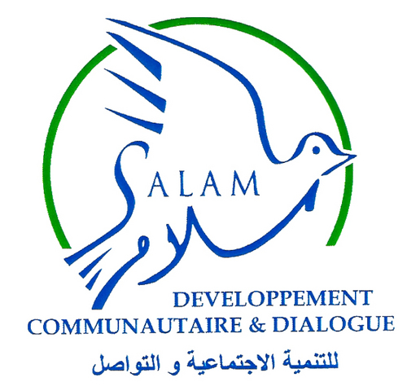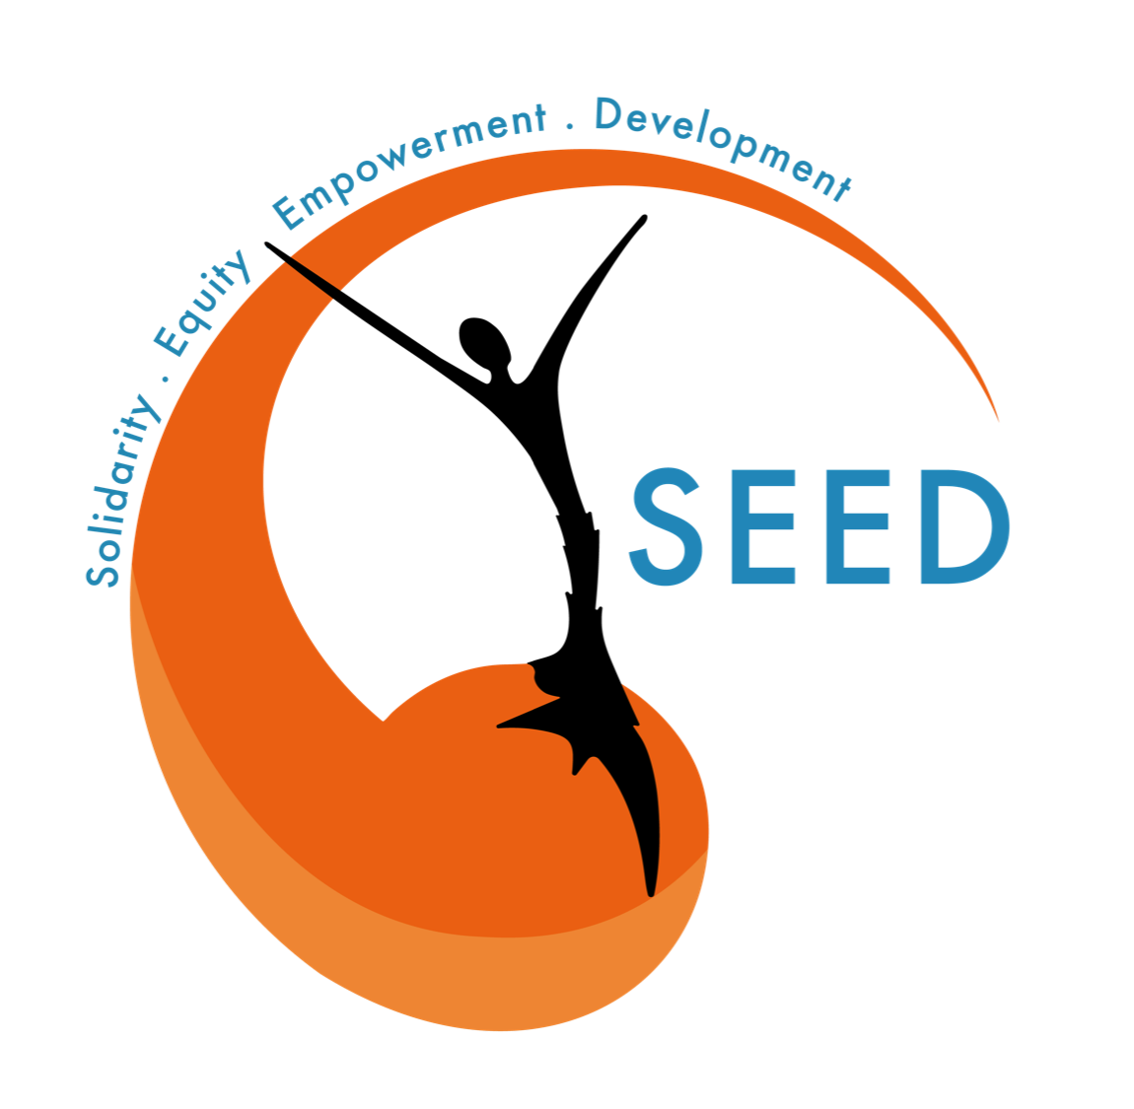
CONCEPT / WORD | DEFINITION | SOURCE (Origins)
Nota Bene : All concepts’ s definition have been worked by local partners to be as relevant as possible for awareness and focus group sessions
DISASTER CYCLE MANAGEMENT
RISK | Mix of the event probability and its negative consequences. Risk is a unit of measurement : more the probability is important (a male group of humanitarian aid workers distributing food boxes to a group of females out of a settlement ) and the consequences are bad and could affect an important part of population (sexual and abuse acts) more the risk is high. It is important to analyze the probability and consequences to know the level of risks. Hazards impact a situation and transform it into a disaster regarding the level of risks. Hazards will affect communities differently in terms of ability and resources with which to cope.
EXPOSURE | The situation of people, infrastructure, housing, production capacities and other tangible human assets located in hazard-prone areas.
PREPAREDNESS | Disaster preparedness refers to measures taken to prepare for and reduce the effects of disasters. That is, to predict and, where possible, prevent disasters, mitigate their impact on vulnerable populations, and respond to and effectively cope with their consequences.
RESPONSE | Aggregate of decisions and measures taken to contain or mitigate the effects of a disastrous event to prevent any further loss of life and/or property, and restore order in its immediate aftermath.
DISASTER | A serious disruption of the functioning of a community or a society at any scale due to hazardous events interacting with conditions of exposure, vulnerability and capacity, leading to one or more of the following: human, material, economic and environmental losses and impact.
MITIGATION | How to stop something from happening, or, when something happens, how to stop it having such a bad effect.  For example, during distributions, humanitarian aid workers are proposing food in exchange for sexual acts to women living in a settlement. To mitigate this, women ask the NGO in charge of the distribution that only female aid workers could do this distribution, in order to avoid sexual abuses. They did not get rid of the hazard : the distribution is still organized by aid workers. But they mitigated the way they worked with the hazard to avoid any harmful act and keep people (especially women) safe during these activities.
RECOVERY | Phase in the emergency management cycle that begins with stabilization of the disaster conditions (the end of the emergency response phase) and ends when the community has restored a normal situation that was disrupted by disaster impacts.The recovery time is often thought in a long-term way.
VULNERABILITY | Vulnerability is related to the risk exposure degree of a group, and the difficulty or lack of possibilities to answer the disaster and recover from the crisis. Certain groups in the community are more vulnerable than others.
SEXUAL EXPLOITATION AND ABUSE
Exploitation | The action or fact of treating someone unfairly in order to benefit from something. | UNHCR
Sexual Exploitation | Any actual or attempted abuse of a position of vulnerability, differential power, or trust, for sexual purposes, including, but not limited to, profiting monetarily, socially or politically from the sexual exploitation of another. It refers to all forms of inappropriate conduct of a sexual nature committed by perpetrators against other members of local communities. | UNFPA
Abuse(s) | Misuse of a position, a right or privilege. | Cambridge Dictionary
Sexual Exploitation and Abuses (SEA) | Sexual Exploitation and Abuse (SEA) relates to the behavior of NGO staff towards third party, referred to local communities, implying acts of sexual exploitation and abuses. It represents a fundamental failure of protection. It brings harm to those NGO staff are mandated to protect. | WHO
Protection to Sexual Exploitation and Abuses (PSEA) | Protection to Sexual Exploitation and Abuses refers to standard operating procedures which are in place for submission and receipt of complaints, reporting, investigation and victim assistance. | UNHCR  OCHA
Consent | The state of agreeing with someone or something, which could be considered strictly as one of those two statements : “yes” and “no”. To be effective, consent has to be free, prior and informed, that is given voluntarily and absent of coercion, intimidation or manipulation, sufficiently in advance of any authorization or commencement of activities, and with awareness considering every element which could enlighten the situation. | Cambridge Dictionary  RED CROSS
Assaults | An act of forcing an unconsenting person to engage in sexual activity. | Oxford British and World English Dictionary
Rape | Rape is the crime of forcing someone to have sex against her or his will, and it often involves the use of physical force or violence. | Oxford British and World English Dictionary
Perpetrators | A person who carries out a violent or harmful act, who is in a position of real or perceived power, decision-making and/or authority and can thus exert control over their victims. | OCHA
Violence | Behaviour intended to hurt, to harm someone. Violence could involve physical force, but could also be verbal. The one who has this behaviour could use physical ways (be in front of another person), or dematerialized ways (sending messages, etc.). | “NO ONE TO TURN TO” - SAVE THE CHILDREN
Victim / Survivors | A person harmed, injured as a result of a harmful act by something or someone (see “perpetrator”). “Victim” and “survivor” are two terms to define this person. The two terms could be used : the person who suffered sexual exploitation or sexual abuse is first a victim, and then is seen to progress from the status of “victim” to become a “survivor” as the rehabilitation process advances. Even if the person is defined or defines itself as a survivor, the person stays a “victim” regarding legal terms : as a victim, the person has rights (especially a right to be helped and to be protected).  The person harmed could choose the more appropriate term, and ask the organizations to use this term. | Oxford British and World English Dictionary  UNHCR
GENDER
Gender Based Violence (GBV) | Gender-Based Violence refers to harmful acts directed at an individual based on their gender. It is rooted in gender inequality, the abuse of power and harmful norms. Gender-based violence can include sexual, physical, mental and economic harm inflicted in public or in private. It also includes threats of violence, coercion and manipulation. | UNHCR
PROTECTION
Child protection | Measures and structures to prevent and respond to abuse, neglect, exploitation and violence affecting children. Child protection means safeguarding children from harm, that includes violence, abuse, exploitation and also neglect. | UNHCR  Save The Children
Droits fondamentaux / droits humains | Human rights are the basic rights inherent to all human beings, regardless of race, sex, nationality, ethnicity, language, religion, gender, or any other status. Universal human rights are compiled in the Universal Declaration of Human Rights that Lebanon adopted (1948). Any violation of these human rights is theoretically severely condemned by laws (international or local). | UNHCR

