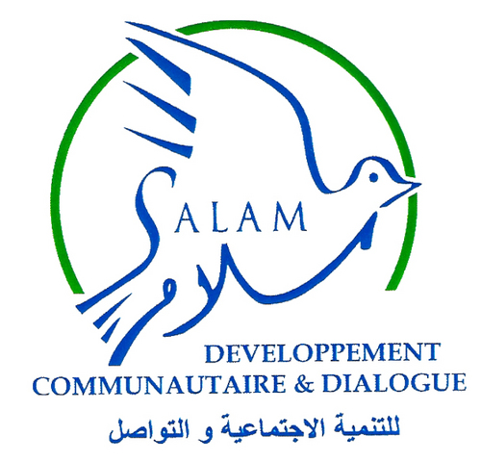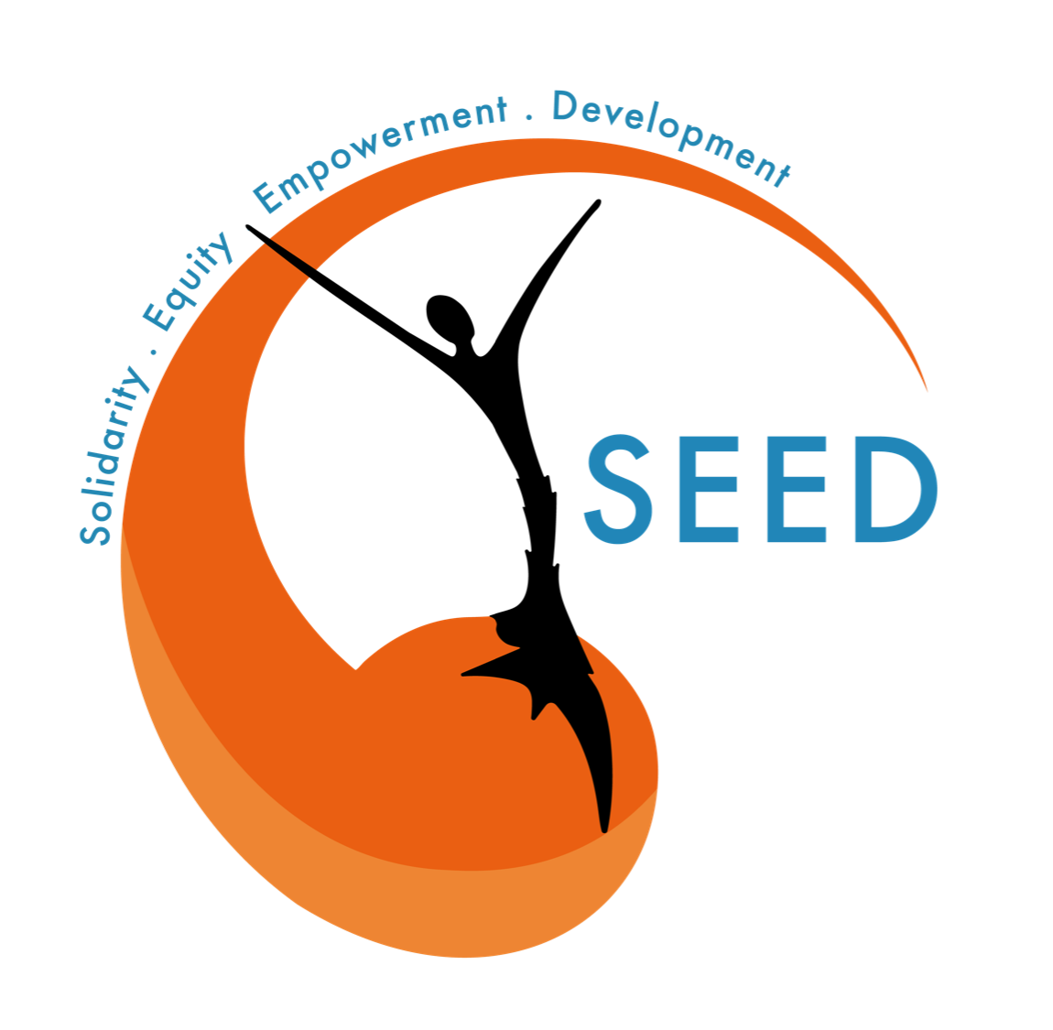
DO NO HARM POLICY

Sexual Exploitation and Abuses as any form of Gender Based Violence are tough subjects to discuss about. During focus groups and awareness sessions, trainers could perform in front of people who have already experienced sexual violence perpetrated by an unknown person, an aid worker, or someone from the community.
This is a traumatic experience and it is important to be able not recreating or amplifying the trauma.
INFORMATION, EDUCATION AND COMMUNICATION MATERIAL AND VOCABULARY  In order to reduce people’s exposure to violent or disturbing memories :  - no photos of real situations are used during focus groups and training sessions;  - only icons and drawings are shown to the participants;  - be careful of the words used during focus groups and awareness sessions;  - take time to explain any complicated concept or words and be sure it is understand by every participant before moving on another subject;  - take time to discuss any violent or difficult word, as rape;  Always informed participants about the subject they will discuss, the objectives of the session and the results. Be honest and transparent on every information, and work to have everyone at the same level of information at the end of the process  Trainers explain that they are conscious of the sensitive aspect of the subject, that is why they inform participants that they are not obliged to talk if they do not feel comfortable. They remind that all information given during the focus group will be strictly confidential, and the idea is to discuss collectively about this subject. Participants are not obliged to speak about personal experiences, the idea is to talk in a general way. Safe and calm places are open to participants in order to talk about personal experiences if they needed it. | POSITION AND POSTURE  - It is necessary to approach any difficult subjects with calmness, being gentle, and sympathetic;  - Taking the time to explain and time to listen. Empathize with people and their stories, and to listen to them closely.  - Being impatient or authoritarian is counterproductive;  - Give good, reliable and relevant information about healthcare, psychosocial support, and case management, as well as on reporting channels. Check twice the information you will give if it is needed to do so;  - If you do not know about a certain subject, do not try being always right, and accept to say you just don’t know.  - Understand local communities position : concepts and words can offend or chock people regarding their culture, religion, personal history, social environment … Do not be impatient. | LOGISTIC  - Women only will lead women and girls focus groups and awareness sessions as well as families focus groups and awareness sessions. Women and men are required to lead a mixed gender focus group;  - Explain and be sure that every information given during collective work is strictly confidential and does not disclose to anybody neither any structure. Any participation will be judged.  - Focus groups and awareness sessions should offer a safe place for local communities to discuss, exchange and which encourage people to participate, mostly person who quite often do not express themselves;  - In order to allow participants considering the place where those activities are organized as a safe place, ensure to choose a place considered secured by local communities, collective, calm, easily accessible and comfortable.  - Organize a place next to the training room to discuss in private if some participants want to do so during the focus group session. If you are uncomfortable with any ideas, concepts, information, feel free to say it and discuss it with the trainer.  - Consider 1 trainer for a group of 5 participants, so 2 for 10, 2 or 3 for 15 (maximum number of participants for a focus group), and an additional trainer which can make a referral if needed;  - Sessions should be timed and time has to be given to participants at the beginning of any session. Nevertheless timing should integrate time for participants to discuss, comments, ask questions, …
PARTICIPATION  - The whole participation is based on volunteering : if participants don’t want to share experiences or memories, don’t force them into;  - If participants do not want to talk, do not insist on their participation : to assist the focus group is already a participation;  - Participants do not need to talk about personal experiences : participation should emphasize collective experiences to allow collective response. If participants want to share personal histories, they are free to do so. |  | REFERRAL  If one of the participant want to discuss a sexual violence or any other kind of traumatic experience, she/he was exposed to, or she/he witness propose to take the person apart in the room next the training one. If the person agrees, propose to help her/him through a referral procedure, explaining any steps of it.  Never force the person into it. If the person does not want to make a referral, for any reason, it is a personal choice we have to respect. Nevertheless give reliable contacts to do so if she/he changes her/his mind later.

CRITICAL CONCEPTS

Concepts to be known by any trainer who wants to realize an PSEA activity. Those critical understandings are the results of local research on SEA, GBV and PSEA based on interviews with major stakeholders of the Lebanese PSEA sector, SOPs analysis and research documents synthesis.

WHEN AID DOES HARM  Protection to Sexual Exploitation and Abuses (PSEA) is one of the main challenge of the aid mechanism, as it calls into question the very fundamental concept of the humanitarian assistance, which is “intended to save lives, alleviate suffering and maintain human dignity during and after man-made crises and disasters caused by natural hazards, as well as to prevent and strengthen preparedness for when such situations occur” (Red Cross, Relief Web),  SEA leads directly to lives destruction, aggravation of vulnerability, and alienation of dignity, by taking out from human beings the power they have on their very own self. | POWER BALANCE  Power balance will be a key concept of PSEA, as long as local communities are considered as beneficiaries of the aid, and humanitarian workers, considered as the ones who bring the solution.  Indeed, unfairness regarding power balance is induced by the humanitarian system itself : groups, people and local communities are depending on the aid and support of NGOs partly or totally. Therefore individuals - victims as witnesses - are staying silent because they fear reprisals for them, loved ones, community, … : to see the aid reduced or simply be cut off from aid. That explains partly why SEA is under reported.  Therefore any people who benefit from humanitarian aid is vulnerable to SEA and could become a victim of sexual assaults and violence. Rebalancing the power ratio by empowering local communities is a major issue.  Moreover, one of the challenges is to un-power aid workers by « decreasing the level of expectation to be sure it will not be harmful ». People might be over-expecting from organizations, therefore it is important to work on decreasing those expectations (no promises, etc.). | NO ONE TO TURN TO  PSEA arises a major reporting issue : the referral pathways and mechanisms are detained by organizations directly linked to perpetrators. Therefore it is easy to understand that victims or witnesses refused to use those pathways to make the referral, in fact Will you go to a police station to report an assault, if the perpetrator was a policeman ? It is important to make people aware they have other pathways to report (national channel, other NGO, police, …). Nevertheless they should know how the “normal” system of reporting works and that it should support and help victims and witnesses.  PSEA mechanisms work mainly in a theoretical way : the lack of referrals could show an absence of assaults, but many NGO agree on saying that those are way underused by local communities for many reasons : lack of trust, fears, cultural matters, lack of knowledge in the system organization, …

INVOLVING LOCAL COMMUNITIES

To make the community understand the value of this kind of mechanism, it is important to raise awareness, and considerate the long-term relation as a first step of the mechanism. It is a way to make the mechanism less systematic and more human.

First of all, is it important to raise awareness for NGO staff. Abaad and Care are providing training to frontliners and protection specialists in order to raise awareness on GBV and PSEA topics. Most NGO staff might not be aware of SEA, even if they are working with communities where the risk of SEA situations is high. They might not be aware of the concept of “exploitation”, neither of “consent”. “I see it in meeting everyday, people don’t understand the concept of consent”

It is also crucial to raise awareness among local communities regarding “consent” : people need to be aware of their right to say “no” to any kind of forced relation.

FEMALE LEADERSHIP  Women and girls as experts in contextual safeguarding and actively engage vulnerable groups and people in their own safety and lifeguarding mechanisms.  Women and girls should not be shouted out in their participation to the aid system (going to distribution, participation in training, receiving experts at home, going to consultation, …). First because they are part of the community and need to be supported by the humanitarian system, second to avoid reinforcing the stigma gender they are already targeting by. | VULNERABLE GROUPS AND PEOPLE  To protect vulnerable groups and people, working only with the less vulnerable (men) could not be agreed as a solution. Indeed, sending only men to distribution or having them all the time at home when an aid worker is in, are situations that tend to reinforce the stigmatization of women and girls : they are weaks, they need to stay at home, they need a man to be protected.  Education plays an important part in reduction of gender based violence : women are recreating a patriarchal system, bringing up violent and superior behaviours. Working on parenting skills are extremely important to have a sustainable impact on SEA and GBV. | MISSING COMPONENT  Awareness sessions are always targeting victims but not offendents. Focus groups with men could allow them to engage discussion about ways to communicate inside the family.  Engage the “missing component” - Men have to be empowered too, and to understand why women, girls and children of their community are changing, being empowered. They have an important role in the community mentality shift. However feeling cast out could strongly impact behaviours, making people frustrated, hangry, even violent.

RISK MANAGEMENT

In this program, Sexual Exploitation and Abuses are analyzed through the risk management prism.

BEFORE  Prevention : knowledge is power  What is sexual violence, exploitation and abuses ? Those terms are not trivial, and it is important to give a good definition of it. Sexual violence could start and end with a word, abuses with a look, and that is not acceptable. Communities need to have access to the all extent of those concepts, mainly when it comes to “exploitation”.  Preparedness and mitigation  Reinstate the power ratio by empowering local communities and support them to develop tools to increase their own protection. However NGO have an important role to play in local communities protection of SEA, their actions have to be complementary to the local communities ones, and should respect local communities at every step. | DURING  Disaster  This is what happens when the risk occurs. Talk about disaster is really important - not to jump from “prevention” to “response”. In between there is the violent act, the assault, the abuse and it's important to talk about it.  Discussing about the SEA act itself participates to deconstruct prejudices about victims and their responsibilities, contribute to recognize status and right of the victim, and can alleviate the suffering to be silenced down and alone.  Moreover, sometimes people do not realize they just came through a serious traumatic experience. Therefore discussing the “disaster” could be a way to help victims talk if they want to. | AFTER  Response  Victims are the only one who can decide to be involved or not in a case management mechanism. It is not an obligation and there should be no judgement if someone refused to go through a reporting mechanism, as well as a legal reporting mechanism.  Nevertheless it is important to give to local communities all the option you know, and encourage them into a case management process for them to be at least supported in their pain.

