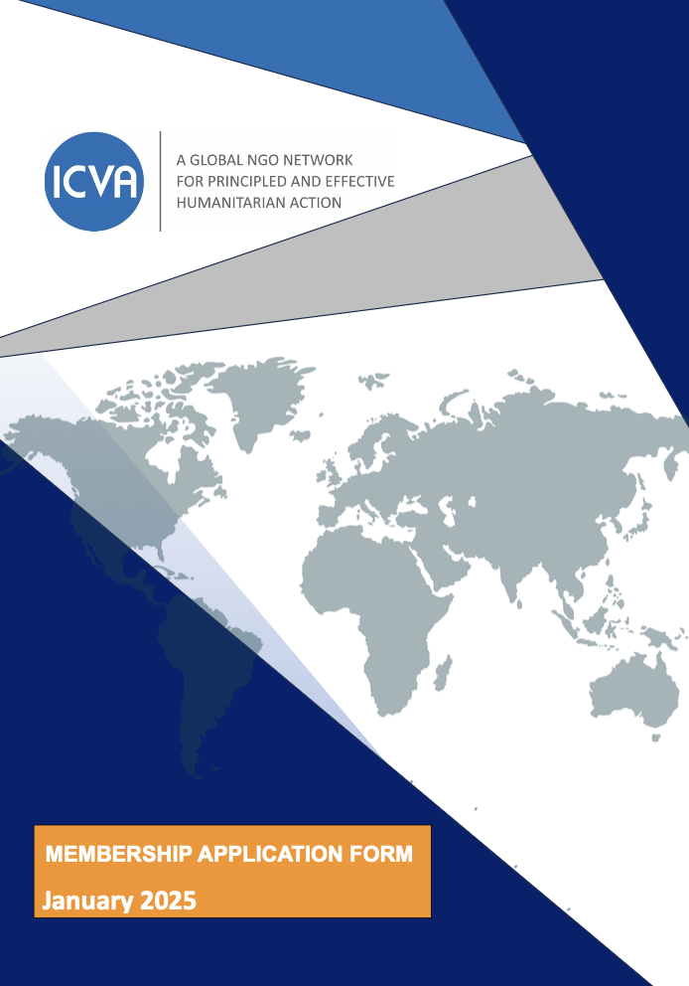
MEMBERSHIP APPLICATION FORM

JULY 2025
Application Form for ICVA Membership

APPLICATION FORM FOR ICVA MEMBERSHIP

This form comprises nine sections requesting information for us to assess your organisation’s eligibility for membership of ICVA:

- Organisation and Contact Details
- Organisation Profile
- ICVA and Your Organisation
- Your Expectations of ICVA
- Humanitarian Principles and Standards
- Membership Dues
- Further information
- Required Documentation
- Declaration

Before completing this form, you should read the How to Join ICVA and the ICVA By-law on Eligibility for Membership. The By-law outlines which organisations are eligible to become Members, Observers, or Affiliate members.

Please tick the appropriate box below to indicate which type of membership your organisation is applying for:

□ Member
□ Observer
□ Affiliate

If applying for Observer status, please explain why:

…….........................................................................................................................................

Checklist for Applicants
Before submitting, ensure you have:
- Completed all sections of the form.
- Calculated your membership dues.
- Attached all required documentation.
- Signed the declaration.

Please note that membership of ICVA does not constitute an endorsement of your work. ICVA makes no judgement about the competence of any member organisation.
Submit completed application to Email: membership@icvanetwork.org

Please ensure that all the requested information is provided. Applications can only be processed once the application is complete.

Please send your completed application form and supporting documents to: membership@icvanetwork.org

The ICVA staff will be happy to help with any questions you have regarding membership or the application process and forms.

Section 1: Organisation and Contact Details

Organisation Name: ___________________________________________

Legal Status: _______________________________________________

Headquarters Address:
- Street: _______________________________________________________
- City: _________________________________________________________
- Country: _____________________________________________________
General Email (e.g., info@yourorganisation.org): ________________
Website: ___________________________________________________
Telephone (e.g., +[country code] [area code] [number]): ___________

Primary Contact:
- Name: ______________________________________________________
- Title/Position: ________________________________________________
- Email: ______________________________________________________
- Phone: ______________________________________________________

2. Organisation Profile

Year of Establishment …...............................................................................................................

Which category best describes your organisation?

□ National NGO
□ International NGO
□ Consortium or network of NGOs

Mission Statement

……........................................................................................................................................

……........................................................................................................................................

Please tick to confirm that your organisation is:

□ Non-governmental;
□ Non-profit;
□ Carrying out human rights/humanitarian programmes and/or activities; and
□ Non-partisan (operates without discrimination in regard to race, nationality, gender, political, or religious conviction, or social and economic background).

Geographic Areas of Operation (List countries or regions):

…….........................................................................................................................................

……........................................................................................................................................

Membership in Other Institutions, Networks, Groups, or Consortia:

…….........................................................................................................................................

……........................................................................................................................................

Key activities and programmes: Briefly outline your key objectives and how they align to ICVA’s mission.

…….........................................................................................................................................

……........................................................................................................................................

…….........................................................................................................................................

……........................................................................................................................................

Section 3: ICVA and Your Organisation

Why are you seeking membership in ICVA? (Describe how your organisation aligns with ICVA’s mission and values):
……........................................................................................................................................

……........................................................................................................................................

ICVA 2030 Strategy

The ICVA 2030 sets the direction and broad areas of work for ICVA. Adoption of the Strategy by the General Assembly implies commitment from all ICVA members to participate in its implementation.
How will your organisation contribute to ICVA’s 2030 Strategy?
……........................................................................................................................................

……........................................................................................................................................

Section 4: Expectations of ICVA

Expectations from ICVA: (Describe the support your organisation seeks from ICVA.)

……........................................................................................................................................

……........................................................................................................................................

Your Contributions to ICVA: (Describe how your organisation plans to support ICVA’s work.)

……........................................................................................................................................

……........................................................................................................................................

Section 5: Humanitarian Principles and Standards

ICVA has identified several accountability and humanitarian principles as minimum commitments for ICVA members.

- Humanitarian Principles and the Code of Conduct:
The Code of Conduct for the International Red Cross and Red Crescent Movement and NGOs in Disaster Relief provides a set of principles and ethical standards for organisations involved in humanitarian work.

The Code can be found at: https://www.icvanetwork.org/resource/code-of-conduct-for-the-international-red-cross-and-red-crescent-movement-and-non-governmental-organizations-ngos-in-disaster-relief/

□ Please acknowledge that your organisation is committed to the Code of Conduct by ticking this box.

- Principles of Partnership
Collaboration with other NGOs and/or partner agencies, in line with the Principles of Partnership of the Global Humanitarian Platform. https://www.icvanetwork.org/uploads/2021/09/Principles-of-Parnership.pdf

□ Please acknowledge that your organisation is committed to the Principles of Partnership by ticking this box.

- Alignment with Humanitarian Standards: Provide examples of how your organisation adheres to the following:
- Sphere Standards
- Core Humanitarian Standard (CHS)
……........................................................................................................................................

……........................................................................................................................................

- Statement of Commitment on Eliminating Sexual Exploitation and Abuse
At the ICVA 17th General Assembly in March 2018, ICVA members endorsed a commitment to protect from sexual harassment, exploitation and abuse the people in the communities in which they work and their employees. The Commitment also requires that ICVA Secretariat and members have systems in place for preventing, detecting and responding to abuse and misconduct. The commitment can be found at https://www.icvanetwork.org/resource/commitment-and-motion-to-action-on-psea-and-sexual-harassment/
Provide examples of how your organisation adheres to this commitment:
……........................................................................................................................................
……........................................................................................................................................

- Commitment and motion to action in climate and environment

At the 18th General Assembly in May 2021 ICVA members committed to reduce the impacts of climate crisis and be part of the solution. The commitment encourages members to sign the Climate and Environment Charter for Humanitarian Organisations.

The commitment can be found at https://www.icvanetwork.org/resource/commitment-and-motion-to-action-on-climate-and-environment/

Provide examples of how your organisation adheres to this commitment:
……........................................................................................................................................
……........................................................................................................................................

- Other principles and standards of your organisation

If there are any other policy statements or declarations of principles that your organisation subscribes to, please add them here:

…….........................................................................................................................................

- United Nations Security Council List

ICVA is requiring its member organisations to certify that their head office, their affiliates, or any individuals linked to the organisation are NOT listed on the UN Security Council List resolutions 1267 List.

The UNSC List can be found at
https://www.un.org/securitycouncil/content/un-sc-consolidated-list

□ Please acknowledge that neither your organisation nor any of its affiliates are listed on the UN Security Council List

□ Please acknowledge that no individual linked to your organisation is listed on the UN Security Council List

Section 6: Membership Dues

ICVA Members and Affiliates dues are based on each organisation’s structure and annual budget. Please use Steps 1-3 to decide your organisation’s fee band.

All Observers fall into Fee Band II, regardless of annual budget.

Annual Budget | Fee Band | Membership Dues | Members, Observers & Affiliates
CHF 50 millions and over | I | CHF 12,000 | - Members & Affiliates
Between CHF 30 and 50 millions | II | CHF 8,000 | - Members & Affiliates  - Observers (regardless of their budget)
Between CHF 10 and 30 millions | III | CHF 4,000 | - Members & Affiliates
Between CHF 10 and 5 millions | IV | CHF 2,000 | - Members & Affiliates
Between CHF 5 and 1 millions | V | CHF 1,000 | - Members & Affiliates
Less than CHF 1 million | VI | CHF 500 | - Members & Affiliates

Your Organisation’s Annual Income: ____________________________

Membership Fee (Based on the table above): ______________________

Section 7: Further information

You are invited to provide any further information that may support your application. This can include contact details of an ICVA member that could provide a reference.

……........................................................................................................................................

……........................................................................................................................................

Section 8: Required Documentation

Attach the following documents to complete your application:
- Statutes/Constitution: To confirm your organisation’s mission and governance.
- Proof of Legal Status: To verify your non-profit status.
- Annual Report or Financial Statements: two most recent versions. To assess dues calculation.
- Names of board of directors or equivalent and senior management
- Code of Conduct or Equivalent: If your organisation has committed to any additional codes of conduct or similar documents.

Application fee
There is a charge of CHF 75.00 to apply for ICVA membership. An invoice will be sent to you once we receive the completed application.

Section 9: Declaration

By submitting this application, you confirm the following:
- Our organisation adheres to the humanitarian principles of humanity, neutrality, impartiality, and independence.
- We commit to upholding ICVA’s mission and values.
- All information provided in this application is accurate to the best of our knowledge.

Authorised Signatory:
- Name: ______________________________________________________
- Title: ______________________________________________________
- Date: ______________________________________________________

Signature (Digital or Handwritten): _______________________________

ICVA- International Council of Voluntary Agencies

Africa | Asia- Pacific | Latin America | MENA
Dakar, Senegal | Bangkok, Thailand | Guadalajara, Mexico | Amman, Jordan
Nairobi, Kenya | Islamabad, Pakistan | Representation
 | Geneva, Switzerland
NGO Humanitarian Hub, La Voie- Creuse 16, 1202 Geneva
 | secretariat@icvanetwork.org
 | www.icvanetwork.org
